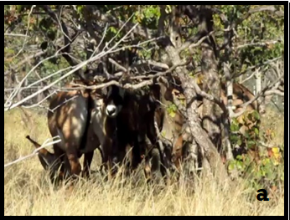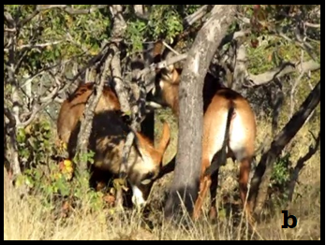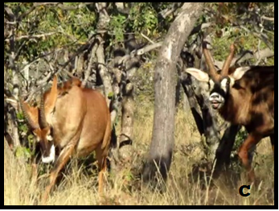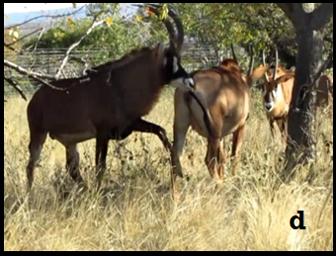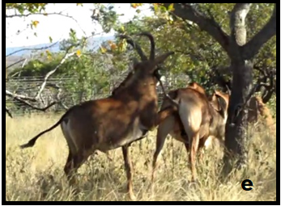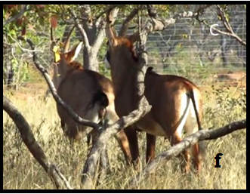
Figure 1: Sequence of behavioural events displayed during mating attempts in roan antelope between a male and a non-receptive female. (a): male approaches the female; (b): the male pushes the females intensively; (c): male follows the female at a gallop; (d); the male gives foreleg kick from the side (e): the male gives foreleg kick between the hind legs of the female. (f): female urinates, male smells urine from stream and executes flehmen.

