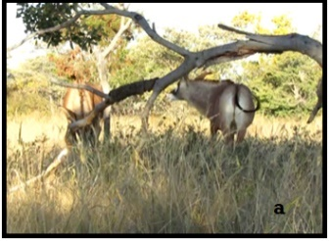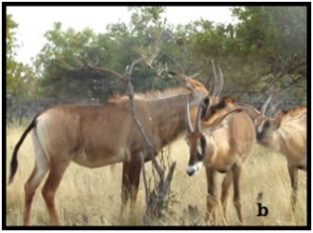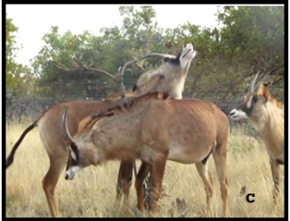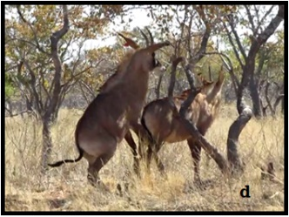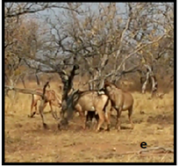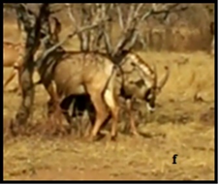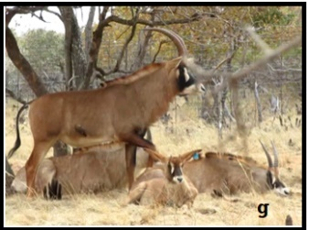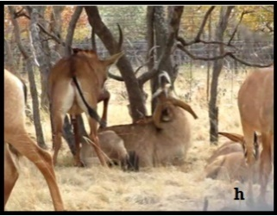
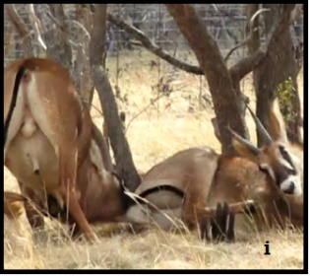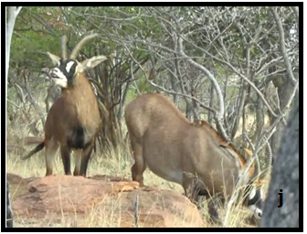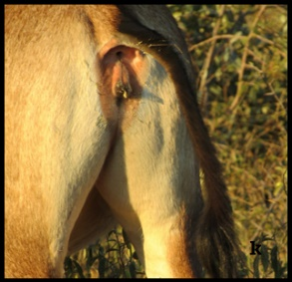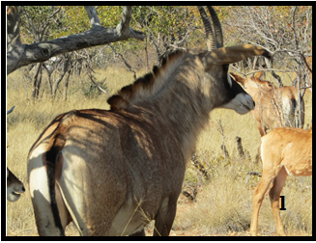
Figure 3: Sexual behaviours displayed by female roan antelopes: (a) female approaching another female with head in the low stretched posture; (b) Females sniffing another female genitalia; (c) female performing flehmen; (d): Female attempting to mount another female; (e). (f): Females executing whirl-around; (g): Non-receptive female lying with outstretched legs and head; (h). (i): Non-receptive female performing agonistic behaviour when approached by the male; (j): Non-receptive female falling onto its knees after a courtship attempt by the male. (k): Receptive female with erect tail presenting vaginal mucus. (l): female presenting hair loss on the rump.

