Characterization of the reproductive behaviour of the roan antelope (Hippotragus equinus)
Mammalian biology

Vanessa W. Kamgang, Tanja E. Wolf, Nigel C. Bennett^{1,} Annemieke C. van der Goot, and Andre Ganswindt
Corresponding author email: vanessa.wandja@gmail.com

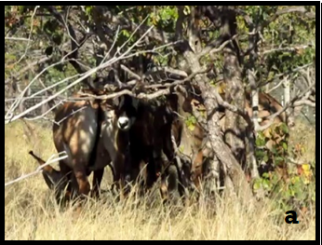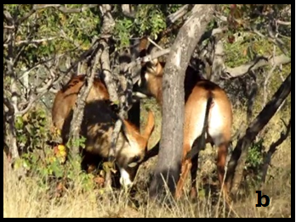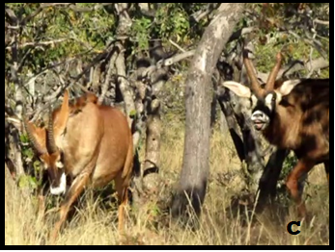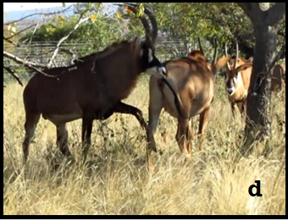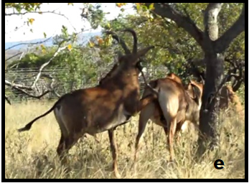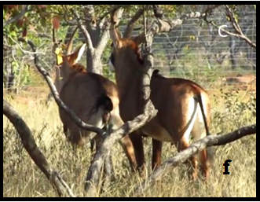
Fig 1 Sequence of behavioural events displayed during mating attempts in roan antelope between a male and a non-receptive female. (a-b): male approaches the female; (c): male follows the female at a gallop; (d); the male gives foreleg kick from the side (e): the male gives foreleg kick between the hind legs of the female. (f): female urinates, male smells urine from stream and executes flehmen.

