Characterization of the reproductive behaviour of the roan antelope (Hippotragus equinus)
Mammalian biology

Vanessa W. Kamgang, Tanja E. Wolf, Nigel C. Bennett^{1,} Annemieke C. van der Goot, and Andre Ganswindt
Corresponding author email: vanessa.wandja@gmail.com

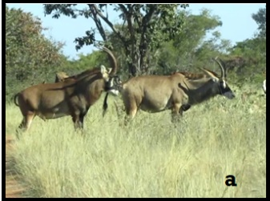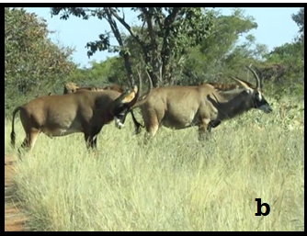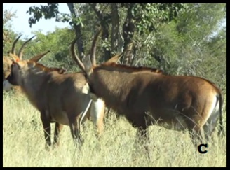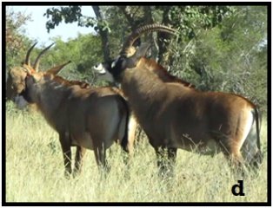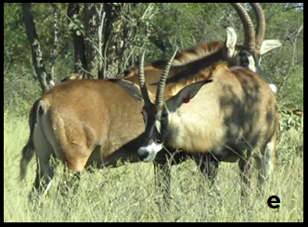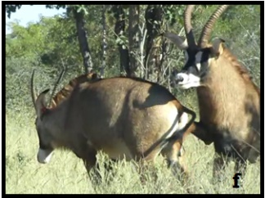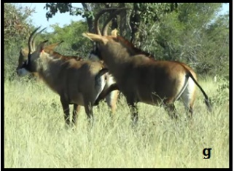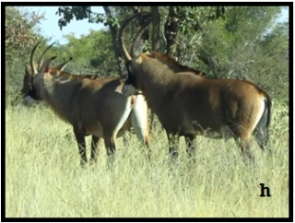
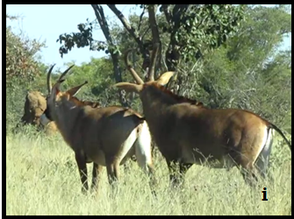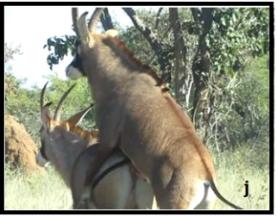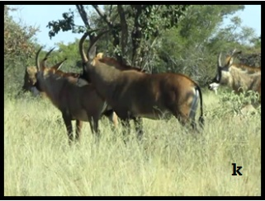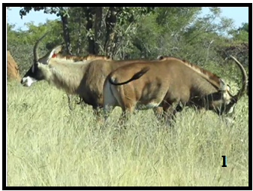
Fig 2 Sequence of behavioural events in roan antelopes between a male and a receptive female. (a): Male approaches the female from the back; (b): Male pushes the females intensively with horns; (c): Male smells the female’s anogenital region of; (d): Male flehmen; (e) Male standing in the posterior flank of the female; (e-g): whirl-around. The female is pushed by the male who kicks with his forelegs between her posterior legs and from the sides; (h): Male stands behind the female; (i): Male stands behind the female and smells her genitalia; (j): mounting with intromission; (k): dismounting; (l): Male and female restart their activities.

