Characterization of the reproductive behaviour of the roan antelope (Hippotragus equinus)
Mammalian biology

Vanessa W. Kamgang, Tanja E. Wolf, Nigel C. Bennett^{1,} Annemieke C. van der Goot, and Andre Ganswindt
Corresponding author email: vanessa.wandja@gmail.com

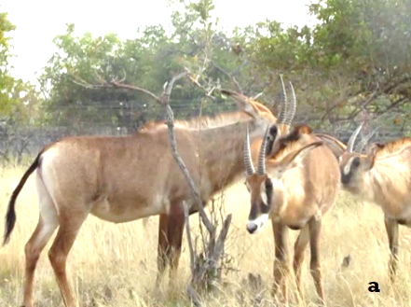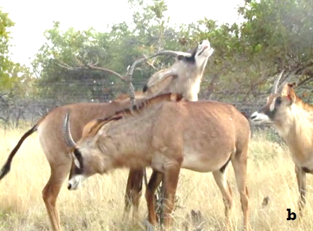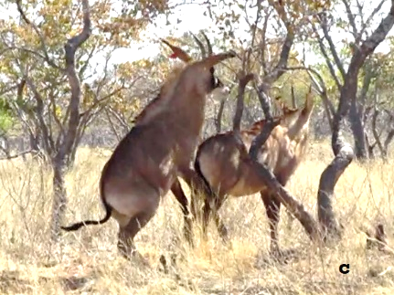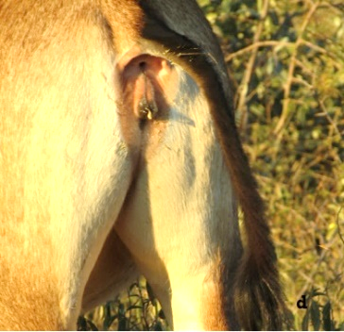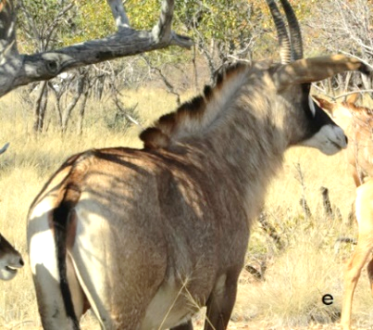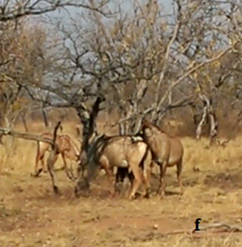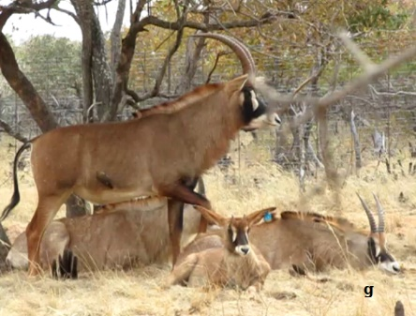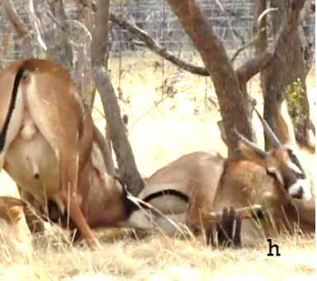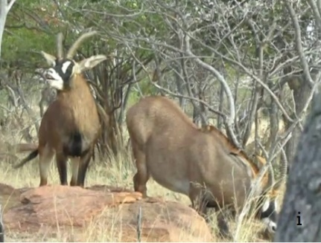
Fig 3 Sexual behaviours displayed by female roan antelopes: (a) Females sniffing another female genitalia; (b) female performing flehmen; (c): Female attempting to mount another female; (d): Receptive female with erect tail presenting vaginal mucus; (e): female presenting hair loss on the rump (f): Females executing whirl-around (g): Non-receptive female lying with outstretched legs and head Females executing whirl-around;(h): Non-receptive female lying and performing agonistic behaviour when approached by the male; (i): Non-receptive female falling onto its knees after a courtship attempt by the male.

