Glass foams from acid-leached phlogopite waste

Helena Maria Deysel¹, Kent Berluti¹, Barend Jacobus du Plessis¹ and Walter Wilhelm Focke¹

¹Institute of Applied Materials, Department of Chemical Engineering, University of Pretoria, Private Bag X20, Hatfield 0028, Pretoria, South Africa

Helena Maria Deysel helenad48@gmail.com ORCID: 0000-0002-6509-9270
Kent Berluti u14083940@tuks.co.za ORCID: 0000-0002-1126-1316
Barend Jacobus du Plessis barend.duplessis@up.ac.za ORCID: 0000-0002-7140-5502
Walter Wilhelm Focke walter.focke@up.ac.za ORCID: 0000-0002-8512-8948

Abstract
XRD analysis and exfoliation behaviour of Palabora phlogopite flakes supplied by PMC indicate a heterogeneous mineralogical composition dominated by phlogopite and hydrobiotite. 4 M nitric acid leaching for 6 h at 65 °C resulted in amorphous silica with a very high surface area (< 450 m²⋅g⁻¹). This was used to produce light-weight and high strength glass foams via a direct foaming method. The best results were obtained with a formulation with borax: waterglass: amorphous silica 23:46:31 wt-%. A closed-cell foam with a density of 0.326 g⋅cm⁻³ and compressive strength of 2.09 MPa was obtained on heating a compacted mixture a ca. 6 K⋅min⁻¹ to 525 °C and keeping it at that temperature for 30 min before allowing it to cool down. These results suggest that the silica waste, obtained from acid leaching of phlogopite mine tailings, could provide a valuable raw material for the manufacture of low-density glass foams.

Keywords: Foam; glass; phlogopite; acid leach; silica

Introduction
Phlogopite is a constituent of the pegmatoid ultrabasic rocks found in the Palabora igneous complex [1]. Surface weathering under the influence of percolating water has, over geological time, led to the progressive vermiculitization of the phlogopite [1]. According to Muiambo et al. [2], Palabora “vermiculite” is chiefly an interstratified material. Hillier et al. [3] identified it as mainly composed of hydrobiotite, a regular 1:1 interstratified vermiculite-biotite previously defined by Brindley et al. [4].
Operations at the Phalabora open-pit mine centre on the extraction of copper and phosphate. This has led to the accumulation of an extensive stockpile of “phlogopite”. For now, this is regarded as a waste but in future, it could be exploited as a potential source of potassium and magnesium. Acid leaching of phlogopite has a long history
[5] [6] [7] [8] [9] [10] and it provides a possible route to the recovery of these elements. The acid leached residue is a hydrated layered but disordered silica with a "distorted" structure [10]. However, macroscopically it still resembles the silicate sheets of the original mineral. Wypych et al. [10] proposed the following model for the formation of this "disordered" silica structure. The removal of the octahedral sheet from the original structures induces distortion in the silica sheets with the tilting of some bonds to produce alternate apical silanol groups. The bonds, which previously connected the octahedral sheet, end up being partially hydroxylated. The final composition of the leached residue approaches H_{2x}Si₂O_{4+x} [10].
Glass foam is a porous heat insulating material [11]. It is considered environmentally friendly material because it does not release harmful substances at high temperatures [12]. It shares some properties with metallic foams, including high stiffness at low densities (Lefebvre and Banhart, 2008). Compared to polymeric foams, ceramic foams offer acceptable mechanical- and thermal insulation properties without the associated fire risk [13]. Additional desirable properties of glass foams include sound absorption, water- and steam resistance, chemically inertness, bacteria resistance and being essentially nontoxic [14]. These advantages prompted the exploration of amorphous silica, from acid-leached phlogopite, as raw material for the fabrication of glass foams.
For this application, highly reactive silica could be desirable, and this implies high porosity, high surface area amorphous powders. Leaching with HNO₃ should, therefore, be considered as Härkönen, Keiski [6] found that the products obtained in that way were significantly more porous than those resulting from leaching with HCl or H₂SO₄. Härkönen, Keiski [6] obtained, for phlogopite exhaustively leached with 30% HNO₃, maximum values for surface area and total pore volume corresponding to 620 m²⋅g⁻¹ and 0.46 cm³⋅g⁻¹ respectively.
Previous investigators explored the optimum conditions for glass foam formation using actual glass powders instead of amorphous silica as the starting material [15] [16,17]. Scarinci et al. [14] noted that the particle size of the starting glass powder significantly influences the final density of the glass foam. According to [18] the particle size of the starting glass must be less than 400 μm; otherwise it halts the foaming process. It is also essential to compact the powder mixture before sintering in order to create a uniform foam structure [14]. The heating rate is another important process variable that influences the properties of glass foams. Scarinci et al. [14] and Bernardo et al. [19] suggested that heating rates between 5 and 10 K⋅min⁻¹ are required for obtaining homogeneous and crack-free glass foams. Scarinci et al. [14] found that the final foam density depends on the length of the soak at the sintering temperature. These findings were considered in the experimental programme used to find optimum glass foam formation conditions. This communication reports on the properties of the amorphous silica, obtained by the acid leaching of the phlogopite, as well as glass foams obtained from it.

Materials and Methods
Materials
C.C. Immelmann (Pty) Ltd. supplied nitric acid 55% (CAS No. [7697-37-2/2]). Pharmaceutical grade sodium tetraborate decahydrate (Na₂B₄O₇·10H₂O), also known as borax, was purchased from Dis-Chem. Granular sodium metasilicate pentahydrate (Na₂SiO₃·5H₂O) (CAS No. [2839111004]), also known as waterglass, was supplied by Protea Chemicals (Product no: 2839111004). Mandoval Vermiculite (Pty) Ltd donated samples of milled Palaborwa “vermiculite”. “Phlogopite”, in the form of flake-shaped particles with a golden lustre, was obtained from Palaborwa Mining Company Ltd. (PMC).

Procedures
Phlogopite leaching procedure. The phlogopite flakes were first milled in a Kenwood BL370 Blender to a particle size less than 2.8 mm. Average grinding time was about 10 s per batch, and the oversize was recycled. In a typical leaching experiment, milled phlogopite (20 g) was placed in a beaker containing 200 mL of 4 M HNO₃. The solids were suspended in the acid by stirring at 300 rpm. The leaching was conducted at a temperature of 65 ± 5 °C for 6 h. After cooling, the product was washed with 200 mL portions of distilled water until the pH of the filtrate exceeded pH = 2. The recovered solids were dried overnight in a convection oven set at 60 °C. The mass of the solids was always between 8 and 8.2 g after drying. This means near-complete leaching of all the cations from the structure, leaving just a silica “backbone”.
The solids from all the leaching runs were combined and milled in a blender for about 20 s to de-agglomerate any particle clumps. A Fritsch heavy-duty vibratory sieve shaker (Model 6580, Idar-Oberstein, Germany) was used to classify the amorphous silica product into particle sizes fractions corresponding to particle size cuts of 500–250 μm, 250–90 μm and 90–45 μm.
Glass foam preparations. Glass foams were made using combinations of the amorphous silica with the waterglass as the binding and foaming agent together with borax as a fluxing agent. Selected mass ratios of the constituents were calculated based on 5 g total mixture. First, the waterglass was pulverised for about 1 min in a coffee grinder. Next, the borax was added, and the combination ground for another minute. Finally, the amorphous silica was added to the resultant powder mixture. It was mixed-in using vigorous shaking taking particular care that no agglomerates remained.
Initial foaming experiments were conducted in Polytop glass vials (75 mm × 24 mm φ) because they can withstand temperatures as high as 800 °C. The mixed powder was poured into the vials and compacted to half the initial height using a steel rod. The compacted samples were sintered in a Carbolite CWF 11/5 muffle furnace capable of a maximum temperature of 1000 °C.
The Polytop vials with the compressed powders were placed in the muffle furnace and subjected to the desired time-temperature protocol. At the end of the dwell time at the chosen soak temperature, the furnace was switched off and the samples allowed to cool down freely. The foams were removed from the furnace when the temperature dropped to below 250 °C. A digital Vernier calliper was used to measure the foam height and diameter before and after the completion of the foaming process.
The optimum conditions for the preparation of low-density glass foams were determined using a Design of Experiment (DOE) approach. The main variables investigated included the amorphous silica particle size (90 - 4 μm and 250–90 μm); the mixture composition; the initial furnace temperature (25 or 120 °C), the nominal heating rate (6, 10, 19 and 30 °C/min); the final sintering temperature (450, 480, 500, 520 and 550 °C), and the dwell time at this temperature (15 or 30 min). Detail of the methods employed and the results obtained are presented elsewhere [20]. Analysis of the results showed that the particle sizes, initial temperatures, and the dwell times considered presently had almost no effect on the final glass properties. Therefore, only the main findings relevant to the effect of the remaining process parameters are discussed below.
Once a promising foam formulation and its associated preparation procedure were identified, a steel mould was used to produce larger foam bricks measuring 110 mm × 45 mm × 40 mm.

Characterisation
Foam density and compressive strength. The glass Polytop vials were broken in order to recover the glass foams. These were cut to size with a hacksaw. The surfaces were smoothed with sandpaper to yield cylindrical shapes with dimensions of approximately 16 mm × 22 mm φ. The foam density (ρ) was estimated from the mass and the volume calculated from the physical dimensions of the foam. The compressive strength of the foams was determined on a Shimadzu EZ-L universal tensile testing machine fitted with a 5 kN load cell. The test samples were cylinders measuring approximately 16 mm × 22 mm φ. The cross-head speed was 1 mm⋅min⁻¹. Reported values are averages of duplicate determinations.
Fourier transform infrared spectroscopy (FTIR). Fourier transform infrared (FTIR) spectra were recorded on a Perkin-Elmer Spectrum 100 in the attenuated total reflection (ATR) mode. The wavenumber ranged from 3800 to 600 cm⁻¹. The reported spectra represent averages of 16 scans obtained at a resolution of 4 cm⁻¹.
Thermogravimetric analysis (TGA). The thermal stability of the leached phlogopite was checked by thermogravimetric analysis (TGA) performed on a Hitachi STA 7000 Thermogravimetric Analyzer. Samples weighing ca. 6 ± 2 mg were placed in open 70 μL alumina pans. They were heated at a rate of 10 K⋅min⁻¹ from ambient to 1000 °C in nitrogen flowing at 50 mL⋅min⁻¹.
Thermomechanical analysis. Thermal expansion measurements were conducted on a TA instruments Q400 Thermomechanical Analyzer. A single flake was sandwiched between the flat surface probe and the bottom surface of an alumina pan. The temperature was scanned from 30 °C to 800 °C in argon at a scan rate of 10 K⋅min⁻¹. Since the objective was to follow the free expansion of the flakes, the lowest possible force (0.001 N) was applied. The expansion relative to the original flake dimension is reported.
Particle size analysis and BET surface area. The particle size distributions of the powders were determined with a Malvern Mastersizer 3000. BET surface areas of the leached phlogopite powders were determined with a Micromeritics TriStar II 3020.
X-ray Fluorescence (XRF). X-ray fluorescence spectroscopy (XRF) analyses were performed on powders milled to a fine particle size (<75 μm). The moisture content was determined by weighing an accurate mass of approximately 3 g of powder into an alumina crucible. The crucible was then heated in an oven at 100 °C for 2 h. After that, the dehydrated samples were roasted at 1000 °C overnight. A sample mass of 1 g of the residue was fused with about 6 g of lithium tetraborate at 1050 °C for metal oxide determination.
X-ray diffraction (XRD). X-ray diffraction (XRD) analyses were performed using a Bruker D8ADVANCE instrument with 2.2 kW Cu long fine focus tube (Co Kα, λ= 0.179026 nm). The system was equipped with a LynxEye detector with 3.7° active area. Samples were scanned from 2θ = 5° to 90° using a step size of 0.05° and with 5 s per step at generator settings of 40 kV and 40 mA. Data manipulation employed the Bruker DIFFRAC.EVA evaluation program. Before XRD analysis, the samples were milled into fine powders using a McCrone tungsten carbide micronizing mill. Acid-leached phlogopite samples were heat-treated at different temperatures for 1 h in order to study the crystallisation behaviour at different soak temperatures. The amorphous content of the acid-leached phlogopite was estimated by adding 20% Si (Aldrich 99% pure) to the sample before milling.
Scanning electron microscopy (SEM). The morphology of leached phlogopite flakes and the fracture surface of the glass foam were imaged with a Zeiss Ultra Plus 55 scanning electron microscope (SEM) fitted with an In-Lens detector. The voltage setting was either 1 kV or 5 kV. The powders were carbon-coated with an Emitech K950X coater before scanning.

Results
Figure 1 shows a SEM micrograph of an acid-leached phlogopite flake. It reveals that the sheet-like structure of the original silicate mineral was retained.
Figure 1. SEM micrograph of acid-leached phlogopite flakes.

Particle size distribution. Table 1 lists the particle size distributions and the BET surface area of the leached phlogopite.

Table 1. Typical particle size distributions and BET surface area for the raw- and acid-leached phlogopite
Property | BET | Particle size (μm)
Sample | (m²⋅g⁻¹) | D10 | D50 | D90
Vermiculite | - | 292 | 606 | 1101
Phlogopite | - | 84.1 | 206 | 382
Leached phlogopite | 456 | 43.8 | 84.7 | 142

Fourier transform infrared spectroscopy (FTIR-ATR). Figure 2 shows FTIR-ATR spectra for the starting phlogopite, the acid leached phlogopite and the Palabora “vermiculite”. Detailed band allocations of the FTIR spectra can be found elsewhere for the phlogopite [21] and the “vermiculite” [2]. Their IR spectra show a strong band at 3400 cm⁻¹ which is ascribed to the characteristic O–H stretching vibration from the water of hydration and bonded silanol groups. Other intense bands are observed at around 1645 cm⁻¹ and they are due to O–H bending vibrations in the water of hydration. Located at ca. 999 cm⁻¹ there is a strong band attributed to Si–O–Si and Si–O–Al stretching vibrations.
Due to polarization effects, the powder spectra of amorphous silica powders depend on the size, shape and state of aggregation of the particles [22]. The broad, weak IR band near 3340 cm⁻¹ is due to adsorbed H₂O [23]. The shoulder at about 1200 cm⁻¹ in the infrared spectrum of the amorphous silica is assigned to a longitudinal mode [22]. The band near 1050 cm⁻¹ is assigned to the Si-O asymmetric stretching vibration [24]. The absorption band at about 950 cm⁻¹ corresponds to a localized mode attributed to stretching of terminal Si-OH (silanol) groups [22,23]. The presence of a band at about 800 cm⁻¹ serves as evidence for a three-dimensional amorphous silica phase [25]. In summary, the IR spectrum is consistent with the model proposed by [10].

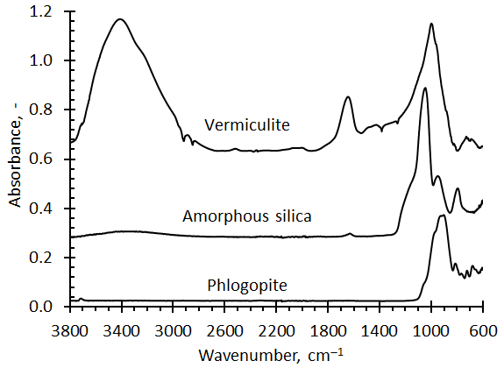
Figure 2. FTIR-ATR spectra for Palabora “vermiculite”, Palabora “phlogopite” and acid leached phlogopite.

Table 2. XRF composition of the neat and acid leached phlogopite compared to literature
Sample | SiO₂ | MgO | Al₂O₃ | K₂O | Fe₂O₃ | CaO | TiO₂ | LOI | Reference
“Phlogopite” | 41.00 | 25.14 | 9.79 | 7.10 | 7.62 | 1.10 | 0.95 | 6.47
Leached phlogopite | 87.62 | 2.05 | 0.74 | 0.44 | 0.63 | 0.01 | 0.34 | 7.71
“Vermiculite” | 46.48 | 21.48 | 8.96 | 4.54 | 7.52 | 2.96 | 0.91 | 7.11
Palaborwa phlogopite | 41.90 | 24.2 | 9.64 | 10.92 | 6.66 | 0.84 | 1.41 | 2.58 | [26]
Palaborwa vermiculite | 38.00 | 27.91 | 9.46 | 4.42 | 2.94 | 0.74 | 1.12 | 13.7 | [26]
Palaborwa hydrobiotite | 41.98 | 25.17 | 9.66 | 7.62 | 7.90 | 0.05 | 1.04 |  | [3]

X-ray fluorescence. Table 1 reports the XRF chemical composition of the Palabora samples to values reported previously for phlogopite and vermiculite. XRF results for the acid-leached silica indicates that most of the cations were removed.
X-ray diffraction (XRD). Figure 3 compares the XRD reflections recorded for the Palabora “vermiculite”, “phlogopite”, the acid-leached phlogopite, and a glass foam. The latter three spectra share sharp reflections attributable to a true phlogopite phase. However, the neat phlogopite also includes broad reflections commensurate with those found for the Palaborwa vermiculite. This indicates that the Palabora “phlogopite” is not the pure mineral. Instead, it appears to be a multiphase blend of hydrobiotite and phlogopite proper. The term hydrobiotite was defined by [4] and used to describe the mica/vermiculite mixed-layer mineral known as Palabora vermiculite [2,3].
The diffractogram for the acid-leached phlogopite is consistent with amorphous material. However, vestiges of the phlogopite reflections are evident. The implication is that, compared to the biotite phase, the hydrobiotite phase is more susceptible to acid attack.
Figure 4 shows that furnace heating for 1 h at temperatures up to 1150 °C. Heat treatment, at temperatures up to 800 °C, did not change the XRD diffraction pattern. However, as the temperature was increased further, the intensity of the reflections indicative of the biotite phlogopite phase decreased in intensity. They were absent for the sample heat-treated at 1100 °C. The conversion to cristobalite commenced at 1100 °C and was fully developed when the sample was heated for 1 h at 1200 °C. This was expected as cristobalite is usually the first phase to form when devitrifying silica [27,28]. It also accords with Ostwald's step rule [29] which states that the least stable polymorph closest in free energy to the original state tends to crystallizes first.

Figure 3. X-ray diffraction traces for Palabora vermiculite, Palabora phlogopite, acid-leached phlogopite and a glass foam prepared from the latter.
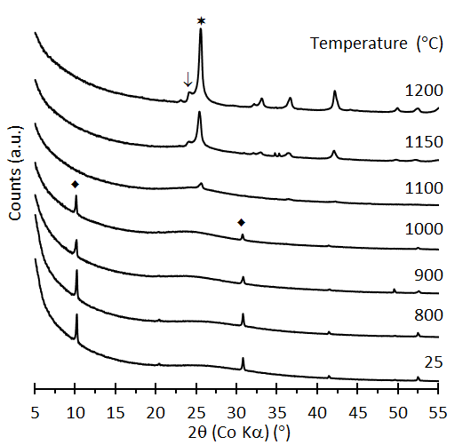
Figure 4. Effect of annealing temperature on the XRD diffractograms of the acid-leached phlogopite: = phlogopite; = cristobalite, and ↓ = tridymite.

Quantitative XRD data analysis for glass foam the indicated 95.3 % amorphous content, the presence of 0.71 % quartz and 0.86 % unreacted phlogopite. It also revealed the presence of some unreacted borax (3.13 %).
Thermomechanical analysis. Unlike the micas, the hydrated minerals vermiculite and hydrobiotite exfoliate on heating to elevated temperatures. Figure 5 shows that the Palaborwa phlogopite does indeed exfoliate at a temperature close to that of the vermiculite. However, the degree of expansion is less than that of the latter. This confirms the XRD results indicating that the actual phlogopite material used presently contained hydrobiotite-like phases. According to Hillier et al. [3], these phases are present within individual flakes.
Figure 5. TMA exfoliation behaviour of Palaborwa phlogopite compared to that of Palaborwa vermiculite.

Thermogravimetric analysis. Figure 6 shows the mass loss and differential mass loss curve for the acid-leached phlogopite. The sample lost a total of ca. 17 wt-% of its original mass when the temperature reached 1000 °C. The DTG indicates that mass loss occurs in more than one step. The first step is associated with a mass loss of approximately 11.6 wt-%. It occurred in the temperature range 20 °C to 150 °C indicating that it most likely represented adsorbed water. The mass loss that occurred at higher temperatures is due to dehydroxylation reactions finally leading to the formation of a silica residue. Based on this information, and correcting for the actual SiO₂ content of the sample, the mass loss is attributed to the reaction suggested in Scheme I with x = 0.17 and y = 1.03:

H_{2x}Si₂O_{4+x}⋅y H₂O → 2 SiO₂ + (x+y) H₂O
Scheme I. Proposed dehydration reaction with x representing the water loss due to dehydroxylation reactions of silanol groups and y representing the surface adsorbed water.
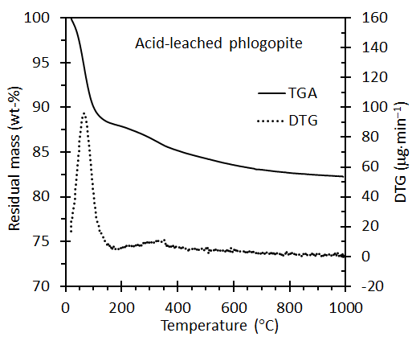
Figure 6. TGA and DTG curves for the acid-leached phlogopite recorded in an inert atmosphere at a scan rate of 10 K⋅min⁻¹.

Foam properties
Figure 7 plots the chemical compositions of the formulations that were investigated on a ternary diagram. The corresponding physical properties, density and compressive strength, are reported in Table 3. It is well-known that the compressive strength of a foam is critically dependent on its density. Gibson, Ashby [30] [31] related the mechanical properties of foams to the properties of the cell wall and the cell geometry. The simplest analysis [30] [32] yields the following power-law description for the crushing strength of brittle foams [33]:
where n = 1.5, C ≈ 0.2 and the subscript w refers to the properties of the solid cell walls. However, the data presented by [34] showed a much stronger dependence with n ≈ 3. Figure 7 shows the present data together with a power-law trend line, established by a least-squares data fit, corresponding to n ≈ 2.5.
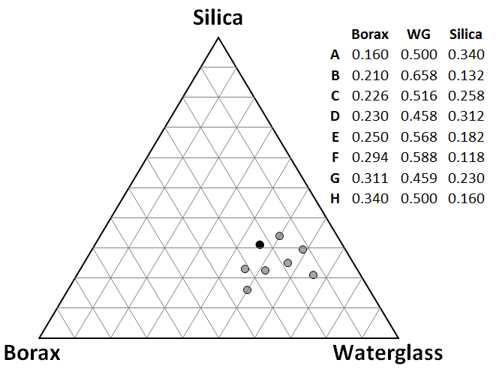
Figure 7. Foam formulations experimental design. Compositions are given in units of wt-%
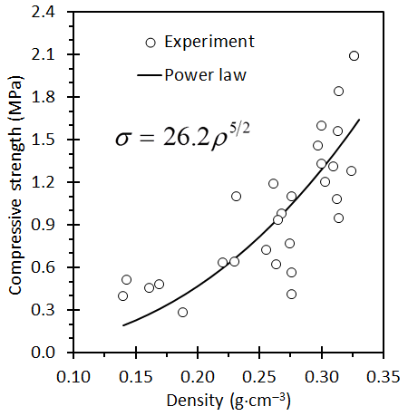
Figure 8. Variation of the compressive with foam density. The solid line shows the least-squares power-law fit
Analysis of variance (ANOVA) [20] showed that, with respect to composition variables, only the correlation between the foam density and the silica to waterglass mass ratio was statistically significant. Figure 9 shows that, for the current data set, the density increases almost linearly with the silica to waterglass ration (correlation coefficient R = 0.92).
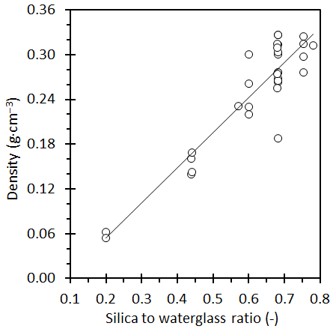
Figure 9. Correlation between foam density and the silica to waterglass ration.
Figure 10 shows the effect of foam composition on density and compressive strength. For each formulation, the minimum, mean and maximum measure value is plotted. The lowest densities were measured for formulations B, C G and H. Formulations A, D, E and F did not yield foams with densities less than 0.2 g⋅cm⁻³. As expected, these same formulations also provided foams with the highest compressive strengths. Formulations B and C produced weak foams even when the foam density was high. The compressive strength of foam F was also very low but that can be attributed to low foam densities.
Figure 11 shows the effect of the two process variables sintering temperature and heating rate on the compressive strength of the foams. Best mechanical properties were obtained for low heating rates and a sintering temperature of 525 °C.
Overall, Formulation E provided the best performance with compressive strength as high as 2.09 MPa at a foam density of just 0.326 g⋅cm⁻³. This foam was produced at a heating rate of ca. 6 K⋅min⁻¹ and a sintering temperature of 525 °C. Figure 12 shows the morphology of the fracture surface of such a foam prepared from amorphous silica with a size range of 250–90 μm. Most of the closed cells vary in size from ca 5 to 100 μm. Figure 13 shows a set of larger foam blocks proving that the process can be used to produce larger shapes.
Figure 10. Effect of the foam composition on (a) the foam density and (b) the compressive strength. The formulations compositions are given in Figure 7 and Table 3.

Table 3. Summary of foam properties obtained for variations in composition and processing conditions (heating rate and sintering temperature)

 | Borax | WG | Silica | HR | Ts | ρ | σ
 | (wt-%) | (wt-%) | (wt-%) | (K⋅min⁻¹) | (°C) | (g⋅cm⁻³) | (MPa)
A | 0.160 | 0.500 | 0.340 | 27.8 | 550 | 0.274 | 0.77
 | 0.160 | 0.500 | 0.340 | 28.7 | 450 | 0.255 | 0.72
 | 0.160 | 0.500 | 0.340 | 29.3 | 450 | 0.314 | 0.95
 | 0.160 | 0.500 | 0.340 | 29.6 | 450 | 0.309 | 1.31
B | 0.182 | 0.568 | 0.250 | 27.8 | 550 | 0.169 | 0.48
 | 0.182 | 0.568 | 0.250 | 28.4 | 550 | 0.143 | 0.51
C | 0.210 | 0.658 | 0.132 | 30.6 | 450 | 0.054 | 0.12
D | 0.220 | 0.438 | 0.342 | 18.8 | 525 | 0.312 | 1.08
 | 0.222 | 0.444 | 0.334 | 7.7 | 500 | 0.324 | 1.28
 | 0.222 | 0.444 | 0.334 | 8.3 | 550 | 0.314 | 1.84
 | 0.222 | 0.444 | 0.334 | 26.3 | 550 | 0.297 | 1.46
 | 0.222 | 0.444 | 0.334 | 28.5 | 500 | 0.276 | 1.10
E | 0.230 | 0.458 | 0.312 | 31.6 | 450 | 0.276 | 0.56
 | 0.230 | 0.458 | 0.312 | 19.4 | 480 | 0.276 | 0.41
 | 0.230 | 0.458 | 0.312 | 20.4 | 520 | 0.263 | 0.62
 | 0.230 | 0.458 | 0.312 | 5.9 | 525 | 0.326 | 2.09
 | 0.230 | 0.458 | 0.312 | 5.9 | 525 | 0.326 | 2.09
 | 0.230 | 0.458 | 0.312 | 18.8 | 525 | 0.313 | 1.56
 | 0.230 | 0.458 | 0.312 | 18.8 | 525 | 0.300 | 1.33
 | 0.230 | 0.458 | 0.312 | 27.5 | 525 | 0.188 | 0.28
 | 0.230 | 0.458 | 0.312 | 27.2 | 550 | 0.268 | 0.98
 | 0.230 | 0.458 | 0.312 | 28.4 | 550 | 0.303 | 1.20
 | 0.230 | 0.458 | 0.312 | 28.4 | 550 | 0.265 | 0.93
F | 0.238 | 0.476 | 0.286 | 7.7 | 500 | 0.230 | 0.64
 | 0.238 | 0.476 | 0.286 | 8.2 | 550 | 0.261 | 1.19
 | 0.238 | 0.476 | 0.286 | 26.3 | 550 | 0.300 | 1.60
 | 0.238 | 0.476 | 0.286 | 28.5 | 500 | 0.220 | 0.63
 | 0.240 | 0.484 | 0.276 | 18.8 | 525 | 0.231 | 1.10
G | 0.258 | 0.516 | 0.226 | 28.7 | 450 | 0.161 | 0.46
 | 0.258 | 0.516 | 0.226 | 28.7 | 450 | 0.140 | 0.40
H | 0.294 | 0.588 | 0.118 | 30.5 | 450 | 0.062 | 0.11

Figure 11. Effect of the process variables of (a) sintering temperature, and (b) heating rate on the compressive strength of the foams

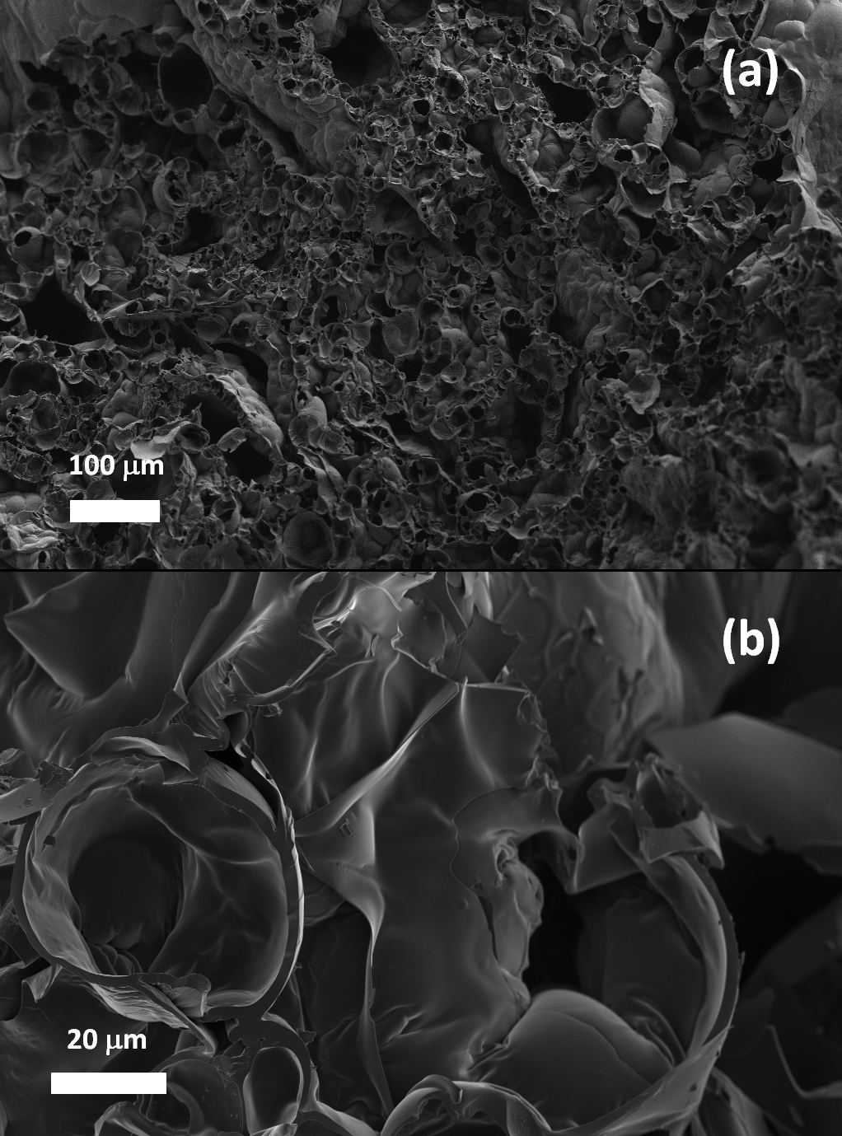
Figure 12. SEM micrographs of the fracture surface of the glass foams.

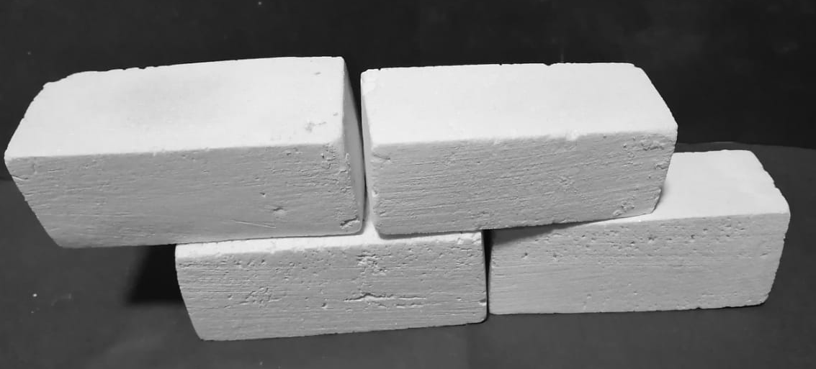
Figure 13. A foam bricks measuring 110 mm × 45 mm × 40 mm.

Conclusions
Palabora phlogopite flakes supplied by PMC have a heterogeneous mineralogical composition dominated by phlogopite and hydrobiotite. It was possible to obtain substantially amorphous silica with a very high surface area (> 450 m²⋅g⁻¹) on leaching this material with 4 M nitric acid. The high reactivity of this silica form made it possible to fabricate glass foams at temperatures as low as 500 °C. The best results were obtained with a formulation with borax: waterglass: amorphous silica 23:46:31 wt-%. A closed-cell foam with a density of 0.326 g⋅cm⁻³ and compressive strength of 2.09 MPa was obtained on heating a compacted mixture a ca 6 K⋅min⁻¹ to 525 °C and keeping it at that temperature for 30 min before cooling down.

Compliance with Ethical Standards:
Funding: Expenses incurred in the execution of this study were covered by internal funds of Department of Chemical Engineering, University of Pretoria
Conflict of Interest: The authors declare that they have no conflict of interest.

References
1. Schoeman JJ (1989) Mica and vermiculite in south africa. Journal of The South African Institute of Mining and Metallurgy 89 (1):1-12
2. Muiambo HF, Focke WW, Atanasova M, der Westhuizen IV, Tiedt LR (2010) Thermal properties of sodium-exchanged palabora vermiculite. Applied Clay Science 50 (1):51-57. doi:10.1016/j.clay.2010.06.023
3. Hillier S, Marwa EMM, Rice CM (2013) On the mechanism of exfoliation of ‘vermiculite’. Clay Minerals 48 (4):563-582. doi:10.1180/claymin.2013.048.4.01
4. Brindley GW, Zalba PE, Bethke CM (1983) Hydrobiotite, a regular 1:1 interstratification of biotite and vermiculite layers. American Mineralogist 68 (3-4):420-425
5. Bulafov VK, Gradusov BP, Zotov AV (1979) Acid leaching of phlogopite. International Geology Review 21 (5):588-596. doi:10.1080/00206818209467097
6. Härkönen MA, Keiski RL (1984) Porosity and surface area of acid-leached phlogopite: The effect of leaching conditions and thermal treatment. Colloids and Surfaces 11 (3):323-339. doi:https://doi.org/10.1016/0166-6622(84)80287-5
7. Kuwahara Y, Aoki Y (1995) Dissolution process of phlogopite in acid solutions. Clays and Clay Minerals 43 (1):39-50. doi:https://doi.org/10.1346/CCMN.1995.0430105
8. Rufe E, Hochella MF (1999) Quantitative assessment of reactive surface area of phlogopite during acid dissolution. Science 285 (5429):874-876. doi:10.1126/science.285.5429.874
9. Okada K, Nakazawa N, Kameshima Y, Yasumori A, Temuujin J, MacKenzie KJD, Smith ME (2002) Preparation and porous properties of materials prepared by selective leaching of phlogopite. Clays and Clay Minerals 50 (5):624-632. doi:10.1346/000986002320679503
10. Wypych F, Adad LB, Mattoso N, Marangon AAS, Schreiner WH (2005) Synthesis and characterization of disordered layered silica obtained by selective leaching of octahedral sheets from chrysotile and phlogopite structures. Journal of Colloid and Interface Science 283 (1):107-112. doi:https://doi.org/10.1016/j.jcis.2004.08.139
11. Ercenk E (2016) The effect of clay on foaming and mechanical properties of glass foam insulating material. Journal of Thermal Analysis and Calorimetry 127 (1):137-146. doi:10.1007/s10973-016-5582-8
12. Zhimalov AA, Bondareva LN, Igitkhanyan YG, Ivashchenko YG (2017) Use of amorphous siliceous rocks — opokas to obtain foam glass with low foaming temperature. Glass and Ceramics 74 (1-2):13-15. doi:10.1007/s10717-017-9916-1
13. Li Y, Cheng X, Cao W, Gong L, Zhang R, Zhang H (2016) Fabrication of adiabatic foam by sodium silicate with glass fiber as supporting body. Construction and Building Materials 112:933-939. doi:https://doi.org/10.1016/j.conbuildmat.2016.01.059
14. Scarinci G, Brusatin G, Bernardo E (2005) Glass foams. In: Scheffler M (ed) Cellular ceramics: Structure, manufacturing, properties and applications. Wiley, p 160
15. Mugoni C, Montorsi M, Siligardi C, Andreola F, Lancellotti I, Bernardo E, Barbieri L (2015) Design of glass foams with low environmental impact. Ceramics International 41 (3, Part A):3400-3408. doi:https://doi.org/10.1016/j.ceramint.2014.10.127
16. Hesky D, Aneziris CG, Groß U, Horn A (2015) Water and waterglass mixtures for foam glass production. Ceramics International 41 (10, Part A):12604-12613. doi:https://doi.org/10.1016/j.ceramint.2015.06.088
17. Barbosa ARJ, Lopes AAS, Sequeira SIH, Oliveira JP, Davarpanah A, Mohseni F, Amaral VS, Monteiro RCC (2016) Effect of processing conditions on the properties of recycled cathode ray tube glass foams. Journal of Porous Materials 23 (6):1663-1669. doi:10.1007/s10934-016-0227-7
18. Ducman V, Kovačević M (1997) The foaming of waste glass. Key Engineering Materials.
19. Bernardo E, Castellan R, Hreglich S, Lancellotti I (2006) Sintered sanidine glass–ceramics from industrial wastes, vol 26. doi:10.1016/j.jeurceramsoc.2005.09.110
20. Deysel H (2019) Synthesis and optimisation of silica foam from amorphous silica and waterglass. CSC411 Report: Department of Chemical Engineering, University of Pretoria, Pretoria
21. Sijakova-Ivanova T, Cukovska LR (2016) Mineralogical characteristics of phlogopite from dupen kamen, republic of macedonia. IOSR Journal of Applied Geology and Geophysics (IOSR-JAGG) 4 (5):72-76
22. Ocaña M, Fornés V, Serna CJ (1989) The variability of the infrared powder spectrum of amorphous sio2. Journal of Non-Crystalline Solids 107 (2-3):187-192. doi:10.1016/0022-3093(89)90461-4
23. Huffman M, McMillan P (1985) Infrared and raman studies of chemically vapor deposited amorphous silica. Journal of Non-Crystalline Solids 76 (2-3):369-379. doi:10.1016/0022-3093(85)90011-0
24. Awazu K (1999) Oscillator strength of the infrared absorption band near 1080 cm-1 in sio2 films. Journal of Non-Crystalline Solids 260 (3):242-244. doi:10.1016/S0022-3093(99)00589-X
25. Temuujin J, Okada K, MacKenzie KJD (2003) Preparation of porous silica from vermiculite by selective leaching. Applied Clay Science 22 (4):187-195. doi:https://doi.org/10.1016/S0169-1317(02)00158-8
26. Obut A, Girgin İ (2002) Hydrogen peroxide exfoliation of vermiculite and phlogopite. Minerals Engineering 15 (9):683-687. doi:https://doi.org/10.1016/S0892-6875(02)00161-9
27. Holmquist SB (1959) A note on the sluggish silica transformations. Zeitschrift fur Kristallographie - New Crystal Structures 111 (1-6):71-76. doi:10.1524/zkri.1959.111.1-6.71
28. Wahl FM, Grim RE, Graf RB (1961) Phase transformations in silica as examined by continuous x-ray diffraction. American Mineralogist 46 (1-2):196-208
29. Ostwald W (1897) Studien über die bildung und umwandlung fester körper. 1. Abhandlung: Übersättigung und überkaltung. Zeitschrift für Physikalische Chemie 22:289–330
30. Gibson LJ, Ashby MF (1982) Mechanics of three-dimensional cellular materials. Proceedings of The Royal Society of London, Series A: Mathematical and Physical Sciences 382 (1782):43-59
31. Gibson L, Ashby M (1997) Cellular solids: Structure and properties. Cambridge solid state science series. Cambridge University Press, Cambridge. doi:doi:10.1017/CBO9781139878326
32. Ashby MF, Medalist RFM (1983) The mechanical properties of cellular solids. Metallurgical Transactions A 14 (9):1755-1769. doi:10.1007/bf02645546
33. Gibson LJ (2005) Biomechanics of cellular solids. Journal of Biomechanics 38 (3):377-399. doi:https://doi.org/10.1016/j.jbiomech.2004.09.027
34. Qu YN, Xu J, Su ZG, Ma N, Zhang XY, Xi XQ, Yang JL (2016) Lightweight and high-strength glass foams prepared by a novel green spheres hollowing technique. Ceramics International 42 (2):2370-2377. doi:10.1016/j.ceramint.2015.10.034

