Hypothesis 2
Descriptive Statistics: Market Value of Equity, Goodwill, Book Value of equirty less good, Net Operating Profit After Tax, Growth rate, Goodwill/Total assets, Disclosure index
Statistics
Variable | N | Mean | StDev | Minimum | Median | Maximum | Skewness
Market Value of Equity | 428 | 123.89 | 483.18 | 0.13 | 20.43 | 5490.35 | 8.40
Goodwill | 428 | 4267.39 | 23018.57 | 0.44 | 550.29 | 380610.48 | 12.08
Book Value of equirty less good | 428 | 10649.42 | 58121.59 | -61407.00 | 2344.87 | 1008926.16 | 13.55
Net Operating Profit After Tax | 428 | 2065.05 | 8039.98 | 3.28 | 467.44 | 137510.01 | 12.82
Growth rate | 428 | 0.09 | 0.16 | -0.64 | 0.07 | 0.74 | 0.40
Goodwill/Total assets | 428 | 0.12 | 0.13 | 0.00 | 0.08 | 0.64 | 1.64
Disclosure index | 428 | 0.90 | 0.14 | 0.11 | 0.94 | 1.00 | -2.70
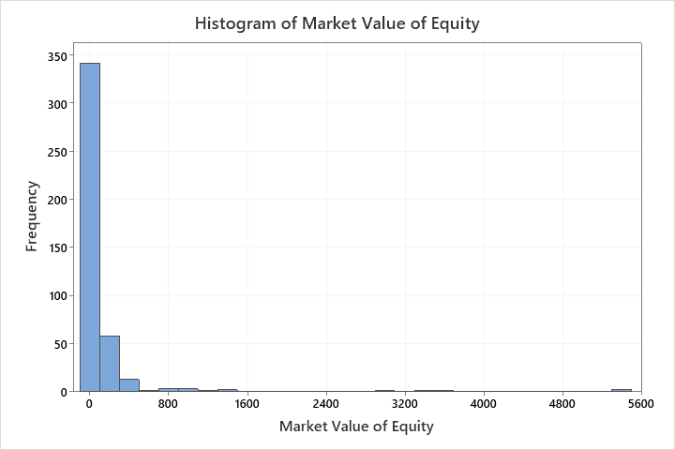
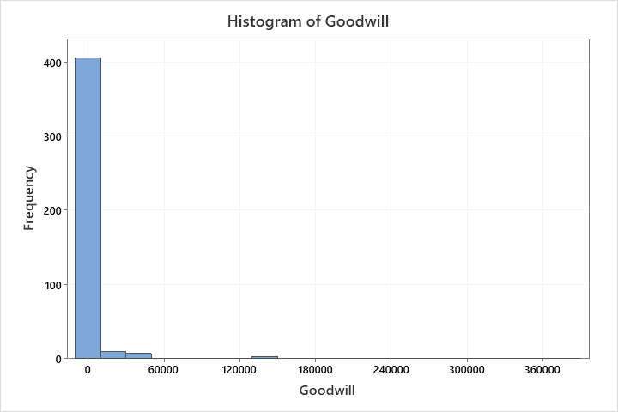
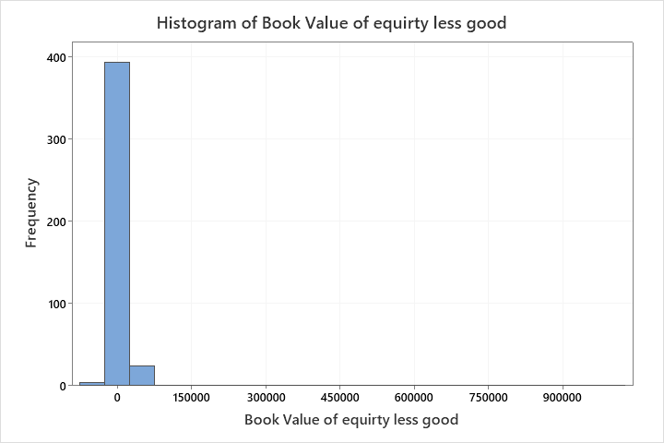
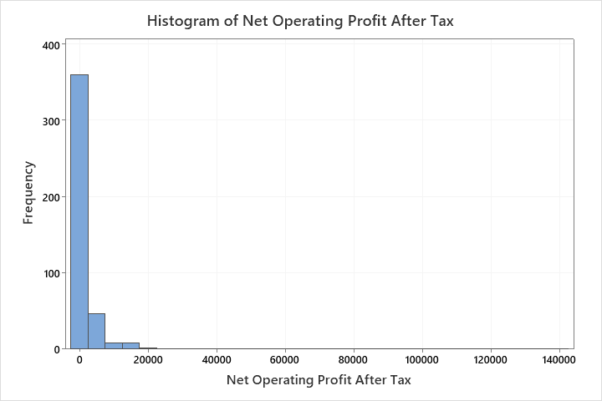
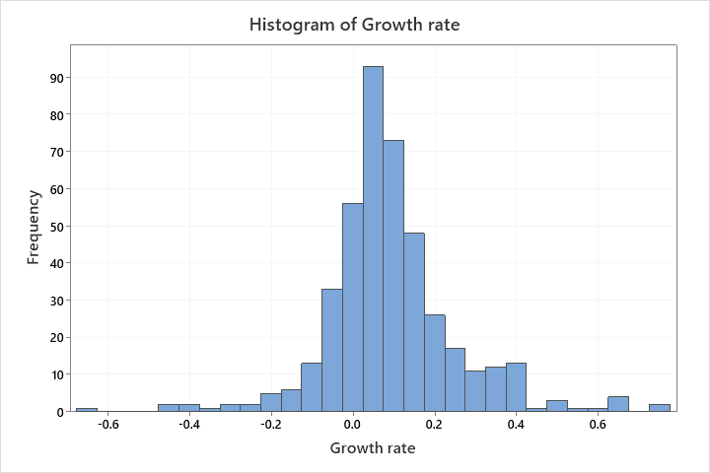
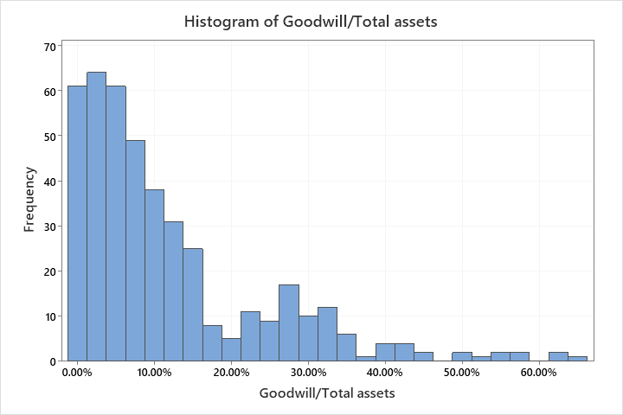
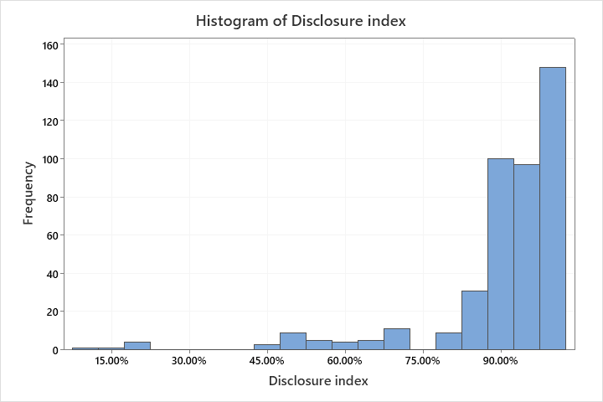
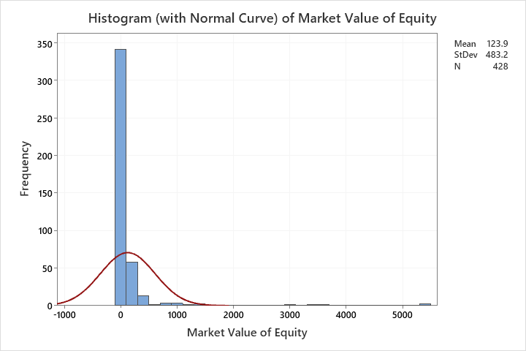
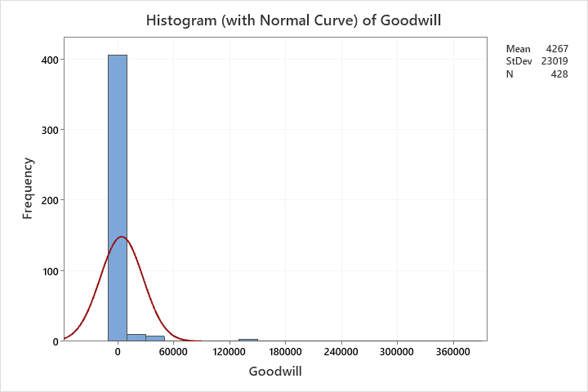
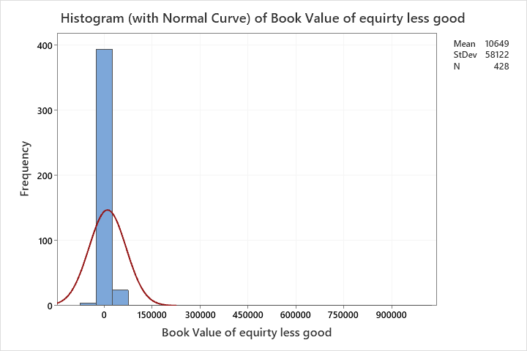
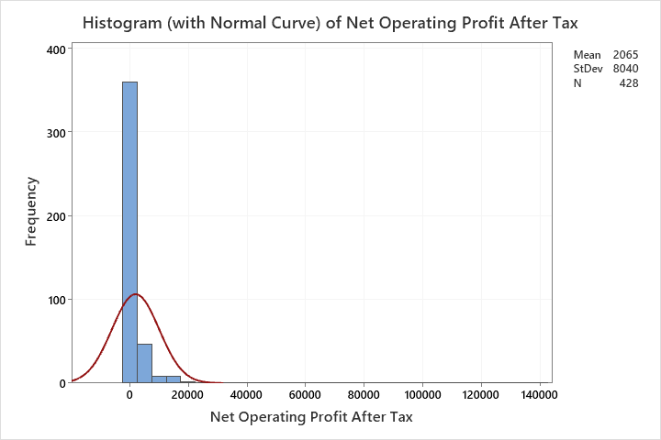
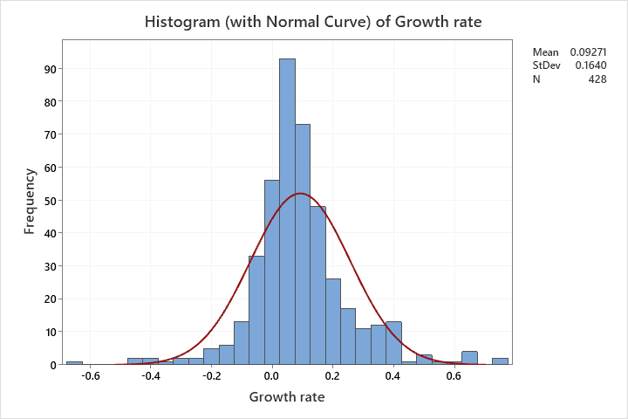
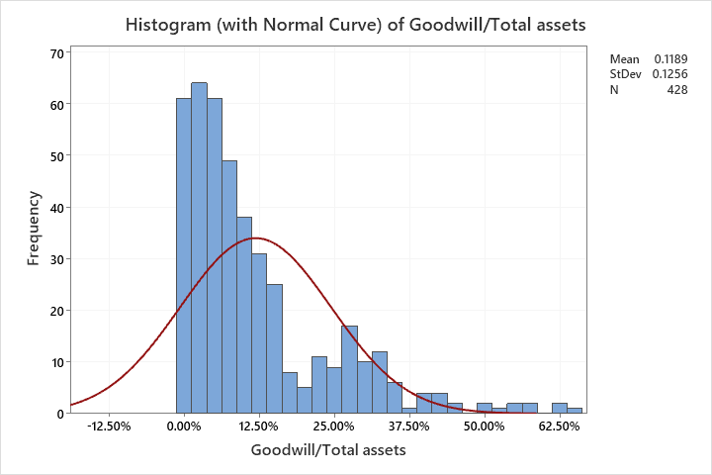
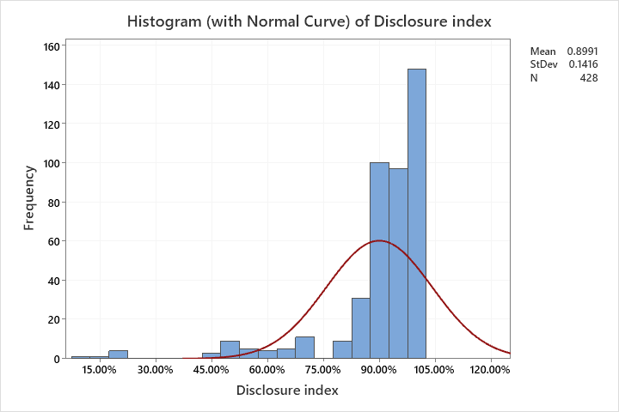
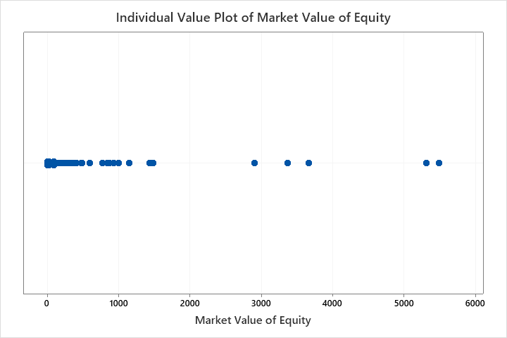
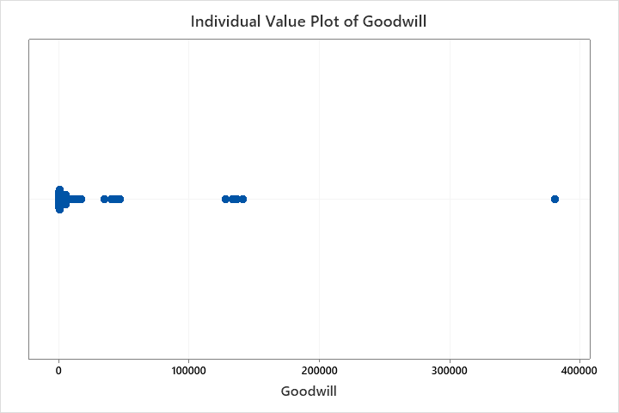
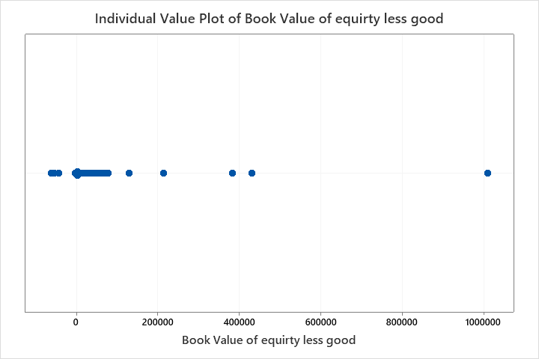
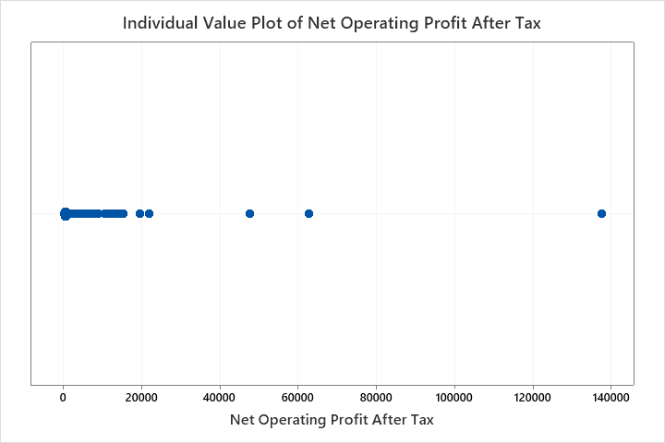
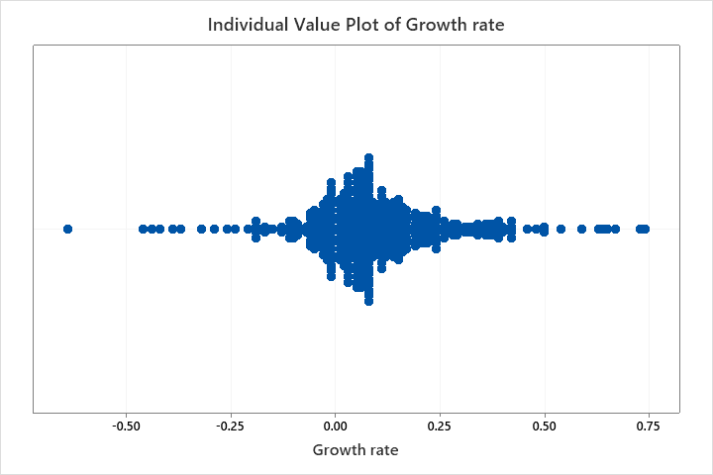
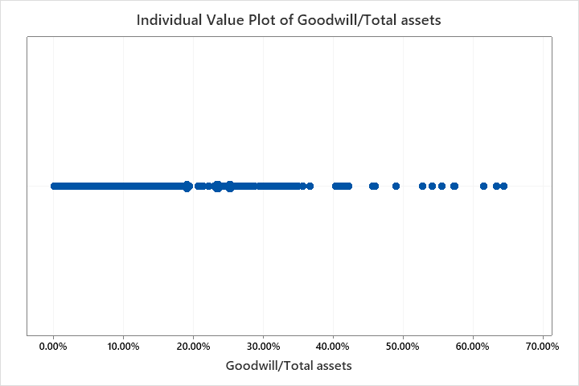
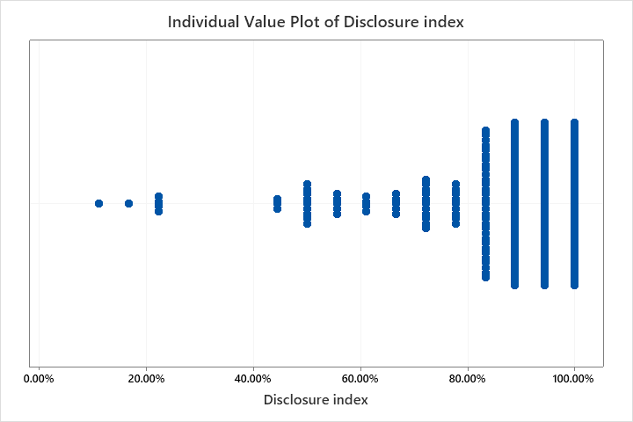
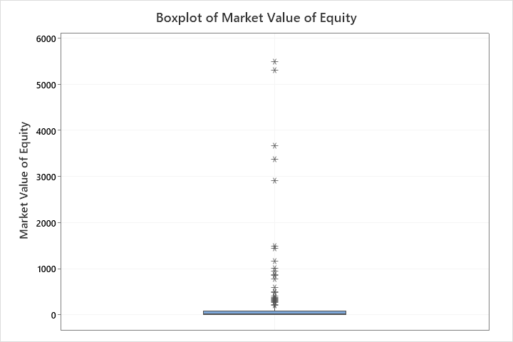
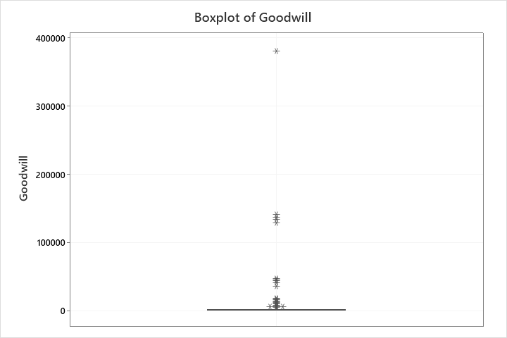
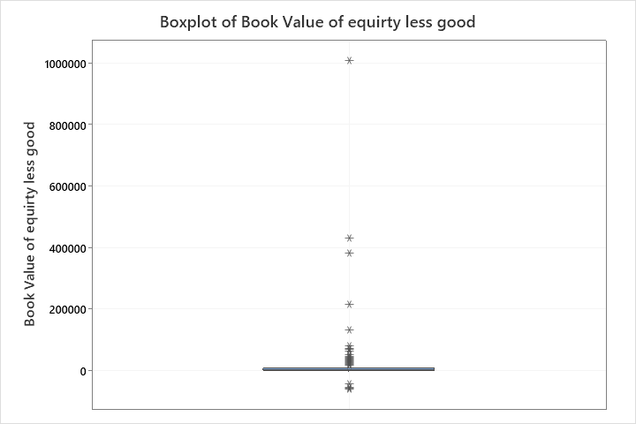
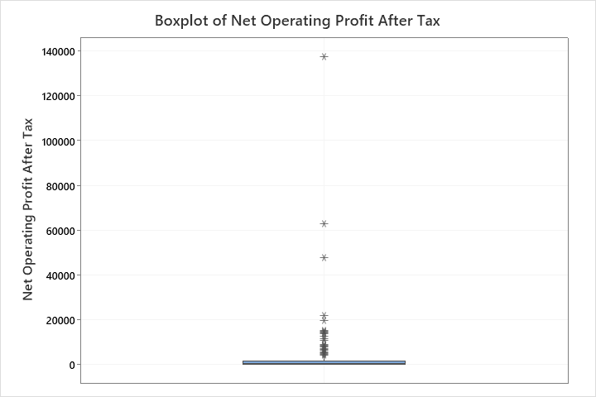
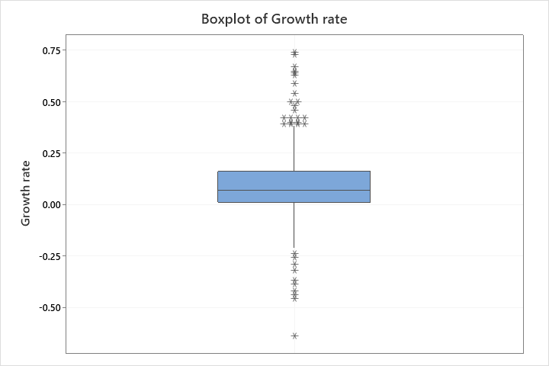
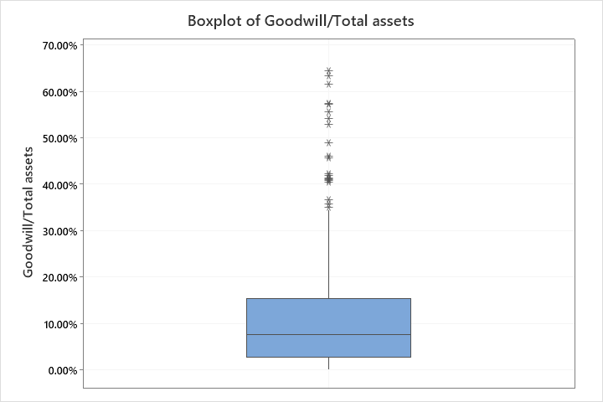
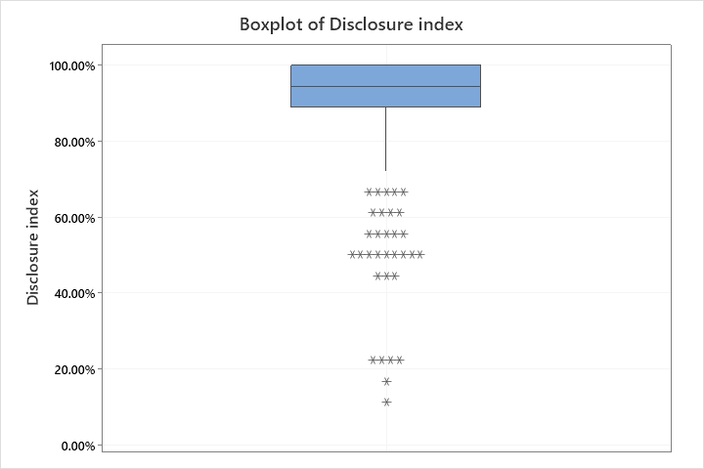

Correlation: Market Value of Equity, Goodwill, Book Value of equirty less good, Net Operating Profit After Tax, Growth rate, Goodwill/Total assets, Disclosure index
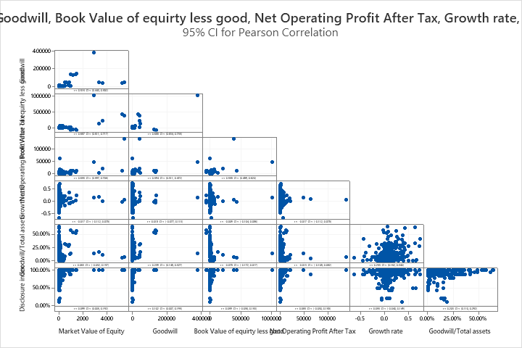
Method
Correlation type | Pearson
Number of rows used | 428
ρ: pairwise Pearson correlation
Correlations
 | Market  Value of  Equity | Goodwill |  | Book Value  of equirty  less good | Net  Operating  Profit  After Tax | Growth rate
Goodwill | 0.516
Book Value of equirty less good | 0.667 | 0.688
Net Operating Profit After Tax | 0.655 | 0.394 |  | 0.558
Growth rate | -0.017 | 0.018 |  | -0.009 | -0.017
Goodwill/Total assets | 0.063 | 0.239 |  | -0.078 | -0.013 | 0.253
Disclosure index | 0.099 | 0.102 |  | 0.059 | 0.065 | 0.055
Goodwill/Total
assets
Goodwill
Book Value of equirty less good
Net Operating Profit After Tax
Growth rate
Goodwill/Total assets
Disclosure index | 0.203
Pairwise Pearson Correlations
Sample 1 | Sample 2 | N | Correlation |  | 95% CI for ρ
Goodwill | Market Value of Equity | 428 | 0.516 |  | (0.443, 0.582)
Book Value of equirty less good | Market Value of Equity | 428 | 0.667 |  | (0.611, 0.717)
Net Operating Profit After Tax | Market Value of Equity | 428 | 0.655 |  | (0.597, 0.706)
Growth rate | Market Value of Equity | 428 | -0.017 |  | (-0.112, 0.078)
Goodwill/Total assets | Market Value of Equity | 428 | 0.063 |  | (-0.032, 0.157)
Disclosure index | Market Value of Equity | 428 | 0.099 |  | (0.005, 0.192)
Book Value of equirty less good | Goodwill | 428 | 0.688 |  | (0.634, 0.735)
Net Operating Profit After Tax | Goodwill | 428 | 0.394 |  | (0.311, 0.472)
Growth rate | Goodwill | 428 | 0.018 |  | (-0.077, 0.113)
Goodwill/Total assets | Goodwill | 428 | 0.239 |  | (0.148, 0.327)
Disclosure index | Goodwill | 428 | 0.102 |  | (0.007, 0.195)
Net Operating Profit After Tax | Book Value of equirty less good | 428 | 0.558 |  | (0.489, 0.620)
Growth rate | Book Value of equirty less good | 428 | -0.009 |  | (-0.104, 0.086)
Goodwill/Total assets | Book Value of equirty less good | 428 | -0.078 |  | (-0.172, 0.017)
Disclosure index | Book Value of equirty less good | 428 | 0.059 |  | (-0.036, 0.153)
Growth rate | Net Operating Profit After Tax | 428 | -0.017 |  | (-0.112, 0.078)
Goodwill/Total assets | Net Operating Profit After Tax | 428 | -0.013 |  | (-0.108, 0.082)
Disclosure index | Net Operating Profit After Tax | 428 | 0.065 |  | (-0.030, 0.158)
Goodwill/Total assets | Growth rate | 428 | 0.253 |  | (0.162, 0.340)
Disclosure index | Growth rate | 428 | 0.055 |  | (-0.040, 0.149)
Disclosure index | Goodwill/Total assets | 428 | 0.203 |  | (0.110, 0.292)
Sample 1 | Sample 2 | P-Value
Goodwill | Market Value of Equity | 0.000
Book Value of equirty less good | Market Value of Equity | 0.000
Net Operating Profit After Tax | Market Value of Equity | 0.000
Growth rate | Market Value of Equity | 0.722
Goodwill/Total assets | Market Value of Equity | 0.194
Disclosure index | Market Value of Equity | 0.040
Book Value of equirty less good | Goodwill | 0.000
Net Operating Profit After Tax | Goodwill | 0.000
Growth rate | Goodwill | 0.710
Goodwill/Total assets | Goodwill | 0.000
Disclosure index | Goodwill | 0.035
Net Operating Profit After Tax | Book Value of equirty less good | 0.000
Growth rate | Book Value of equirty less good | 0.853
Goodwill/Total assets | Book Value of equirty less good | 0.105
Disclosure index | Book Value of equirty less good | 0.221
Growth rate | Net Operating Profit After Tax | 0.725
Goodwill/Total assets | Net Operating Profit After Tax | 0.784
Disclosure index | Net Operating Profit After Tax | 0.182
Goodwill/Total assets | Growth rate | 0.000
Disclosure index | Growth rate | 0.253
Disclosure index | Goodwill/Total assets | 0.000

Regression Analysis: Market Value of Equity versus Goodwill, Book Value of equirty less good, Net Operating Profit After Tax, Growth rate, Goodwill/Total assets, Disclosure index
Regression Equation
Market Value of Equity | = | -83.6 + 0.00099 Goodwill + 0.003448 Book Value of equirty less good  + 0.02426 Net Operating Profit After Tax - 95.2 Growth rate  + 355 Goodwill/Total assets + 92 Disclosure index
Coefficients
Term | Coef | SE Coef | T-Value | P-Value | VIF
Constant | -83.59 | 99.17 | -0.84 | 0.40
Goodwill | 0.00 | 0.00 | 0.98 | 0.33 | 2.28
Book Value of equirty less good | 0.00 | 0.00 | 8.06 | 0.00 | 2.62
Net Operating Profit After Tax | 0.02 | 0.00 | 10.52 | 0.00 | 1.46
Growth rate | -95.23 | 97.13 | -0.98 | 0.33 | 1.08
Goodwill/Total assets | 354.57 | 141.51 | 2.51 | 0.01 | 1.34
Disclosure index | 92.43 | 111.16 | 0.83 | 0.41 | 1.05
Model Summary
S | R-sq | R-sq(adj) | R-sq(pred)
317.410 | 57.45% | 56.85% | 0.00%
Analysis of Variance
Source | DF | Adj SS | Adj MS | F-Value | P-Value
Regression | 6 | 57274263 | 9545711 | 94.75 | 0.00
Goodwill | 1 | 96580 | 96580 | 0.96 | 0.33
Book Value of equirty less good | 1 | 6542522 | 6542522 | 64.94 | 0.00
Net Operating Profit After Tax | 1 | 11150326 | 11150326 | 110.67 | 0.00
Growth rate | 1 | 96847 | 96847 | 0.96 | 0.33
Goodwill/Total assets | 1 | 632498 | 632498 | 6.28 | 0.01
Disclosure index | 1 | 69668 | 69668 | 0.69 | 0.41
Error | 421 | 42415289 | 100749
Total | 427 | 99689552
Fits and Diagnostics for Unusual Observations
Obs | Market  Value of  Equity | Fit | Resid | Std Resid
13 | 1150 | 484 | 665 | 2.31 | R | X
24 | 36 | -12 | 48 | 0.15 |  | X
79 | 5311 | 1896 | 3415 | 12.20 | R | X
83 | 87 | 746 | -660 | -2.09 | R
97 | 995 | 412 | 583 | 2.06 | R | X
109 | 45 | -12 | 57 | 0.19 |  | X
117 | 13 | -53 | 66 | 0.21 |  | X
169 | 5490 | 4725 | 765 | 4.72 | R | X
172 | 9 | 177 | -168 | -0.55 |  | X
184 | 18 | -92 | 110 | 0.35 |  | X
187 | 1487 | 463 | 1025 | 3.67 | R | X
244 | 0 | 284 | -283 | -0.92 |  | X
251 | 933 | 91 | 842 | 2.66 | R
255 | 3666 | 1353 | 2313 | 7.43 | R
275 | 1431 | 335 | 1096 | 3.86 | R | X
286 | 83 | -9 | 92 | 0.30 |  | X
292 | 9 | 216 | -206 | -0.67 |  | X
300 | 83 | 1530 | -1447 | -5.11 | R | X
327 | 19 | 63 | -44 | -0.14 |  | X
343 | 3369 | 615 | 2754 | 8.76 | R
346 | 4 | 259 | -255 | -0.83 |  | X
358 | 842 | 209 | 633 | 2.01 | R
367 | 86 | -21 | 108 | 0.35 |  | X
415 | 9 | -39 | 48 | 0.16 |  | X
419 | 9 | 184 | -175 | -0.57 |  | X
422 | 999 | 109 | 890 | 2.81 | R
425 | 2903 | 5055 | -2152 | -17.10 | R | X
R Large residual
X Unusual X
Durbin-Watson Statistic
Durbin-Watson Statistic = | 1.99960
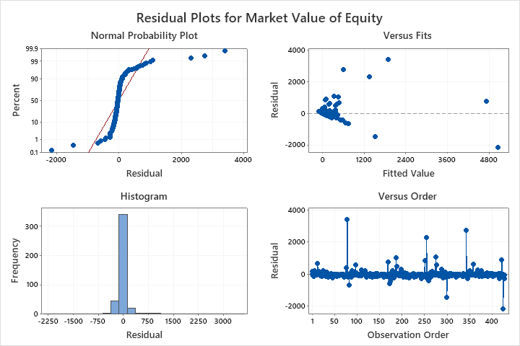

WORKSHEET 2
Descriptive Statistics: Disclosure index, Goodwill/Total assets, Impairment of goodwill/Prior ye
Statistics
Variable | N | Mean | StDev | Minimum | Median | Maximum | Skewness
Disclosure index | 149 | 0.9128 | 0.1263 | 0.4444 | 0.9444 | 1.0000 | -2.17
Goodwill/Total assets | 149 | 0.11905 | 0.11085 | 0.00220 | 0.08463 | 0.57263 | 1.40
Impairment of goodwill/Prior ye | 149 | 0.1384 | 0.2119 | 0.0000 | 0.0403 | 1.0000 | 1.93
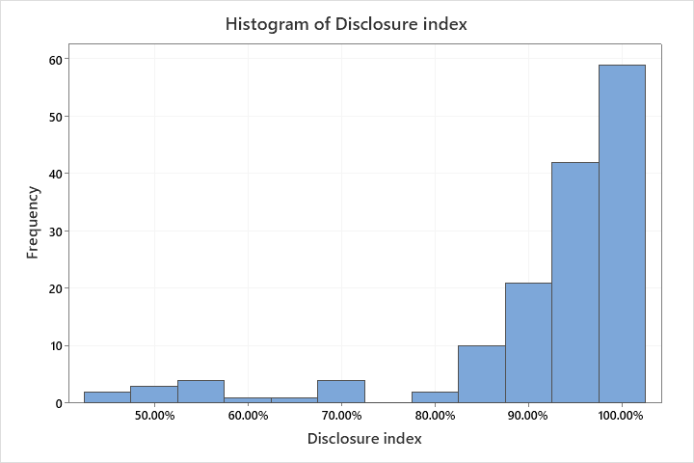
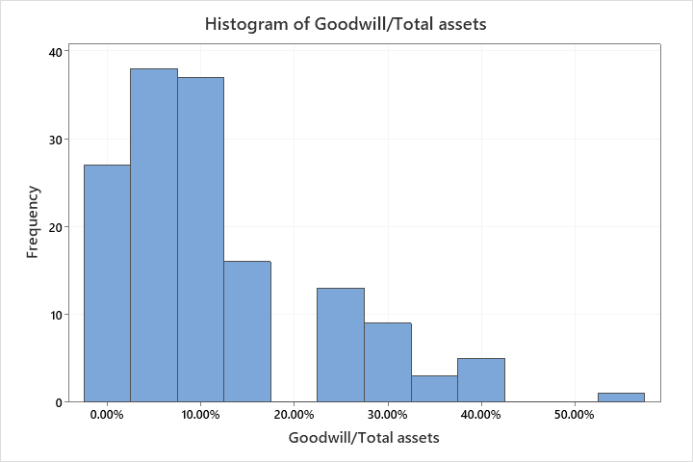
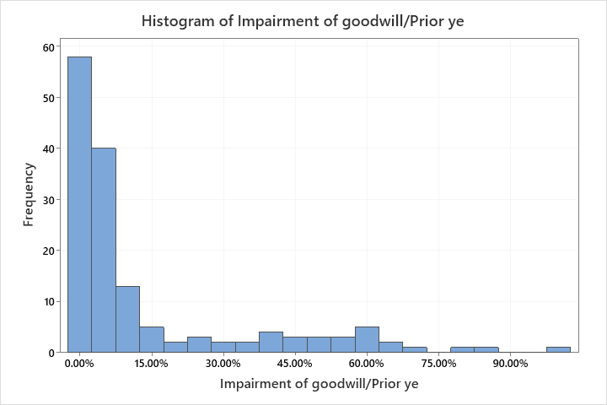
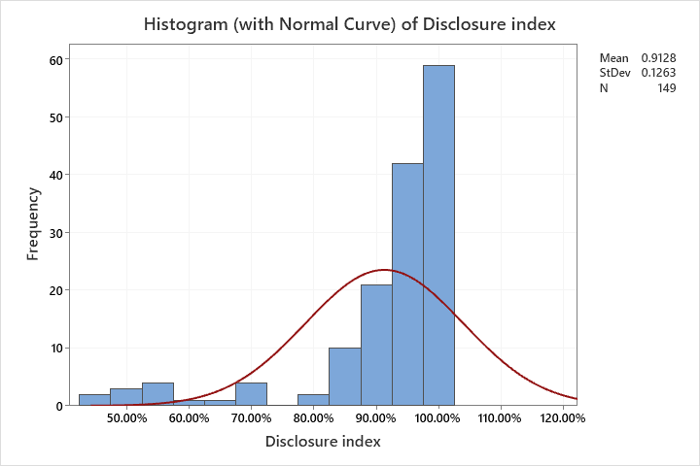
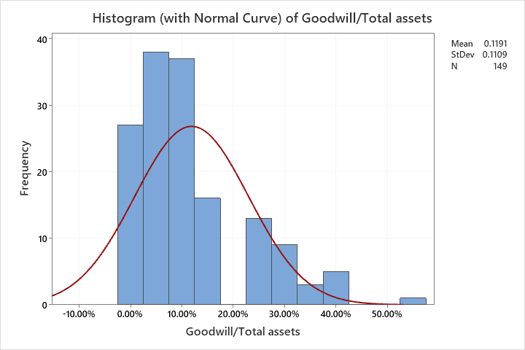
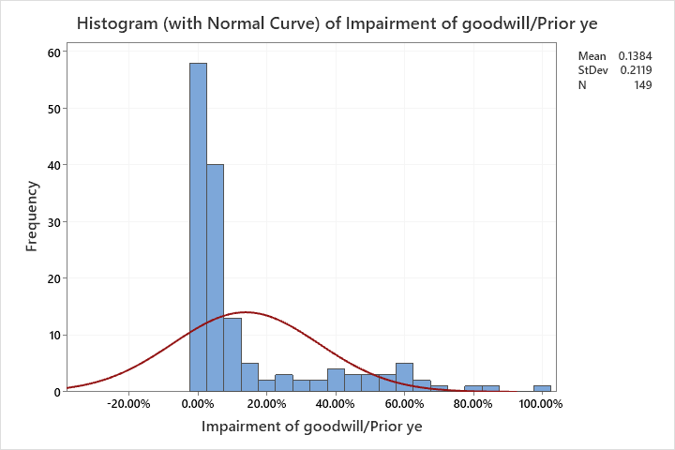
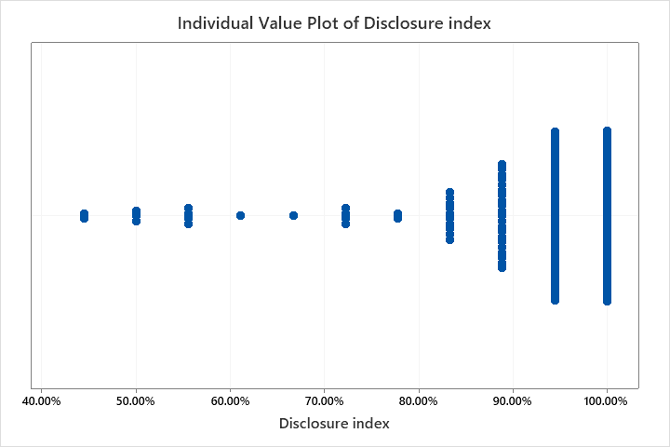
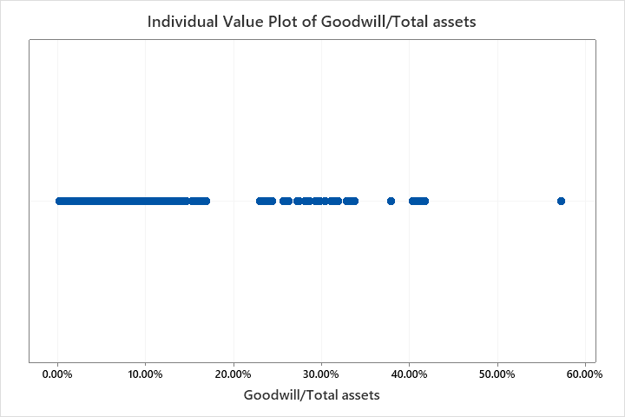
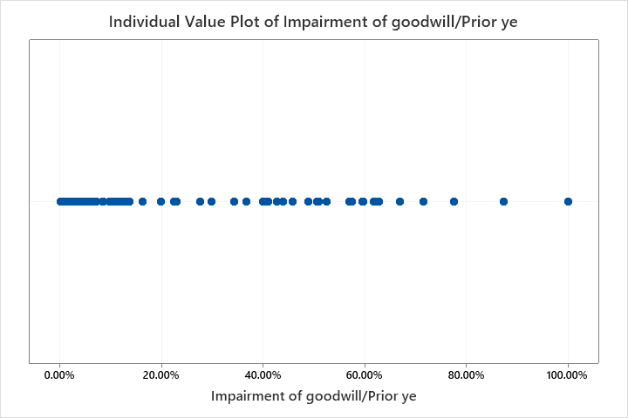
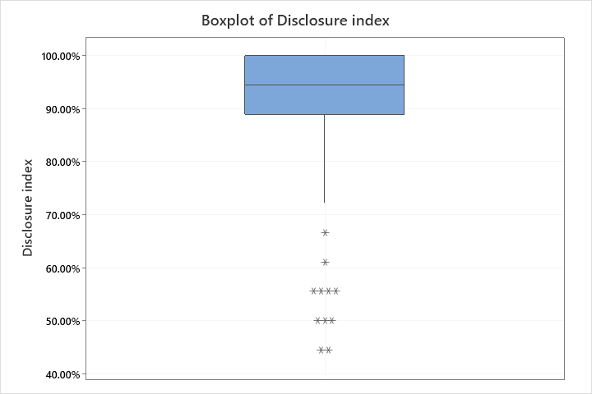
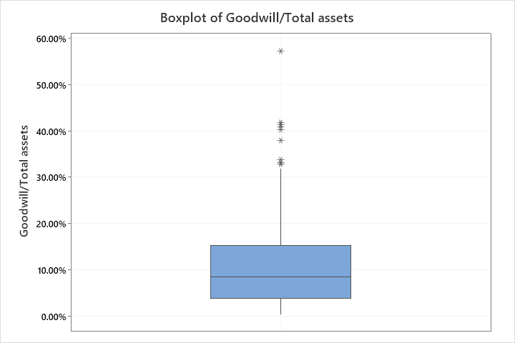
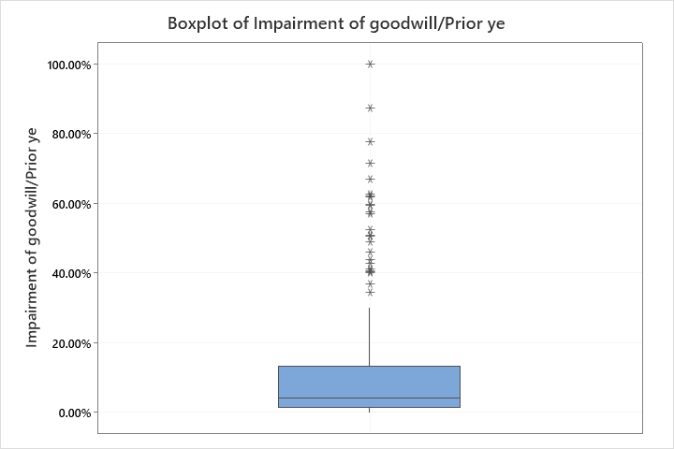

WORKSHEET 2
Correlation: Disclosure index, Goodwill/Total assets, Impairment of goodwill/Prior ye
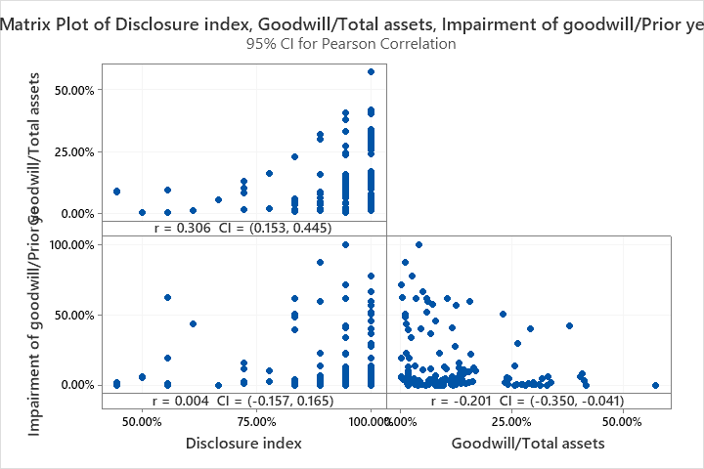
Method
Correlation type | Pearson
Number of rows used | 149
ρ: pairwise Pearson correlation
Correlations
 | Disclosure  index | Goodwill/Total  assets
Goodwill/Total assets | 0.306
Impairment of goodwill/Prior ye | 0.004 | -0.201
Pairwise Pearson Correlations
Sample 1 | Sample 2 | N | Correlation | 95% CI for ρ | P-Value
Goodwill/Total assets | Disclosure index | 149 | 0.306 | (0.153, 0.445) | 0.000
Impairment of goodwill/Prior ye | Disclosure index | 149 | 0.004 | (-0.157, 0.165) | 0.958
Impairment of goodwill/Prior ye | Goodwill/Total assets | 149 | -0.201 | (-0.350, -0.041) | 0.014

WORKSHEET 2
Regression Analysis: Disclosure index versus Goodwill/Total assets, Impairment of goodwill/Prior ye
Regression Equation
Disclosure index | = | 0.8637 + 0.3643 Goodwill/Total assets  + 0.0409 Impairment of goodwill/Prior ye
Coefficients
Term | Coef | SE Coef | T-Value | P-Value | VIF
Constant | 0.8637 | 0.0170 | 50.81 | 0.000
Goodwill/Total assets | 0.3643 | 0.0914 | 3.99 | 0.000 | 1.04
Impairment of goodwill/Prior ye | 0.0409 | 0.0478 | 0.86 | 0.394 | 1.04
Model Summary
S | R-sq | R-sq(adj) | R-sq(pred)
0.120725 | 9.82% | 8.58% | 6.71%
Analysis of Variance
 | Source |  | DF |  | Adj SS |  | Adj MS |  | F-Value |  | P-Value
Regression |  | 2 |  | 0.23172 |  | 0.11586 |  | 7.95 |  | 0.001
Goodwill/Total assets |  | 1 |  | 0.23167 |  | 0.23167 |  | 15.90 |  | 0.000
Impairment of goodwill/Prior ye |  | 1 |  | 0.01066 |  | 0.01066 |  | 0.73 |  | 0.394
 | Error |  | 146 |  | 2.12788 |  | 0.01457
 | Total |  | 148 |  | 2.35960
Fits and Diagnostics for Unusual Observations
Obs | Disclosure  index | Fit | Resid | Std Resid
14 | 1.0000 | 0.9049 | 0.0951 | 0.82 |  | X
39 | 0.5556 | 0.8729 | -0.3173 | -2.65 | R
65 | 0.9444 | 1.0193 | -0.0749 | -0.64 |  | X
67 | 0.5556 | 0.8986 | -0.3430 | -2.86 | R
70 | 0.8889 | 0.9037 | -0.0148 | -0.13 |  | X
71 | 0.5000 | 0.8672 | -0.3672 | -3.07 | R
72 | 1.0000 | 1.0723 | -0.0723 | -0.64 |  | X
73 | 0.5556 | 0.8907 | -0.3351 | -2.84 | R
95 | 0.5556 | 0.8999 | -0.3444 | -2.87 | R
97 | 0.5000 | 0.8670 | -0.3670 | -3.07 | R
110 | 0.9444 | 0.9198 | 0.0247 | 0.22 |  | X
123 | 0.4444 | 0.8964 | -0.4520 | -3.76 | R
127 | 0.5000 | 0.8670 | -0.3670 | -3.07 | R
134 | 0.6111 | 0.8862 | -0.2751 | -2.31 | R
149 | 0.4444 | 0.8963 | -0.4518 | -3.76 | R
R Large residual
X Unusual X
Durbin-Watson Statistic
Durbin-Watson Statistic = | 1.87911
