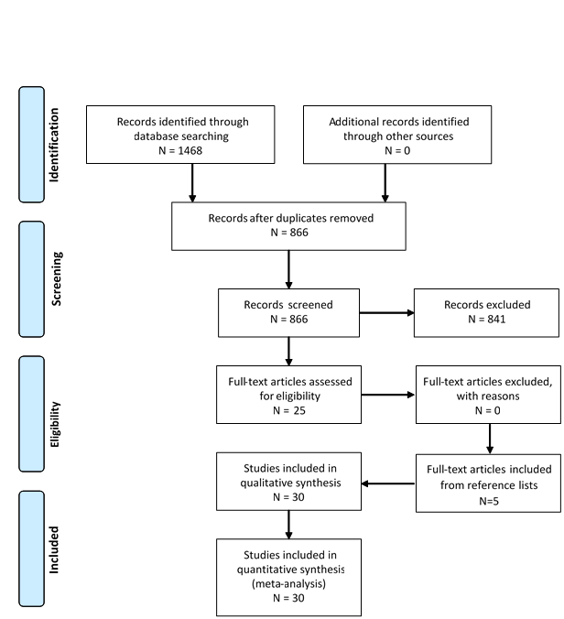
Figure 4.1: Search strategy used to identify articles for inclusion in scoping review

