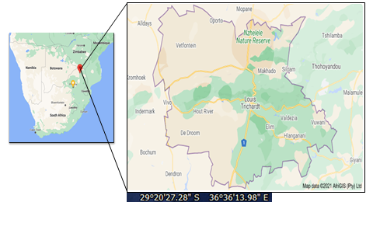

**Figure 3.1: The Designated Area of Study, Makhado local municipality, Limpopo**



**Figure 4.1 Density distribution of loss aversion parameters**