TABLES, FLOW CHARTS AND GRAPHS USED IN THE REPORTING OF THE RESULTS.

Flow chart 4.1: Flow chart representing the participant recruitment process and number of participants included.

Table 4.1: The KOOS-12 Summary knee impact score for each investigated variable.
Variable investigated | Category (n) | Mean Pain | Mean ADL | Mean QOL | KOOS-12 Summary
Gender | Male (58) | 54.41 | 56.88 | 34.76 | 48.68
 | Female (28) | 65.29 | 63.07 | 50.46 | 59.61
Age | 20-39 years (55) | 61.60 | 65.33 | 42.90 | 56.61
 | 40-60 years (31) | 51.48 | 47.44 | 34.48 | 44.47
Occupation | Unemployed (31) | 57.00 | 58.77 | 40.74 | 52.17
 | Employed (55) | 58.49 | 58.96 | 39.38 | 52.64
Social support | No (7) | 46.57 | 51.86 | 32.29 | 43.69
 | Yes (79) | 58.96 | 59.52 | 40.54 | 53.00
Pre-injury activity level | Low (12) | 57.33 | 53.75 | 36.58 | 49.22
 | Moderate (30) | 63.13 | 65.27 | 47.07 | 58.49
 | High (44) | 54.59 | 55.96 | 35.86 | 48.80
Fracture type | Low energy injury (49) | 60.71 | 61.31 | 41.90 | 54.64
 | High energy injury (37) | 54.30 | 55.70 | 37.19 | 49.03
Surgical intervention | No (19) | 65.85 | 69.80 | 50.05 | 61.90
 | Yes (67) | 55.56 | 55.59 | 36.78 | 49.31
Conservative intervention | No (67) | 55.76 | 55.97 | 37.08 | 49.60
 | Yes (19) | 65.68 | 69.21 | 49.74 | 61.54
Physiotherapy | No (26) | 62.81 | 63.35 | 39.46 | 54.01
 | Yes (60) | 55.85 | 56.97 | 40.05 | 50.96
*HEP/advice | No (35) | 62.06 | 61.89 | 38.09 | 54.01
 | Yes (51) | 56.84 | 56.84 | 41.10 | 51.59
*HEP = Home exercise program. All measures scored indicated 0 = worst possible and 100 = best possible score.

Table 4.2: Linear relationships between the aspect of pain described in the KOOS-12 pain sub-scale of the KOOS-12 questionnaire and variables under investigation in this study
Variables investigated | Category (n) | Mean (SD) | 95% CI | Mean difference | p-value
Gender | Male (58) | 54.41 (25.87) | (47.61 ; 61.21) | 10.87 | 0.0611
 | Female (28) | 65.29 (22.70) | (56.49 ; 74.09)
Age | 20-39 years (55) | 61.60 (23.98) | (55.11 ; 68.08) | 10.11 | 0.0439
 | 40-60 years (31) | 51.48 (26.58) | (41.73 ; 61.23)
Occupation | Unemployed (31) | 57.00 (24.92) | (47.86 ; 66.14) | 1.49 | 0.7945
 | Employed (55) | 58.49 (25.67) | (51.55 ; 65.43)
Social support | No (7) | 46.57 (36.92) | (12.43 ; 80.72) | 12.39 | 0.2157
 | Yes (79) | 58.96 (24.05) | (53.58 ; 64.35)
Pre-injury activity level | Low (12) | 57.33 (18.94) | (48.96 ; 67.13) | 7.48 | 0.3636
 | Moderate (30) | 63.13 (27.90) | (54.35 ; 75.48)
 | High (44) | 54.59 (24.80) | (46.58 ; 62.58)
Fracture type | Low energy injury (49) | 60.71 (24.49) | (53.68 ; 67.75) | 6.41 | 0.2459
 | High energy injury (37) | 54.30 (26.14) | (45.58 ; 63.01)
Surgical intervention | No (19) | 65.85 (24.85) | (54.23 ; 77.48) | 10.29 | 0.1111
 | Yes (67) | 55.56 (25.09) | (49.39 ; 61.73)
Conservative intervention | No (67) | 55.76 (24.95) | (49.68 ; 61.85) | 10.00 | 0.1316
 | Yes (19) | 65.68 (25.53) | (53.38 ; 77.99)
Physiotherapy | No (26) | 62.81 (27.70) | (51.62 ; 73.99) | 6.96 | 0.2432
 | Yes (60) | 55.85 (24.08) | (49.63 ; 62.07)
*HEP/advice | No (35) | 62.06 (25.74) | (53.21 ; 70.90) | 6.92 | 0.2141
 | Yes (51) | 56.84 (30.36) | (48.16 ; 62.11)
*: Statistically significant (p<0.05). HEP = home exercise programme. Mean (SD) scores in the KOOS-12 Pain sub-scale and 95% CI by various factors.

Table 4.3: Linear relationships between the functional outcomes described in the KOOS-12 Function sub-scale of the KOOS-12 questionnaire and variables under investigation in this study.
Variables investigated | Category (n) | Mean (SD) | 95% CI | Mean difference | P-value
Sex | Male (58) | 56.88 (27.79) | (49.57 ; 64.19) | 6.19 | 0.3530
 | Female (28) | 63.07 (30.84) | (51.11 ; 75.03)
Age | 20-39 years (55) | 65.33 (25.51) | (58.43 ; 72.22) | 17.89 | 0.0076
 | 40-60 years (31) | 47.44 (31.08) | (36.08 ; 58.88)
Occupation | Unemployed (31) | 58.77 (31.40) | (49.57 ; 64.18) | 0.19 | 0.7945
 | Employed (55) | 58.96 (27.51) | (51.11 ; 75.03)
Social support | No (7) | 51.86 (30.23) | (23.90 ; 79.81) | 7.66 | 0.5030
 | Yes (79) | 59.52 (28.77) | (53.07 ; 65.96)
Pre-injury activity level | Low (12) | 53.75 (33.09) | (50.50 ; 68.01) | 6.70 | 0.3184
 | Moderate (30) | 65.27 (30.11) | (53.87 ; 72.68)
 | High (44) | 55.96 (26.50) | (48.84 ; 65.82)
Fracture type | Low impact injury (49) | 61.31 (29.29) | (52.90 ; 69.71) | 5.61 | 0.3746
 | High impact injury (37) | 55.70 (28.23) | (46.30 ; 65.11)
Surgical intervention | No (19) | 69.80 (26.07) | (57.60 ; 82.00) | 14.21 | 0.0526
 | Yes (67) | 55.59 (28.94) | (48.48 ; 62.70)
Conservative intervention | No (67) | 55.97 (28.89) | (48.92 ; 63.02) | 13.24 | 0.0767
 | Yes (19) | 69.21 (26.64) | (56.37 ; 82.05)
Physiotherapy | No (26) | 63.35 (26.02) | (52.83 ; 73.86) | 6.38 | 0.35483
 | Yes (60) | 56.97 (29.91) | (49.24 ; 64.69)
HEP/advice | No (35) | 61.89 (26.46) | (52.80 ; 70.98) | 5.05 | 0.4281
 | Yes (51) | 56.84 (30.36) | (48.30 ; 65.39)
*: Statistically significant (p<0.05). HEP: home exercise programme. Mean (SD) scores in the KOOS-12 Function subs-scale and 95% CI by various factors.

Table 4.4: Linear relationships between the knee-related QOL described in the KOOS-12 Quality of life sub-scale of the KOOS-12 questionnaire and variables under investigation in this study.
Variables investigated | Category (n) | Mean (SD) | 95% CI | Mean difference | p-value
Sex | Male (58) | 34.76 (26.16) | (27.88 ; 41.64) | 15.71 | 0.0102
 | Female (28) | 50.46 (25.61) | (40.53 ; 60.40)
Age | 20-39 years (55) | 42.90 (26.96) | (35.62 ; 50.20) | 8.42 | 0.0800
 | 40-60 years (31) | 34.48 (26.28) | (24.84 ; 44.12)
Occupation | Unemployed (31) | 40.74 (27.79) | (27.88 ; 41.64) | 1.36 | 0.8232
 | Employed (55) | 39.38 (26.58) | (40.53 ; 60.40)
Social support | No (7) | 32.29 (33.02) | (1.75 ; 62.82) | 8.26 | 0.4390
 | Yes (79) | 40.54 (26. 41) | (34.62 ; 46.46)
Pre-injury activity level | Low (12) | 36.58 (17.87) | (49.01 ; 69.58) | 5.81 | 0.1924
 | Moderate (30) | 47.07 (32.45) | (55.78 ; 70.62)
 | High (44) | 35.86 (24.08) | (46.82 ; 67.03)
Fracture type | Low impact injury (49) | 41.90 (25.29) | (25.27 ; 34.63) | 4.71 | 0.4243
 | High impact injury (37) | 37.19 (28.97) | (27.53 ; 46.85)
Surgical intervention | No (19) | 50.05 (28.14) | (36.88 ; 63.22) | 13.26 | 0.0526
 | Yes (67) | 36.78 (25.91) | (30.42 ; 43.16)
Conservative intervention | No (67) | 37.08 (25.82) | (30.78 ; 43.37) | 12.38 | 0.0696
 | Yes (19) | 49.74 (28.88) | (35.81 ; 63.65)
Physiotherapy | No (26) | 39.46 (27.89) | (28.19 ; 50.73) | 0.59 | 0.9263
 | Yes (60) | 40.05 (26.65) | (33.16 ; 46.93)
HEP/advice | No (35) | 38.09 (25.55) | (29.30 ; 46.87) | 3.01 | 0.6124
 | Yes (51) | 41.10 (27.92) | (33.25 ; 48.95)
*: Statistically significant (p<0.05). HEP: home exercise programme. Mean (SD) scores in the KOOS-12 QOL sub-scale and 95% CI by various factors.

Table 4.5 Predicted mean pain score in relation to sex and surgical intervention (adjusted for age)
Factor (outcome) | Category (n) | Mean | 95% CI | Mean difference | p-value
Gender | Male (58) | 54.41 | (47.86 ; 60.69) | 10.99 | 0.0550
 | Female (28) | 65.28 | (56.04 ; 74.51)
Surgical intervention | No (20) | 65.81 | (54.87 ; 76.75) | 13.26 | 0.0526
 | Yes (66) | 55.44 | (49.43 ; 61.46)

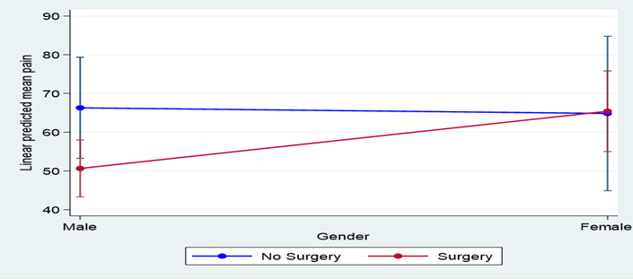
Figure 4.1: Adjusted prediction of sex and surgical intervention

Table 4.6: Predicted mean KOOS-12 Function score in relation to sex and surgical intervention (adjusted for age)
Factor (outcome) | Category (n) | Mean | 95% CI | Mean difference | P-value
Sex | Male (58) | 56.71 | ( 49.30 ; 64.12) | 6.44 | 0.3530
 | Female (28) | 63.15 | ( 52.49 ; 73.82)
Surgical intervention | No (20) | 69.70 | ( 57.06 ; 82.32) | 14.18 | 0.0526
 | Yes (66) | 55.52 | ( 48.57 ; 62.46)

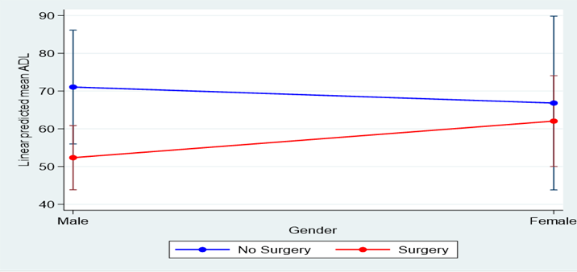
Figure 4.2: Linear predicted mean KOOS-12 Function score in relation to sex (gender) and surgical intervention.

Table 4.7: Predicted mean KOOS-12 QOL score in relation to sex and surgical intervention
Factor (outcome) | Category (n=total) | Mean | 95% CI | Mean difference | p-value
Sex | Male (58) | 34.76 | ( 27.88 ; 41.64) | 15.93 | 0.0102
 | Female (28) | 50.46 | ( 40,53 ; 60.11)
Surgical intervention | No (20) | 50.18 | ( 38.83 ; 61.52) | 13.54 | 0.0526
 | Yes (66) | 36.64 | ( 30.40 ; 42.87)

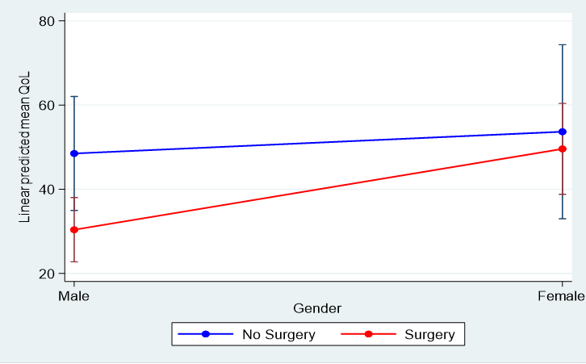
Figure 4.3: Display of linear predicted mean KOOS-12 QOL score in relation to sex (gender) and surgical intervention.

