General Linear Model

Between-Subjects Factors
 |  | N
Combinations | 0 0 0 0 | 209
 | 1 0 1 0 | 145
 | 1 1 0 0 | 168
 | 1 1 0 1 | 139
 | 2 0 1 0 | 43
 | 2 0 2 0 | 30
 | 2 1 0 0 | 59
 | 2 1 0 1 | 53
 | 2 1 1 0 | 60
 | 2 1 1 1 | 42
 | 2 2 0 0 | 29
 | 2 2 0 1 | 63

Box's Test of Equality of Covariance Matricesª
Box's M | 1353.935
F | 1.444
df1 | 858
df2 | 162305.127
Sig. | .000

Tests the null hypothesis that the observed covariance matrices of the dependent variables are equal across groups.ª
a. Design: Intercept + Combinations

Multivariate Testsª
Effect |  | Value | F | Hypothesis df | Error df | Sig. | Partial Eta Squared
Intercept | Pillai's Trace | .969 | 2639.490^{b} | 12.000 | 1017.000 | .000 | .969
 | Wilks' Lambda | .031 | 2639.490^{b} | 12.000 | 1017.000 | .000 | .969
 | Hotelling's Trace | 31.144 | 2639.490^{b} | 12.000 | 1017.000 | .000 | .969
 | Roy's Largest Root | 31.144 | 2639.490^{b} | 12.000 | 1017.000 | .000 | .969
Combinations | Pillai's Trace | .396 | 3.196 | 132.000 | 11297.000 | .000 | .036
 | Wilks' Lambda | .654 | 3.365 | 132.000 | 8341.357 | .000 | .038
 | Hotelling's Trace | .457 | 3.518 | 132.000 | 11167.000 | .000 | .040
 | Roy's Largest Root | .248 | 21.225^{c} | 12.000 | 1027.000 | .000 | .199

a. Design: Intercept + Combinations
b. Exact statistic
c. The statistic is an upper bound on F that yields a lower bound on the significance level.

Levene's Test of Equality of Error Variancesª
 |  | Levene Statistic | df1 | df2 | Sig.
BW-dir | Based on Mean | .808 | 7 | 1032 | .581
 | Based on Median | .810 | 7 | 1032 | .579
 | Based on Median and with adjusted df | .810 | 7 | 1007.746 | .579
 | Based on trimmed mean | .813 | 7 | 1032 | .577
Wean dir | Based on Mean | 1.307 | 7 | 1032 | .244
 | Based on Median | 1.167 | 7 | 1032 | .319
 | Based on Median and with adjusted df | 1.167 | 7 | 984.188 | .319
 | Based on trimmed mean | 1.290 | 7 | 1032 | .252
Mature wt | Based on Mean | 3.021 | 7 | 1032 | .004
 | Based on Median | 2.963 | 7 | 1032 | .004
 | Based on Median and with adjusted df | 2.963 | 7 | 981.398 | .004
 | Based on trimmed mean | 3.047 | 7 | 1032 | .004
ADG | Based on Mean | .360 | 7 | 1032 | .925
 | Based on Median | .308 | 7 | 1032 | .951
 | Based on Median and with adjusted df | .308 | 7 | 1014.780 | .951
 | Based on trimmed mean | .334 | 7 | 1032 | .939
FCR | Based on Mean | 1.479 | 7 | 1032 | .171
 | Based on Median | 1.416 | 7 | 1032 | .195
 | Based on Median and with adjusted df | 1.416 | 7 | 988.908 | .195
 | Based on trimmed mean | 1.475 | 7 | 1032 | .172
Fat | Based on Mean | 4.464 | 7 | 1032 | .000
 | Based on Median | 4.429 | 7 | 1032 | .000
 | Based on Median and with adjusted df | 4.429 | 7 | 981.818 | .000
 | Based on trimmed mean | 4.494 | 7 | 1032 | .000
EMA | Based on Mean | 1.115 | 7 | 1032 | .351
 | Based on Median | 1.180 | 7 | 1032 | .311
 | Based on Median and with adjusted df | 1.180 | 7 | 991.282 | .311
 | Based on trimmed mean | 1.150 | 7 | 1032 | .329
Marb | Based on Mean | .689 | 7 | 1032 | .682
 | Based on Median | .792 | 7 | 1032 | .594
 | Based on Median and with adjusted df | .792 | 7 | 970.976 | .594
 | Based on trimmed mean | .695 | 7 | 1032 | .676
afc_ebv | Based on Mean | 1.866 | 7 | 1032 | .072
 | Based on Median | 1.686 | 7 | 1032 | .109
 | Based on Median and with adjusted df | 1.686 | 7 | 994.212 | .109
 | Based on trimmed mean | 1.835 | 7 | 1032 | .077
icp_ebv | Based on Mean | 3.137 | 7 | 1032 | .003
 | Based on Median | 2.914 | 7 | 1032 | .005
 | Based on Median and with adjusted df | 2.914 | 7 | 914.518 | .005
 | Based on trimmed mean | 2.988 | 7 | 1032 | .004
skr_ebv | Based on Mean | 1.089 | 7 | 1032 | .368
 | Based on Median | 1.045 | 7 | 1032 | .398
 | Based on Median and with adjusted df | 1.045 | 7 | 1010.174 | .398
 | Based on trimmed mean | 1.084 | 7 | 1032 | .371
Longevity | Based on Mean | 1.057 | 7 | 1032 | .389
 | Based on Median | 1.046 | 7 | 1032 | .397
 | Based on Median and with adjusted df | 1.046 | 7 | 1017.711 | .397
 | Based on trimmed mean | 1.071 | 7 | 1032 | .380

Tests the null hypothesis that the error variance of the dependent variable is equal across groups.ª
a. Design: Intercept + Combinations

Tests of Between-Subjects Effects
Source | Dependent Variable | Type III Sum of Squares | df | Mean Square | F | Sig. | Partial Eta Squared
Corrected Model | BW-dir | 73.900ª | 11 | 6.718 | 3.454 | .000 | .036
 | Wean dir | 920.296^{b} | 11 | 83.663 | 2.267 | .010 | .024
 | Mature wt | 3401.380^{c} | 11 | 309.216 | 1.565 | .104 | .016
 | ADG | 81770.430^{d} | 11 | 7433.675 | 2.107 | .018 | .022
 | FCR | 22943.174e | 11 | 2085.743 | 4.901 | .000 | .050
 | Fat | 141.550^{f} | 11 | 12.868 | 4.612 | .000 | .047
 | EMA | 67.094^{g} | 11 | 6.099 | 2.953 | .001 | .031
 | Marb | 41.055^{h} | 11 | 3.732 | 4.492 | .000 | .046
 | afc_ebv | 3091.959^{i} | 11 | 281.087 | 3.263 | .000 | .034
 | icp_ebv | 466.523^{j} | 11 | 42.411 | 4.914 | .000 | .050
 | skr_ebv | 1923.821^{k} | 11 | 174.893 | 2.526 | .004 | .026
 | Longevity | 1486.883^{l} | 11 | 135.171 | 6.664 | .000 | .067
Intercept | BW-dir | 1254.946 | 1 | 1254.946 | 645.133 | .000 | .386
 | Wean dir | 186517.160 | 1 | 186517.160 | 5054.850 | .000 | .831
 | Mature wt | 122753.180 | 1 | 122753.180 | 621.138 | .000 | .377
 | ADG | 11197198.148 | 1 | 11197198.148 | 3173.827 | .000 | .755
 | FCR | 1895333.512 | 1 | 1895333.512 | 4454.023 | .000 | .812
 | Fat | 88.052 | 1 | 88.052 | 31.557 | .000 | .030
 | EMA | 1121.568 | 1 | 1121.568 | 543.090 | .000 | .346
 | Marb | .137 | 1 | .137 | .165 | .685 | .000
 | afc_ebv | 40998.978 | 1 | 40998.978 | 475.872 | .000 | .316
 | icp_ebv | 5079.394 | 1 | 5079.394 | 588.528 | .000 | .364
 | skr_ebv | 127325.829 | 1 | 127325.829 | 1839.200 | .000 | .641
 | Longevity | 532800.485 | 1 | 532800.485 | 26268.758 | .000 | .962
Combinations | BW-dir | 73.900 | 11 | 6.718 | 3.454 | .000 | .036
 | Wean dir | 920.296 | 11 | 83.663 | 2.267 | .010 | .024
 | Mature wt | 3401.380 | 11 | 309.216 | 1.565 | .104 | .016
 | ADG | 81770.430 | 11 | 7433.675 | 2.107 | .018 | .022
 | FCR | 22943.174 | 11 | 2085.743 | 4.901 | .000 | .050
 | Fat | 141.550 | 11 | 12.868 | 4.612 | .000 | .047
 | EMA | 67.094 | 11 | 6.099 | 2.953 | .001 | .031
 | Marb | 41.055 | 11 | 3.732 | 4.492 | .000 | .046
 | afc_ebv | 3091.959 | 11 | 281.087 | 3.263 | .000 | .034
 | icp_ebv | 466.523 | 11 | 42.411 | 4.914 | .000 | .050
 | skr_ebv | 1923.821 | 11 | 174.893 | 2.526 | .004 | .026
 | Longevity | 1486.883 | 11 | 135.171 | 6.664 | .000 | .067
Error | BW-dir | 1999.719 | 1028 | 1.945
 | Wean dir | 37931.814 | 1028 | 36.899
 | Mature wt | 203159.841 | 1028 | 197.626
 | ADG | 3626763.226 | 1028 | 3527.980
 | FCR | 437447.831 | 1028 | 425.533
 | Fat | 2868.326 | 1028 | 2.790
 | EMA | 2122.987 | 1028 | 2.065
 | Marb | 854.166 | 1028 | .831
 | afc_ebv | 88567.853 | 1028 | 86.155
 | icp_ebv | 8872.337 | 1028 | 8.631
 | skr_ebv | 71167.343 | 1028 | 69.229
 | Longevity | 20850.582 | 1028 | 20.283
Total | BW-dir | 3759.954 | 1040
 | Wean dir | 313468.674 | 1040
 | Mature wt | 386039.622 | 1040
 | ADG | 20383571.153 | 1040
 | FCR | 3176443.707 | 1040
 | Fat | 3137.100 | 1040
 | EMA | 3645.197 | 1040
 | Marb | 895.943 | 1040
 | afc_ebv | 155071.008 | 1040
 | icp_ebv | 16646.505 | 1040
 | skr_ebv | 271215.142 | 1040
 | Longevity | 845467.521 | 1040
Corrected Total | BW-dir | 2073.619 | 1039
 | Wean dir | 38852.110 | 1039
 | Mature wt | 206561.221 | 1039
 | ADG | 3708533.656 | 1039
 | FCR | 460391.005 | 1039
 | Fat | 3009.876 | 1039
 | EMA | 2190.080 | 1039
 | Marb | 895.221 | 1039
 | afc_ebv | 91659.812 | 1039
 | icp_ebv | 9338.860 | 1039
 | skr_ebv | 73091.164 | 1039
 | Longevity | 22337.466 | 1039

a. R Squared = .036 (Adjusted R Squared = .025)
b. R Squared = .024 (Adjusted R Squared = .013)
c. R Squared = .016 (Adjusted R Squared = .006)
d. R Squared = .022 (Adjusted R Squared = .012)
e. R Squared = .050 (Adjusted R Squared = .040)
f. R Squared = .047 (Adjusted R Squared = .037)
g. R Squared = .031 (Adjusted R Squared = .020)
h. R Squared = .046 (Adjusted R Squared = .036)
i. R Squared = .034 (Adjusted R Squared = .023)
j. R Squared = .050 (Adjusted R Squared = .040)
k. R Squared = .026 (Adjusted R Squared = .016)
l. R Squared = .067 (Adjusted R Squared = .057)

Estimated Marginal Means

Combinations
Dependent Variable | Combinations | Mean | Std. Error | 95% Confidence Interval
 |  |  |  | Lower Bound | Upper Bound
BW-dir | 0 0 0 0 | 1.177 | .096 | .987 | 1.366
 | 1 0 1 0 | 1.077 | .116 | .850 | 1.304
 | 1 1 0 0 | 1.021 | .108 | .810 | 1.232
 | 1 1 0 1 | 1.530 | .118 | 1.298 | 1.762
 | 2 0 1 0 | 1.376 | .213 | .958 | 1.793
 | 2 0 2 0 | .954 | .255 | .454 | 1.453
 | 2 1 0 0 | 1.416 | .182 | 1.060 | 1.772
 | 2 1 0 1 | 1.884 | .192 | 1.508 | 2.260
 | 2 1 1 0 | .955 | .180 | .602 | 1.309
 | 2 1 1 1 | 1.827 | .215 | 1.404 | 2.249
 | 2 2 0 0 | 1.547 | .259 | 1.039 | 2.056
 | 2 2 0 1 | 1.395 | .176 | 1.050 | 1.740
Wean dir | 0 0 0 0 | 15.860 | .420 | 15.036 | 16.685
 | 1 0 1 0 | 15.630 | .504 | 14.640 | 16.620
 | 1 1 0 0 | 15.354 | .469 | 14.435 | 16.274
 | 1 1 0 1 | 17.540 | .515 | 16.529 | 18.551
 | 2 0 1 0 | 17.242 | .926 | 15.425 | 19.060
 | 2 0 2 0 | 14.901 | 1.109 | 12.725 | 17.078
 | 2 1 0 0 | 17.053 | .791 | 15.501 | 18.605
 | 2 1 0 1 | 18.594 | .834 | 16.957 | 20.232
 | 2 1 1 0 | 15.834 | .784 | 14.295 | 17.373
 | 2 1 1 1 | 16.655 | .937 | 14.816 | 18.494
 | 2 2 0 0 | 16.633 | 1.128 | 14.419 | 18.846
 | 2 2 0 1 | 15.700 | .765 | 14.199 | 17.202
Mature wt | 0 0 0 0 | 12.368 | .972 | 10.460 | 14.276
 | 1 0 1 0 | 12.919 | 1.167 | 10.628 | 15.210
 | 1 1 0 0 | 11.281 | 1.085 | 9.153 | 13.410
 | 1 1 0 1 | 15.471 | 1.192 | 13.131 | 17.811
 | 2 0 1 0 | 14.488 | 2.144 | 10.282 | 18.695
 | 2 0 2 0 | 9.662 | 2.567 | 4.626 | 14.699
 | 2 1 0 0 | 16.662 | 1.830 | 13.071 | 20.254
 | 2 1 0 1 | 15.563 | 1.931 | 11.774 | 19.353
 | 2 1 1 0 | 12.539 | 1.815 | 8.977 | 16.100
 | 2 1 1 1 | 14.609 | 2.169 | 10.353 | 18.866
 | 2 2 0 0 | 13.417 | 2.610 | 8.295 | 18.540
 | 2 2 0 1 | 10.833 | 1.771 | 7.358 | 14.308
ADG | 0 0 0 0 | 129.170 | 4.109 | 121.108 | 137.233
 | 1 0 1 0 | 122.681 | 4.933 | 113.002 | 132.360
 | 1 1 0 0 | 118.439 | 4.583 | 109.446 | 127.431
 | 1 1 0 1 | 131.115 | 5.038 | 121.229 | 141.001
 | 2 0 1 0 | 144.321 | 9.058 | 126.547 | 162.095
 | 2 0 2 0 | 118.265 | 10.844 | 96.985 | 139.544
 | 2 1 0 0 | 139.931 | 7.733 | 124.757 | 155.104
 | 2 1 0 1 | 145.468 | 8.159 | 129.459 | 161.478
 | 2 1 1 0 | 125.308 | 7.668 | 110.261 | 140.355
 | 2 1 1 1 | 110.941 | 9.165 | 92.957 | 128.926
 | 2 2 0 0 | 125.924 | 11.030 | 104.281 | 147.568
 | 2 2 0 1 | 114.790 | 7.483 | 100.106 | 129.475
FCR | 0 0 0 0 | -47.567 | 1.427 | -50.367 | -44.767
 | 1 0 1 0 | -47.299 | 1.713 | -50.661 | -43.938
 | 1 1 0 0 | -47.415 | 1.592 | -50.538 | -44.292
 | 1 1 0 1 | -57.248 | 1.750 | -60.682 | -53.815
 | 2 0 1 0 | -56.911 | 3.146 | -63.084 | -50.738
 | 2 0 2 0 | -47.414 | 3.766 | -54.804 | -40.024
 | 2 1 0 0 | -56.357 | 2.686 | -61.627 | -51.087
 | 2 1 0 1 | -60.911 | 2.834 | -66.471 | -55.350
 | 2 1 1 0 | -51.500 | 2.663 | -56.725 | -46.274
 | 2 1 1 1 | -57.399 | 3.183 | -63.645 | -51.153
 | 2 2 0 0 | -49.124 | 3.831 | -56.640 | -41.607
 | 2 2 0 1 | -48.832 | 2.599 | -53.932 | -43.732
Fat | 0 0 0 0 | -.341 | .116 | -.567 | -.114
 | 1 0 1 0 | -.166 | .139 | -.439 | .106
 | 1 1 0 0 | -.109 | .129 | -.362 | .144
 | 1 1 0 1 | -.571 | .142 | -.849 | -.293
 | 2 0 1 0 | .012 | .255 | -.488 | .512
 | 2 0 2 0 | -.257 | .305 | -.855 | .342
 | 2 1 0 0 | -.114 | .217 | -.541 | .312
 | 2 1 0 1 | -.909 | .229 | -1.359 | -.459
 | 2 1 1 0 | -.043 | .216 | -.467 | .380
 | 2 1 1 1 | -1.124 | .258 | -1.630 | -.618
 | 2 2 0 0 | .511 | .310 | -.098 | 1.119
 | 2 2 0 1 | -1.168 | .210 | -1.581 | -.755
EMA | 0 0 0 0 | .924 | .099 | .729 | 1.119
 | 1 0 1 0 | 1.101 | .119 | .867 | 1.336
 | 1 1 0 0 | 1.024 | .111 | .806 | 1.242
 | 1 1 0 1 | 1.372 | .122 | 1.133 | 1.611
 | 2 0 1 0 | 1.247 | .219 | .817 | 1.677
 | 2 0 2 0 | 1.676 | .262 | 1.161 | 2.191
 | 2 1 0 0 | 1.117 | .187 | .750 | 1.484
 | 2 1 0 1 | 1.950 | .197 | 1.562 | 2.337
 | 2 1 1 0 | 1.181 | .186 | .817 | 1.545
 | 2 1 1 1 | 1.302 | .222 | .867 | 1.738
 | 2 2 0 0 | 1.002 | .267 | .478 | 1.525
 | 2 2 0 1 | 1.380 | .181 | 1.024 | 1.735
Marb | 0 0 0 0 | .102 | .063 | -.022 | .226
 | 1 0 1 0 | .172 | .076 | .023 | .320
 | 1 1 0 0 | .221 | .070 | .083 | .359
 | 1 1 0 1 | -.194 | .077 | -.346 | -.043
 | 2 0 1 0 | -.148 | .139 | -.421 | .125
 | 2 0 2 0 | .173 | .166 | -.154 | .500
 | 2 1 0 0 | -.060 | .119 | -.293 | .173
 | 2 1 0 1 | -.109 | .125 | -.355 | .137
 | 2 1 1 0 | .243 | .118 | .012 | .474
 | 2 1 1 1 | -.441 | .141 | -.717 | -.165
 | 2 2 0 0 | .192 | .169 | -.140 | .524
 | 2 2 0 1 | -.319 | .115 | -.544 | -.093
afc_ebv | 0 0 0 0 | -8.084 | .642 | -9.344 | -6.825
 | 1 0 1 0 | -8.315 | .771 | -9.827 | -6.802
 | 1 1 0 0 | -9.035 | .716 | -10.440 | -7.629
 | 1 1 0 1 | -6.463 | .787 | -8.007 | -4.918
 | 2 0 1 0 | -7.679 | 1.415 | -10.457 | -4.902
 | 2 0 2 0 | -13.152 | 1.695 | -16.478 | -9.827
 | 2 1 0 0 | -6.701 | 1.208 | -9.072 | -4.330
 | 2 1 0 1 | -5.883 | 1.275 | -8.385 | -3.381
 | 2 1 1 0 | -10.728 | 1.198 | -13.080 | -8.377
 | 2 1 1 1 | -3.821 | 1.432 | -6.631 | -1.010
 | 2 2 0 0 | -6.299 | 1.724 | -9.682 | -2.917
 | 2 2 0 1 | -6.201 | 1.169 | -8.495 | -3.906
icp_ebv | 0 0 0 0 | -2.471 | .203 | -2.870 | -2.073
 | 1 0 1 0 | -2.883 | .244 | -3.361 | -2.404
 | 1 1 0 0 | -3.157 | .227 | -3.602 | -2.712
 | 1 1 0 1 | -1.975 | .249 | -2.464 | -1.486
 | 2 0 1 0 | -2.000 | .448 | -2.879 | -1.121
 | 2 0 2 0 | -4.212 | .536 | -5.265 | -3.160
 | 2 1 0 0 | -3.286 | .382 | -4.037 | -2.536
 | 2 1 0 1 | -2.084 | .404 | -2.875 | -1.292
 | 2 1 1 0 | -3.927 | .379 | -4.671 | -3.182
 | 2 1 1 1 | -1.757 | .453 | -2.647 | -.868
 | 2 2 0 0 | -3.188 | .546 | -4.258 | -2.117
 | 2 2 0 1 | -1.569 | .370 | -2.296 | -.843
skr_ebv | 0 0 0 0 | 14.553 | .576 | 13.423 | 15.682
 | 1 0 1 0 | 14.076 | .691 | 12.720 | 15.432
 | 1 1 0 0 | 13.990 | .642 | 12.730 | 15.249
 | 1 1 0 1 | 13.423 | .706 | 12.038 | 14.808
 | 2 0 1 0 | 16.358 | 1.269 | 13.868 | 18.848
 | 2 0 2 0 | 13.111 | 1.519 | 10.130 | 16.092
 | 2 1 0 0 | 15.394 | 1.083 | 13.268 | 17.519
 | 2 1 0 1 | 13.991 | 1.143 | 11.749 | 16.234
 | 2 1 1 0 | 12.616 | 1.074 | 10.508 | 14.724
 | 2 1 1 1 | 8.730 | 1.284 | 6.211 | 11.250
 | 2 2 0 0 | 14.272 | 1.545 | 11.240 | 17.303
 | 2 2 0 1 | 12.252 | 1.048 | 10.195 | 14.309
Longevity | 0 0 0 0 | 29.335 | .312 | 28.724 | 29.947
 | 1 0 1 0 | 27.142 | .374 | 26.408 | 27.876
 | 1 1 0 0 | 27.472 | .347 | 26.791 | 28.154
 | 1 1 0 1 | 29.269 | .382 | 28.519 | 30.018
 | 2 0 1 0 | 29.141 | .687 | 27.794 | 30.489
 | 2 0 2 0 | 25.494 | .822 | 23.880 | 27.107
 | 2 1 0 0 | 27.463 | .586 | 26.312 | 28.613
 | 2 1 0 1 | 29.636 | .619 | 28.422 | 30.850
 | 2 1 1 0 | 27.118 | .581 | 25.977 | 28.259
 | 2 1 1 1 | 27.440 | .695 | 26.076 | 28.804
 | 2 2 0 0 | 24.921 | .836 | 23.279 | 26.562
 | 2 2 0 1 | 28.522 | .567 | 27.409 | 29.636

Post Hoc Tests

Combinations

Multiple Comparisons
Dunnett t (2-sided)ª
Dependent Variable | (I) Combinations | (J) Combinations | Mean Difference (I-J) | Std. Error | Sig. | 95% Confidence Interval
 |  |  |  |  |  | Lower Bound | Upper Bound
BW-dir | 1 0 1 0 | 0 0 0 0 | -.099718 | .1507414 | .999 | -.524380 | .324944
 | 1 1 0 0 | 0 0 0 0 | -.155544 | .1445210 | .960 | -.562682 | .251594
 | 1 1 0 1 | 0 0 0 0 | .353366 | .1526501 | .188 | -.076673 | .783405
 | 2 0 1 0 | 0 0 0 0 | .199016 | .2335505 | .993 | -.458933 | .856964
 | 2 0 2 0 | 0 0 0 0 | -.223167 | .2723035 | .995 | -.990288 | .543954
 | 2 1 0 0 | 0 0 0 0 | .239499 | .2056157 | .933 | -.339752 | .818751
 | 2 1 0 1 | 0 0 0 0 | .707057* | .2145001 | .011 | .102777 | 1.311337
 | 2 1 1 0 | 0 0 0 0 | -.221224 | .2042751 | .958 | -.796698 | .354251
 | 2 1 1 1 | 0 0 0 0 | .650051 | .2358452 | .060 | -.014361 | 1.314464
 | 2 2 0 0 | 0 0 0 0 | .370692 | .2763785 | .851 | -.407909 | 1.149294
 | 2 2 0 1 | 0 0 0 0 | .218598 | .2004606 | .956 | -.346130 | .783327
Wean dir | 1 0 1 0 | 0 0 0 0 | -.230043 | .6565227 | 1.000 | -2.079570 | 1.619484
 | 1 1 0 0 | 0 0 0 0 | -.505766 | .6294310 | .996 | -2.278971 | 1.267440
 | 1 1 0 1 | 0 0 0 0 | 1.679530 | .6648357 | .112 | -.193416 | 3.552476
 | 2 0 1 0 | 0 0 0 0 | 1.382238 | 1.0171808 | .841 | -1.483319 | 4.247795
 | 2 0 2 0 | 0 0 0 0 | -.958733 | 1.1859611 | .995 | -4.299770 | 2.382305
 | 2 1 0 0 | 0 0 0 0 | 1.193195 | .8955163 | .856 | -1.329614 | 3.716004
 | 2 1 0 1 | 0 0 0 0 | 2.734349* | .9342107 | .036 | .102532 | 5.366166
 | 2 1 1 0 | 0 0 0 0 | -.026141 | .8896775 | 1.000 | -2.532501 | 2.480219
 | 2 1 1 1 | 0 0 0 0 | .794771 | 1.0271747 | .997 | -2.098940 | 3.688483
 | 2 2 0 0 | 0 0 0 0 | .772875 | 1.2037092 | .999 | -2.618162 | 4.163912
 | 2 2 0 1 | 0 0 0 0 | -.159726 | .8730644 | 1.000 | -2.619284 | 2.299833
Mature wt | 1 0 1 0 | 0 0 0 0 | .550722 | 1.5193816 | 1.000 | -3.729613 | 4.831057
 | 1 1 0 0 | 0 0 0 0 | -1.086634 | 1.4566837 | .998 | -5.190339 | 3.017072
 | 1 1 0 1 | 0 0 0 0 | 3.102991 | 1.5386203 | .353 | -1.231542 | 7.437525
 | 2 0 1 0 | 0 0 0 0 | 2.120190 | 2.3540478 | .989 | -4.511529 | 8.751910
 | 2 0 2 0 | 0 0 0 0 | -2.705633 | 2.7446537 | .978 | -10.437750 | 5.026485
 | 2 1 0 0 | 0 0 0 0 | 4.294306 | 2.0724813 | .318 | -1.544197 | 10.132809
 | 2 1 0 1 | 0 0 0 0 | 3.195238 | 2.1620311 | .762 | -2.895540 | 9.286017
 | 2 1 1 0 | 0 0 0 0 | .170611 | 2.0589687 | 1.000 | -5.629825 | 5.971047
 | 2 1 1 1 | 0 0 0 0 | 2.241250 | 2.3771766 | .985 | -4.455627 | 8.938128
 | 2 2 0 0 | 0 0 0 0 | 1.049340 | 2.7857280 | 1.000 | -6.798490 | 8.897170
 | 2 2 0 1 | 0 0 0 0 | -1.535094 | 2.0205212 | .997 | -7.227217 | 4.157029
ADG | 1 0 1 0 | 0 0 0 0 | -6.489207 | 6.4195935 | .974 | -24.574203 | 11.595789
 | 1 1 0 0 | 0 0 0 0 | -10.731902 | 6.1546865 | .557 | -28.070614 | 6.606809
 | 1 1 0 1 | 0 0 0 0 | 1.944560 | 6.5008796 | 1.000 | -16.369431 | 20.258552
 | 2 0 1 0 | 0 0 0 0 | 15.150694 | 9.9461715 | .729 | -12.869222 | 43.170610
 | 2 0 2 0 | 0 0 0 0 | -10.905875 | 11.5965345 | .985 | -43.575121 | 21.763371
 | 2 1 0 0 | 0 0 0 0 | 10.760067 | 8.7565149 | .908 | -13.908401 | 35.428535
 | 2 1 0 1 | 0 0 0 0 | 16.297887 | 9.1348751 | .525 | -9.436481 | 42.032254
 | 2 1 1 0 | 0 0 0 0 | -3.862572 | 8.6994224 | 1.000 | -28.370201 | 20.645057
 | 2 1 1 1 | 0 0 0 0 | -18.229295 | 10.0438939 | .500 | -46.524510 | 10.065921
 | 2 2 0 0 | 0 0 0 0 | -3.245992 | 11.7700791 | 1.000 | -36.404140 | 29.912156
 | 2 2 0 1 | 0 0 0 0 | -14.380082 | 8.5369764 | .604 | -38.430076 | 9.669912
FCR | 1 0 1 0 | 0 0 0 0 | .2680 | 2.22952 | 1.000 | -6.0129 | 6.5489
 | 1 1 0 0 | 0 0 0 0 | .1527 | 2.13752 | 1.000 | -5.8690 | 6.1744
 | 1 1 0 1 | 0 0 0 0 | -9.6809* | 2.25775 | .000 | -16.0413 | -3.3205
 | 2 0 1 0 | 0 0 0 0 | -9.3435 | 3.45430 | .069 | -19.0748 | .3878
 | 2 0 2 0 | 0 0 0 0 | .1536 | 4.02746 | 1.000 | -11.1924 | 11.4996
 | 2 1 0 0 | 0 0 0 0 | -8.7899* | 3.04113 | .040 | -17.3572 | -.2226
 | 2 1 0 1 | 0 0 0 0 | -13.3432* | 3.17253 | .000 | -22.2807 | -4.4056
 | 2 1 1 0 | 0 0 0 0 | -3.9323 | 3.02130 | .873 | -12.4438 | 4.5792
 | 2 1 1 1 | 0 0 0 0 | -9.8311* | 3.48823 | .050 | -19.6580 | -.0042
 | 2 2 0 0 | 0 0 0 0 | -1.5562 | 4.08774 | 1.000 | -13.0720 | 9.9596
 | 2 2 0 1 | 0 0 0 0 | -1.2647 | 2.96488 | 1.000 | -9.6172 | 7.0879
Fat | 1 0 1 0 | 0 0 0 0 | .17421 | .180535 | .982 | -.33438 | .68281
 | 1 1 0 0 | 0 0 0 0 | .23135 | .173085 | .854 | -.25626 | .71896
 | 1 1 0 1 | 0 0 0 0 | -.23013 | .182821 | .894 | -.74517 | .28490
 | 2 0 1 0 | 0 0 0 0 | .35233 | .279712 | .894 | -.43567 | 1.14032
 | 2 0 2 0 | 0 0 0 0 | .08377 | .326124 | 1.000 | -.83497 | 1.00252
 | 2 1 0 0 | 0 0 0 0 | .22642 | .246255 | .987 | -.46732 | .92016
 | 2 1 0 1 | 0 0 0 0 | -.56819 | .256896 | .238 | -1.29191 | .15552
 | 2 1 1 0 | 0 0 0 0 | .29717 | .244650 | .914 | -.39204 | .98639
 | 2 1 1 1 | 0 0 0 0 | -.78311 | .282460 | .057 | -1.57884 | .01262
 | 2 2 0 0 | 0 0 0 0 | .85136 | .331005 | .099 | -.08113 | 1.78386
 | 2 2 0 1 | 0 0 0 0 | -.82734* | .240082 | .006 | -1.50369 | -.15099
EMA | 1 0 1 0 | 0 0 0 0 | .177731 | .1553179 | .940 | -.259824 | .615285
 | 1 1 0 0 | 0 0 0 0 | .100250 | .1489087 | .999 | -.319249 | .519749
 | 1 1 0 1 | 0 0 0 0 | .448107* | .1572846 | .046 | .005012 | .891203
 | 2 0 1 0 | 0 0 0 0 | .323554 | .2406412 | .849 | -.354369 | 1.001478
 | 2 0 2 0 | 0 0 0 0 | .752291 | .2805707 | .074 | -.038120 | 1.542702
 | 2 1 0 0 | 0 0 0 0 | .193567 | .2118582 | .988 | -.403271 | .790405
 | 2 1 0 1 | 0 0 0 0 | 1.026022* | .2210124 | .000 | .403395 | 1.648648
 | 2 1 1 0 | 0 0 0 0 | .257331 | .2104769 | .911 | -.335615 | .850277
 | 2 1 1 1 | 0 0 0 0 | .378784 | .2430055 | .703 | -.305800 | 1.063369
 | 2 2 0 0 | 0 0 0 0 | .078063 | .2847695 | 1.000 | -.724177 | .880303
 | 2 2 0 1 | 0 0 0 0 | .456045 | .2065466 | .240 | -.125829 | 1.037919
Marb | 1 0 1 0 | 0 0 0 0 | .06969 | .098519 | .999 | -.20785 | .34724
 | 1 1 0 0 | 0 0 0 0 | .11874 | .094453 | .895 | -.14735 | .38483
 | 1 1 0 1 | 0 0 0 0 | -.29643* | .099766 | .031 | -.57749 | -.01537
 | 2 0 1 0 | 0 0 0 0 | -.25022 | .152640 | .640 | -.68023 | .17979
 | 2 0 2 0 | 0 0 0 0 | .07079 | .177967 | 1.000 | -.43058 | .57215
 | 2 1 0 0 | 0 0 0 0 | -.16181 | .134383 | .918 | -.54039 | .21677
 | 2 1 0 1 | 0 0 0 0 | -.21134 | .140189 | .741 | -.60627 | .18360
 | 2 1 1 0 | 0 0 0 0 | .14070 | .133506 | .965 | -.23541 | .51681
 | 2 1 1 1 | 0 0 0 0 | -.54341* | .154139 | .005 | -.97764 | -.10918
 | 2 2 0 0 | 0 0 0 0 | .08975 | .180630 | 1.000 | -.41912 | .59861
 | 2 2 0 1 | 0 0 0 0 | -.42099* | .131013 | .014 | -.79007 | -.05190
afc_ebv | 1 0 1 0 | 0 0 0 0 | -.230380 | 1.0031965 | 1.000 | -3.056541 | 2.595781
 | 1 1 0 0 | 0 0 0 0 | -.950023 | .9617992 | .978 | -3.659561 | 1.759515
 | 1 1 0 1 | 0 0 0 0 | 1.621923 | 1.0158991 | .674 | -1.240023 | 4.483869
 | 2 0 1 0 | 0 0 0 0 | .405355 | 1.5542984 | 1.000 | -3.973346 | 4.784056
 | 2 0 2 0 | 0 0 0 0 | -5.067686 | 1.8122023 | .053 | -10.172943 | .037570
 | 2 1 0 0 | 0 0 0 0 | 1.383687 | 1.3683896 | .974 | -2.471280 | 5.238654
 | 2 1 0 1 | 0 0 0 0 | 2.201467 | 1.4275163 | .715 | -1.820069 | 6.223003
 | 2 1 1 0 | 0 0 0 0 | -2.643793 | 1.3594676 | .403 | -6.473625 | 1.186039
 | 2 1 1 1 | 0 0 0 0 | 4.263726 | 1.5695696 | .067 | -.157997 | 8.685448
 | 2 2 0 0 | 0 0 0 0 | 1.785084 | 1.8393223 | .981 | -3.396574 | 6.966742
 | 2 2 0 1 | 0 0 0 0 | 1.883723 | 1.3340820 | .807 | -1.874594 | 5.642040
icp_ebv | 1 0 1 0 | 0 0 0 0 | -.411251 | .3175170 | .876 | -1.305746 | .483244
 | 1 1 0 0 | 0 0 0 0 | -.685557 | .3044145 | .217 | -1.543140 | .172026
 | 1 1 0 1 | 0 0 0 0 | .496543 | .3215374 | .714 | -.409278 | 1.402364
 | 2 0 1 0 | 0 0 0 0 | .471352 | .4919436 | .983 | -.914530 | 1.857234
 | 2 0 2 0 | 0 0 0 0 | -1.740728* | .5735716 | .026 | -3.356568 | -.124887
 | 2 1 0 0 | 0 0 0 0 | -.814954 | .4331025 | .449 | -2.035071 | .405164
 | 2 1 0 1 | 0 0 0 0 | .387780 | .4518164 | .993 | -.885057 | 1.660618
 | 2 1 1 0 | 0 0 0 0 | -1.455131* | .4302787 | .008 | -2.667293 | -.242969
 | 2 1 1 1 | 0 0 0 0 | .713998 | .4967770 | .791 | -.685500 | 2.113497
 | 2 2 0 0 | 0 0 0 0 | -.716460 | .5821552 | .907 | -2.356482 | .923562
 | 2 2 0 1 | 0 0 0 0 | .902135 | .4222440 | .279 | -.287393 | 2.091662
skr_ebv | 1 0 1 0 | 0 0 0 0 | -.476383 | .8992663 | 1.000 | -3.009756 | 2.056990
 | 1 1 0 0 | 0 0 0 0 | -.562733 | .8621577 | .999 | -2.991565 | 1.866100
 | 1 1 0 1 | 0 0 0 0 | -1.129871 | .9106529 | .903 | -3.695323 | 1.435580
 | 2 0 1 0 | 0 0 0 0 | 1.805629 | 1.3932746 | .876 | -2.119443 | 5.730700
 | 2 0 2 0 | 0 0 0 0 | -1.441828 | 1.6244599 | .990 | -6.018185 | 3.134529
 | 2 1 0 0 | 0 0 0 0 | .840958 | 1.2266257 | .999 | -2.614638 | 4.296553
 | 2 1 0 1 | 0 0 0 0 | -.561335 | 1.2796270 | 1.000 | -4.166244 | 3.043573
 | 2 1 1 0 | 0 0 0 0 | -1.936793 | 1.2186281 | .679 | -5.369858 | 1.496272
 | 2 1 1 1 | 0 0 0 0 | -5.822317* | 1.4069637 | .000 | -9.785953 | -1.858680
 | 2 2 0 0 | 0 0 0 0 | -.281016 | 1.6487703 | 1.000 | -4.925859 | 4.363827
 | 2 2 0 1 | 0 0 0 0 | -2.300971 | 1.1958724 | .418 | -5.669930 | 1.067988
Longevity | 1 0 1 0 | 0 0 0 0 | -2.193311* | .4867512 | .000 | -3.564565 | -.822057
 | 1 1 0 0 | 0 0 0 0 | -1.862862* | .4666652 | .001 | -3.177531 | -.548194
 | 1 1 0 1 | 0 0 0 0 | -.066652 | .4929145 | 1.000 | -1.455269 | 1.321965
 | 2 0 1 0 | 0 0 0 0 | -.193984 | .7541460 | 1.000 | -2.318530 | 1.930563
 | 2 0 2 0 | 0 0 0 0 | -3.841477* | .8792811 | .000 | -6.318548 | -1.364405
 | 2 1 0 0 | 0 0 0 0 | -1.872483* | .6639430 | .050 | -3.742914 | -.002052
 | 2 1 0 1 | 0 0 0 0 | .301056 | .6926313 | 1.000 | -1.650195 | 2.252306
 | 2 1 1 0 | 0 0 0 0 | -2.217527* | .6596141 | .009 | -4.075762 | -.359291
 | 2 1 1 1 | 0 0 0 0 | -1.895243 | .7615556 | .123 | -4.040664 | .250178
 | 2 2 0 0 | 0 0 0 0 | -4.414766* | .8924397 | .000 | -6.928908 | -1.900624
 | 2 2 0 1 | 0 0 0 0 | -.813077 | .6472970 | .896 | -2.636613 | 1.010460

Based on observed means.
The error term is Mean Square(Error) = 20.283.
*. The mean difference is significant at the ,05 level.
a. Dunnett t-tests treat one group as a control, and compare all other groups against it.

Profile Plots

BW-dir

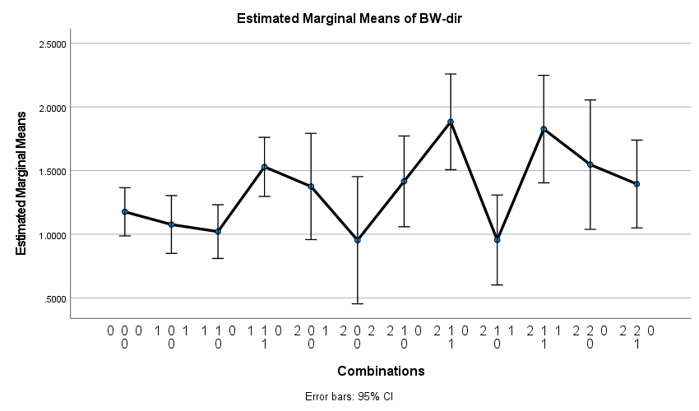

Wean dir

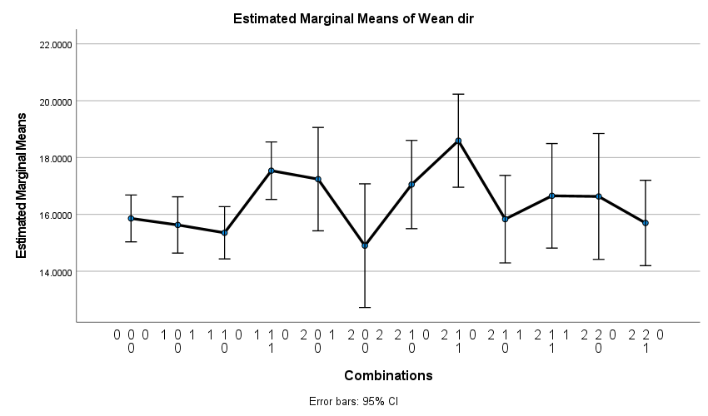

Mature wt

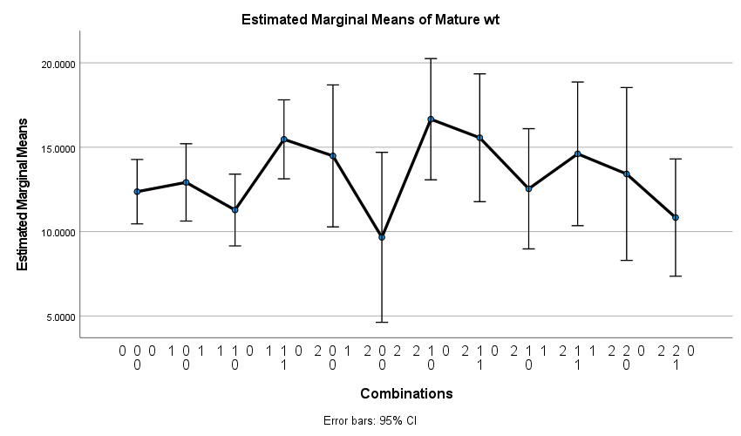

ADG

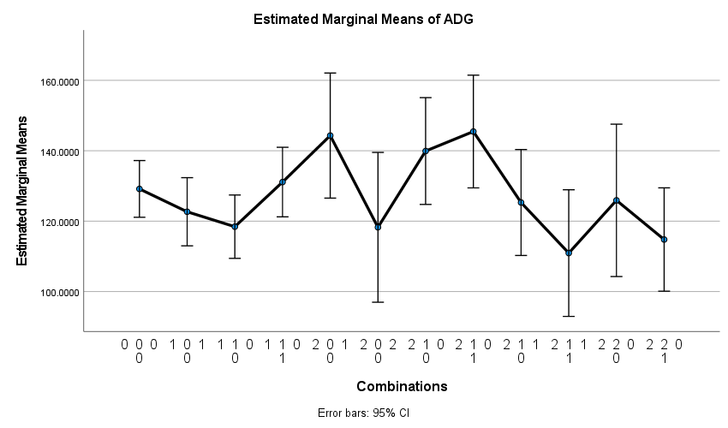

FCR

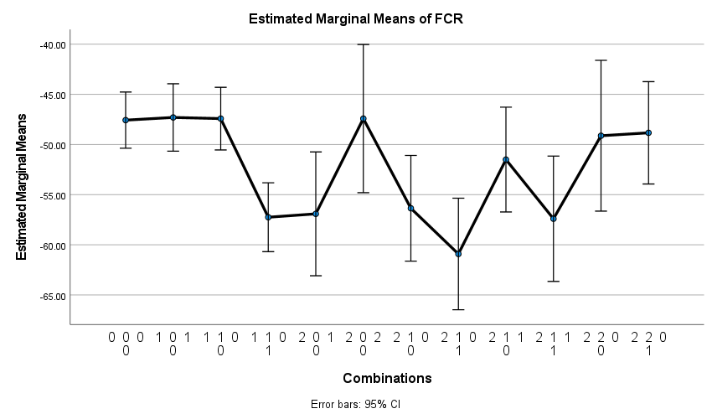

Fat

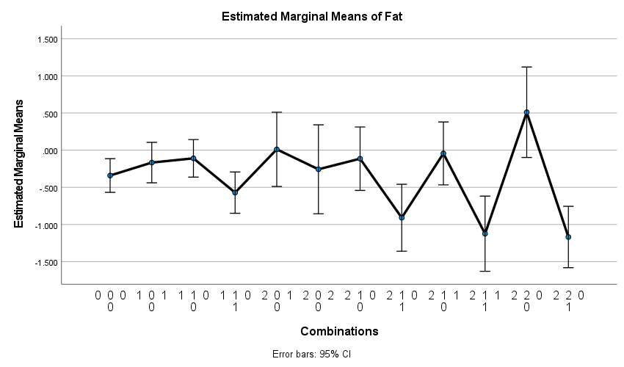

EMA

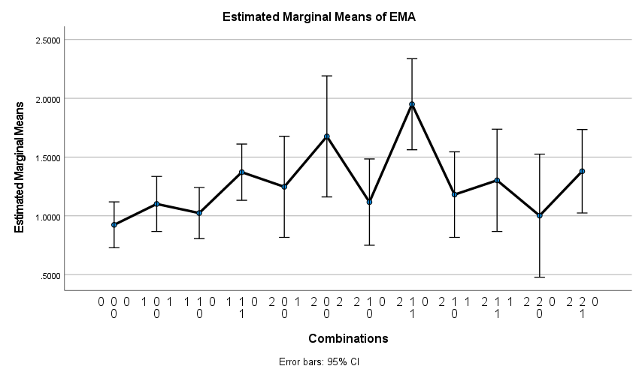

Marb

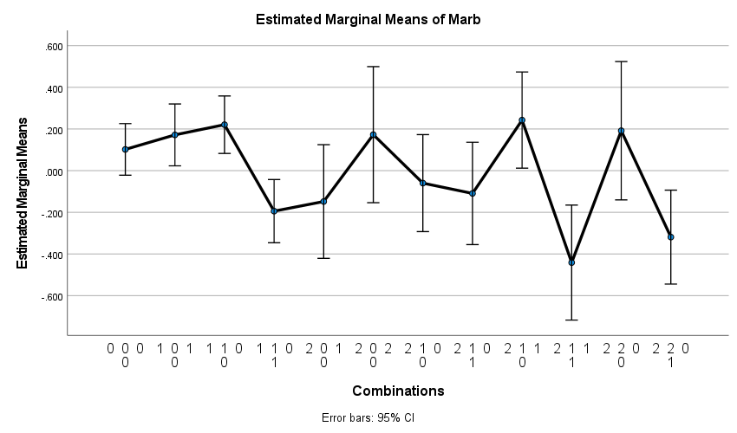

afc_ebv

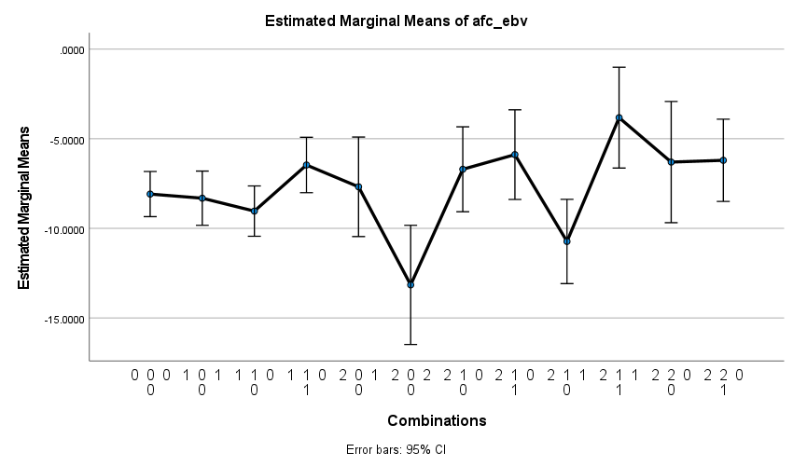

icp_ebv

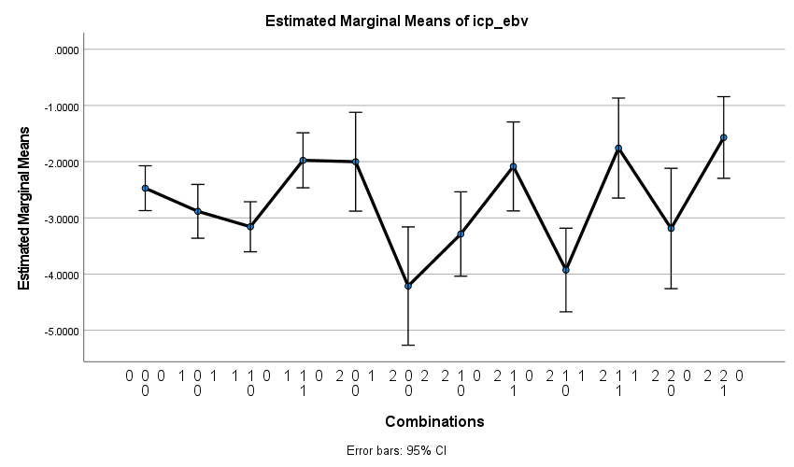

skr_ebv

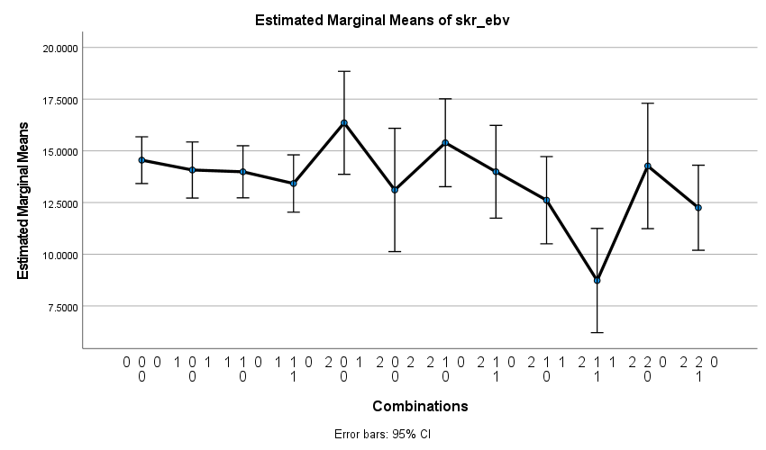

Longevity

