General Linear Model

Between-Subjects Factors
 |  | N
Combinations | 0 0 0 | 95
 | 1 0 1 | 10
 | 1 1 0 | 46
 | 1 1 1 | 19
 | 2 1 0 | 21
 | 2 2 0 | 14

Box's Test of Equality of Covariance Matricesª
Box's M | 602.800
F | 1.454
df1 | 312
df2 | 10385.946
Sig. | .000

Tests the null hypothesis that the observed covariance matrices of the dependent variables are equal across groups.ª
a. Design: Intercept + Combinations

Multivariate Testsª
Effect |  | Value | F | Hypothesis df | Error df | Sig. | Partial Eta Squared
Intercept | Pillai's Trace | .950 | 299.696^{b} | 12.000 | 188.000 | .000 | .950
 | Wilks' Lambda | .050 | 299.696^{b} | 12.000 | 188.000 | .000 | .950
 | Hotelling's Trace | 19.130 | 299.696^{b} | 12.000 | 188.000 | .000 | .950
 | Roy's Largest Root | 19.130 | 299.696^{b} | 12.000 | 188.000 | .000 | .950
Combinations | Pillai's Trace | .313 | 1.068 | 60.000 | 960.000 | .341 | .063
 | Wilks' Lambda | .720 | 1.072 | 60.000 | 884.109 | .334 | .064
 | Hotelling's Trace | .346 | 1.076 | 60.000 | 932.000 | .327 | .065
 | Roy's Largest Root | .145 | 2.316^{c} | 12.000 | 192.000 | .009 | .126

a. Design: Intercept + Combinations
b. Exact statistic
c. The statistic is an upper bound on F that yields a lower bound on the significance level.

Levene's Test of Equality of Error Variancesª
 |  | Levene Statistic | df1 | df2 | Sig.
BW-dir | Based on Mean | .731 | 5 | 199 | .601
 | Based on Median | .641 | 5 | 199 | .669
 | Based on Median and with adjusted df | .641 | 5 | 184.847 | .669
 | Based on trimmed mean | .706 | 5 | 199 | .620
Wean dir | Based on Mean | .964 | 5 | 199 | .441
 | Based on Median | 1.003 | 5 | 199 | .417
 | Based on Median and with adjusted df | 1.003 | 5 | 185.957 | .417
 | Based on trimmed mean | .970 | 5 | 199 | .437
Mature wt | Based on Mean | 1.208 | 5 | 199 | .307
 | Based on Median | 1.069 | 5 | 199 | .379
 | Based on Median and with adjusted df | 1.069 | 5 | 190.269 | .379
 | Based on trimmed mean | 1.246 | 5 | 199 | .289
ADG | Based on Mean | .502 | 5 | 199 | .774
 | Based on Median | .466 | 5 | 199 | .801
 | Based on Median and with adjusted df | .466 | 5 | 187.686 | .801
 | Based on trimmed mean | .475 | 5 | 199 | .795
FCR | Based on Mean | .260 | 5 | 199 | .934
 | Based on Median | .334 | 5 | 199 | .892
 | Based on Median and with adjusted df | .334 | 5 | 183.940 | .892
 | Based on trimmed mean | .267 | 5 | 199 | .931
Fat | Based on Mean | 1.266 | 5 | 199 | .280
 | Based on Median | 1.281 | 5 | 199 | .274
 | Based on Median and with adjusted df | 1.281 | 5 | 178.485 | .274
 | Based on trimmed mean | 1.257 | 5 | 199 | .284
EMA | Based on Mean | .723 | 5 | 199 | .607
 | Based on Median | .749 | 5 | 199 | .588
 | Based on Median and with adjusted df | .749 | 5 | 176.226 | .588
 | Based on trimmed mean | .729 | 5 | 199 | .602
Marb | Based on Mean | 2.223 | 5 | 199 | .053
 | Based on Median | 1.371 | 5 | 199 | .237
 | Based on Median and with adjusted df | 1.371 | 5 | 123.377 | .240
 | Based on trimmed mean | 2.002 | 5 | 199 | .080
afc_ebv | Based on Mean | 1.156 | 5 | 199 | .333
 | Based on Median | 1.104 | 5 | 199 | .360
 | Based on Median and with adjusted df | 1.104 | 5 | 194.426 | .360
 | Based on trimmed mean | 1.167 | 5 | 199 | .327
icp_ebv | Based on Mean | .603 | 5 | 199 | .698
 | Based on Median | .626 | 5 | 199 | .680
 | Based on Median and with adjusted df | .626 | 5 | 192.641 | .680
 | Based on trimmed mean | .611 | 5 | 199 | .692
skr_ebv | Based on Mean | .222 | 5 | 199 | .953
 | Based on Median | .208 | 5 | 199 | .959
 | Based on Median and with adjusted df | .208 | 5 | 191.881 | .959
 | Based on trimmed mean | .208 | 5 | 199 | .959
Longevity | Based on Mean | .718 | 5 | 199 | .610
 | Based on Median | .742 | 5 | 199 | .593
 | Based on Median and with adjusted df | .742 | 5 | 194.465 | .593
 | Based on trimmed mean | .776 | 5 | 199 | .568

Tests the null hypothesis that the error variance of the dependent variable is equal across groups.ª
a. Design: Intercept + Combinations

Tests of Between-Subjects Effects
Source | Dependent Variable | Type III Sum of Squares | df | Mean Square | F | Sig. | Partial Eta Squared
Corrected Model | BW-dir | 11.096ª | 5 | 2.219 | 1.218 | .302 | .030
 | Wean dir | 108.832^{b} | 5 | 21.766 | .795 | .554 | .020
 | Mature wt | 635.359^{c} | 5 | 127.072 | 1.123 | .349 | .027
 | ADG | 10849.702^{d} | 5 | 2169.940 | .918 | .470 | .023
 | FCR | 2599.835e | 5 | 519.967 | 1.001 | .418 | .025
 | Fat | .342^{f} | 5 | .068 | .063 | .997 | .002
 | EMA | 5.208^{g} | 5 | 1.042 | .623 | .682 | .015
 | Marb | 2.373^{h} | 5 | .475 | 1.087 | .369 | .027
 | afc_ebv | 165.990^{i} | 5 | 33.198 | .465 | .802 | .012
 | icp_ebv | 20.905^{j} | 5 | 4.181 | .833 | .528 | .020
 | skr_ebv | 603.977^{k} | 5 | 120.795 | 2.300 | .046 | .055
 | Longevity | 168.334^{l} | 5 | 33.667 | 1.503 | .190 | .036
Intercept | BW-dir | 3.029 | 1 | 3.029 | 1.663 | .199 | .008
 | Wean dir | 9600.398 | 1 | 9600.398 | 350.849 | .000 | .638
 | Mature wt | 17421.574 | 1 | 17421.574 | 153.941 | .000 | .436
 | ADG | 430715.201 | 1 | 430715.201 | 182.188 | .000 | .478
 | FCR | 191374.924 | 1 | 191374.924 | 368.555 | .000 | .649
 | Fat | .284 | 1 | .284 | .264 | .608 | .001
 | EMA | 65.539 | 1 | 65.539 | 39.226 | .000 | .165
 | Marb | 6.829 | 1 | 6.829 | 15.637 | .000 | .073
 | afc_ebv | 500.242 | 1 | 500.242 | 7.001 | .009 | .034
 | icp_ebv | 557.943 | 1 | 557.943 | 111.124 | .000 | .358
 | skr_ebv | 14706.815 | 1 | 14706.815 | 280.065 | .000 | .585
 | Longevity | 66508.791 | 1 | 66508.791 | 2969.652 | .000 | .937
Combinations | BW-dir | 11.096 | 5 | 2.219 | 1.218 | .302 | .030
 | Wean dir | 108.832 | 5 | 21.766 | .795 | .554 | .020
 | Mature wt | 635.359 | 5 | 127.072 | 1.123 | .349 | .027
 | ADG | 10849.702 | 5 | 2169.940 | .918 | .470 | .023
 | FCR | 2599.835 | 5 | 519.967 | 1.001 | .418 | .025
 | Fat | .342 | 5 | .068 | .063 | .997 | .002
 | EMA | 5.208 | 5 | 1.042 | .623 | .682 | .015
 | Marb | 2.373 | 5 | .475 | 1.087 | .369 | .027
 | afc_ebv | 165.990 | 5 | 33.198 | .465 | .802 | .012
 | icp_ebv | 20.905 | 5 | 4.181 | .833 | .528 | .020
 | skr_ebv | 603.977 | 5 | 120.795 | 2.300 | .046 | .055
 | Longevity | 168.334 | 5 | 33.667 | 1.503 | .190 | .036
Error | BW-dir | 362.524 | 199 | 1.822
 | Wean dir | 5445.307 | 199 | 27.363
 | Mature wt | 22520.917 | 199 | 113.170
 | ADG | 470461.731 | 199 | 2364.129
 | FCR | 103332.090 | 199 | 519.257
 | Fat | 214.576 | 199 | 1.078
 | EMA | 332.495 | 199 | 1.671
 | Marb | 86.909 | 199 | .437
 | afc_ebv | 14219.855 | 199 | 71.457
 | icp_ebv | 999.162 | 199 | 5.021
 | skr_ebv | 10449.915 | 199 | 52.512
 | Longevity | 4456.835 | 199 | 22.396
Total | BW-dir | 373.900 | 205
 | Wean dir | 21386.649 | 205
 | Mature wt | 51397.855 | 205
 | ADG | 1212197.288 | 205
 | FCR | 434691.500 | 205
 | Fat | 215.552 | 205
 | EMA | 452.808 | 205
 | Marb | 109.115 | 205
 | afc_ebv | 15290.478 | 205
 | icp_ebv | 1828.722 | 205
 | skr_ebv | 38896.152 | 205
 | Longevity | 126669.191 | 205
Corrected Total | BW-dir | 373.620 | 204
 | Wean dir | 5554.139 | 204
 | Mature wt | 23156.277 | 204
 | ADG | 481311.432 | 204
 | FCR | 105931.925 | 204
 | Fat | 214.918 | 204
 | EMA | 337.703 | 204
 | Marb | 89.282 | 204
 | afc_ebv | 14385.845 | 204
 | icp_ebv | 1020.067 | 204
 | skr_ebv | 11053.893 | 204
 | Longevity | 4625.169 | 204

a. R Squared = .030 (Adjusted R Squared = .005)
b. R Squared = .020 (Adjusted R Squared = -.005)
c. R Squared = .027 (Adjusted R Squared = .003)
d. R Squared = .023 (Adjusted R Squared = -.002)
e. R Squared = .025 (Adjusted R Squared = .000)
f. R Squared = .002 (Adjusted R Squared = -.023)
g. R Squared = .015 (Adjusted R Squared = -.009)
h. R Squared = .027 (Adjusted R Squared = .002)
i. R Squared = .012 (Adjusted R Squared = -.013)
j. R Squared = .020 (Adjusted R Squared = -.004)
k. R Squared = .055 (Adjusted R Squared = .031)
l. R Squared = .036 (Adjusted R Squared = .012)

Estimated Marginal Means

Combinations
Dependent Variable | Combinations | Mean | Std. Error | 95% Confidence Interval
 |  |  |  | Lower Bound | Upper Bound
BW-dir | 0 0 0 | -.064 | .138 | -.337 | .209
 | 1 0 1 | .653 | .427 | -.188 | 1.495
 | 1 1 0 | -.042 | .199 | -.434 | .351
 | 1 1 1 | -.115 | .310 | -.726 | .495
 | 2 1 0 | .551 | .295 | -.030 | 1.132
 | 2 2 0 | -.024 | .361 | -.735 | .687
Wean dir | 0 0 0 | 9.023 | .537 | 7.965 | 10.082
 | 1 0 1 | 11.351 | 1.654 | 8.089 | 14.613
 | 1 1 0 | 7.960 | .771 | 6.439 | 9.480
 | 1 1 1 | 8.503 | 1.200 | 6.136 | 10.869
 | 2 1 0 | 8.945 | 1.141 | 6.694 | 11.196
 | 2 2 0 | 8.237 | 1.398 | 5.480 | 10.994
Mature wt | 0 0 0 | 12.217 | 1.091 | 10.065 | 14.369
 | 1 0 1 | 15.650 | 3.364 | 9.016 | 22.284
 | 1 1 0 | 9.772 | 1.569 | 6.679 | 12.865
 | 1 1 1 | 14.924 | 2.441 | 10.111 | 19.737
 | 2 1 0 | 10.439 | 2.321 | 5.861 | 15.017
 | 2 2 0 | 9.766 | 2.843 | 4.159 | 15.372
ADG | 0 0 0 | 63.867 | 4.989 | 54.030 | 73.704
 | 1 0 1 | 82.213 | 15.376 | 51.892 | 112.533
 | 1 1 0 | 53.071 | 7.169 | 38.934 | 67.208
 | 1 1 1 | 51.687 | 11.155 | 29.690 | 73.683
 | 2 1 0 | 53.429 | 10.610 | 32.506 | 74.352
 | 2 2 0 | 57.554 | 12.995 | 31.928 | 83.179
FCR | 0 0 0 | -42.105 | 2.338 | -46.716 | -37.495
 | 1 0 1 | -49.219 | 7.206 | -63.429 | -35.009
 | 1 1 0 | -36.423 | 3.360 | -43.048 | -29.797
 | 1 1 1 | -33.861 | 5.228 | -44.170 | -23.552
 | 2 1 0 | -40.640 | 4.973 | -50.445 | -30.834
 | 2 2 0 | -38.932 | 6.090 | -50.941 | -26.922
Fat | 0 0 0 | .070 | .107 | -.140 | .280
 | 1 0 1 | .133 | .328 | -.515 | .780
 | 1 1 0 | .053 | .153 | -.249 | .355
 | 1 1 1 | .093 | .238 | -.376 | .563
 | 2 1 0 | -.006 | .227 | -.453 | .441
 | 2 2 0 | -.050 | .278 | -.597 | .498
EMA | 0 0 0 | .787 | .133 | .526 | 1.049
 | 1 0 1 | .898 | .409 | .092 | 1.704
 | 1 1 0 | .764 | .191 | .388 | 1.139
 | 1 1 1 | .890 | .297 | .305 | 1.475
 | 2 1 0 | .293 | .282 | -.263 | .849
 | 2 2 0 | .831 | .345 | .150 | 1.512
Marb | 0 0 0 | .403 | .068 | .269 | .537
 | 1 0 1 | .037 | .209 | -.375 | .449
 | 1 1 0 | .251 | .097 | .059 | .443
 | 1 1 1 | .375 | .152 | .076 | .674
 | 2 1 0 | .171 | .144 | -.114 | .455
 | 2 2 0 | .204 | .177 | -.144 | .552
afc_ebv | 0 0 0 | -1.918 | .867 | -3.628 | -.207
 | 1 0 1 | -3.436 | 2.673 | -8.707 | 1.835
 | 1 1 0 | -2.717 | 1.246 | -5.175 | -.259
 | 1 1 1 | -2.884 | 1.939 | -6.709 | .940
 | 2 1 0 | -2.150 | 1.845 | -5.788 | 1.488
 | 2 2 0 | .775 | 2.259 | -3.680 | 5.230
icp_ebv | 0 0 0 | -1.889 | .230 | -2.342 | -1.435
 | 1 0 1 | -2.829 | .709 | -4.226 | -1.432
 | 1 1 0 | -1.738 | .330 | -2.390 | -1.087
 | 1 1 1 | -2.706 | .514 | -3.720 | -1.692
 | 2 1 0 | -2.002 | .489 | -2.966 | -1.037
 | 2 2 0 | -1.859 | .599 | -3.040 | -.678
skr_ebv | 0 0 0 | 12.501 | .743 | 11.034 | 13.967
 | 1 0 1 | 12.053 | 2.292 | 7.534 | 16.572
 | 1 1 0 | 11.744 | 1.068 | 9.637 | 13.851
 | 1 1 1 | 6.416 | 1.662 | 3.138 | 9.695
 | 2 1 0 | 11.547 | 1.581 | 8.429 | 14.665
 | 2 2 0 | 12.598 | 1.937 | 8.779 | 16.417
Longevity | 0 0 0 | 24.880 | .486 | 23.923 | 25.838
 | 1 0 1 | 22.233 | 1.497 | 19.282 | 25.184
 | 1 1 0 | 25.200 | .698 | 23.824 | 26.576
 | 1 1 1 | 23.417 | 1.086 | 21.276 | 25.558
 | 2 1 0 | 23.074 | 1.033 | 21.037 | 25.110
 | 2 2 0 | 23.374 | 1.265 | 20.880 | 25.869

Post Hoc Tests

Combinations

Multiple Comparisons
Dunnett t (2-sided)ª
Dependent Variable | (I) Combinations | (J) Combinations | Mean Difference (I-J) | Std. Error | Sig. | 95% Confidence Interval
 |  |  |  |  |  | Lower Bound | Upper Bound
BW-dir | 1 0 1 | 0 0 0 | .7174 | .44872 | .432 | -.4429 | 1.8778
 | 1 1 0 | 0 0 0 | .0224 | .24244 | 1.000 | -.6045 | .6494
 | 1 1 1 | 0 0 0 | -.0514 | .33920 | 1.000 | -.9285 | .8258
 | 2 1 0 | 0 0 0 | .6151 | .32546 | .258 | -.2266 | 1.4567
 | 2 2 0 | 0 0 0 | .0399 | .38639 | 1.000 | -.9593 | 1.0391
Wean dir | 1 0 1 | 0 0 0 | 2.3277 | 1.73907 | .618 | -2.1695 | 6.8248
 | 1 1 0 | 0 0 0 | -1.0637 | .93962 | .762 | -3.4936 | 1.3661
 | 1 1 1 | 0 0 0 | -.5203 | 1.31461 | .997 | -3.9198 | 2.8792
 | 2 1 0 | 0 0 0 | -.0784 | 1.26137 | 1.000 | -3.3402 | 3.1834
 | 2 2 0 | 0 0 0 | -.7864 | 1.49752 | .988 | -4.6589 | 3.0861
Mature wt | 1 0 1 | 0 0 0 | 3.4331 | 3.53671 | .857 | -5.7126 | 12.5789
 | 1 1 0 | 0 0 0 | -2.4449 | 1.91089 | .661 | -7.3863 | 2.4966
 | 1 1 1 | 0 0 0 | 2.7067 | 2.67350 | .835 | -4.2068 | 9.6203
 | 2 1 0 | 0 0 0 | -1.7780 | 2.56522 | .961 | -8.4115 | 4.8555
 | 2 2 0 | 0 0 0 | -2.4516 | 3.04547 | .929 | -10.3270 | 5.4238
ADG | 1 0 1 | 0 0 0 | 18.3456 | 16.16473 | .760 | -23.4554 | 60.1466
 | 1 1 0 | 0 0 0 | -10.7961 | 8.73382 | .691 | -33.3812 | 11.7891
 | 1 1 1 | 0 0 0 | -12.1805 | 12.21939 | .843 | -43.7791 | 19.4181
 | 2 1 0 | 0 0 0 | -10.4384 | 11.72447 | .895 | -40.7571 | 19.8804
 | 2 2 0 | 0 0 0 | -6.3136 | 13.91948 | .994 | -42.3085 | 29.6814
FCR | 1 0 1 | 0 0 0 | -7.1132 | 7.57572 | .873 | -26.7036 | 12.4772
 | 1 1 0 | 0 0 0 | 5.6827 | 4.09317 | .581 | -4.9020 | 16.2674
 | 1 1 1 | 0 0 0 | 8.2446 | 5.72671 | .544 | -6.5643 | 23.0535
 | 2 1 0 | 0 0 0 | 1.4659 | 5.49476 | 1.000 | -12.7432 | 15.6751
 | 2 2 0 | 0 0 0 | 3.1738 | 6.52347 | .992 | -13.6955 | 20.0431
Fat | 1 0 1 | 0 0 0 | .0625 | .34522 | 1.000 | -.8302 | .9552
 | 1 1 0 | 0 0 0 | -.0174 | .18652 | 1.000 | -.4997 | .4649
 | 1 1 1 | 0 0 0 | .0232 | .26096 | 1.000 | -.6517 | .6980
 | 2 1 0 | 0 0 0 | -.0762 | .25039 | .999 | -.7237 | .5713
 | 2 2 0 | 0 0 0 | -.1200 | .29727 | .997 | -.8887 | .6488
EMA | 1 0 1 | 0 0 0 | .1104 | .42973 | 1.000 | -1.0009 | 1.2217
 | 1 1 0 | 0 0 0 | -.0238 | .23219 | 1.000 | -.6242 | .5766
 | 1 1 1 | 0 0 0 | .1029 | .32485 | .999 | -.7372 | .9429
 | 2 1 0 | 0 0 0 | -.4942 | .31169 | .441 | -1.3002 | .3118
 | 2 2 0 | 0 0 0 | .0436 | .37004 | 1.000 | -.9133 | 1.0005
Marb | 1 0 1 | 0 0 0 | -.3658 | .21970 | .388 | -.9339 | .2024
 | 1 1 0 | 0 0 0 | -.1524 | .11871 | .658 | -.4594 | .1546
 | 1 1 1 | 0 0 0 | -.0282 | .16608 | 1.000 | -.4577 | .4013
 | 2 1 0 | 0 0 0 | -.2323 | .15935 | .531 | -.6444 | .1798
 | 2 2 0 | 0 0 0 | -.1991 | .18919 | .812 | -.6883 | .2901
afc_ebv | 1 0 1 | 0 0 0 | -1.5185 | 2.81031 | .987 | -8.7858 | 5.7488
 | 1 1 0 | 0 0 0 | -.7996 | 1.51841 | .988 | -4.7261 | 3.1269
 | 1 1 1 | 0 0 0 | -.9668 | 2.12439 | .994 | -6.4604 | 4.5267
 | 2 1 0 | 0 0 0 | -.2323 | 2.03835 | 1.000 | -5.5034 | 5.0387
 | 2 2 0 | 0 0 0 | 2.6925 | 2.41996 | .775 | -3.5654 | 8.9504
icp_ebv | 1 0 1 | 0 0 0 | -.9401 | .74494 | .673 | -2.8665 | .9862
 | 1 1 0 | 0 0 0 | .1505 | .40249 | .998 | -.8903 | 1.1913
 | 1 1 1 | 0 0 0 | -.8172 | .56313 | .536 | -2.2734 | .6390
 | 2 1 0 | 0 0 0 | -.1128 | .54032 | 1.000 | -1.5100 | 1.2845
 | 2 2 0 | 0 0 0 | .0298 | .64147 | 1.000 | -1.6290 | 1.6886
skr_ebv | 1 0 1 | 0 0 0 | -.4477 | 2.40914 | 1.000 | -6.6776 | 5.7822
 | 1 1 0 | 0 0 0 | -.7566 | 1.30166 | .982 | -4.1226 | 2.6095
 | 1 1 1 | 0 0 0 | -6.0842* | 1.82114 | .005 | -10.7935 | -1.3748
 | 2 1 0 | 0 0 0 | -.9537 | 1.74738 | .986 | -5.4723 | 3.5650
 | 2 2 0 | 0 0 0 | .0972 | 2.07452 | 1.000 | -5.2674 | 5.4618
Longevity | 1 0 1 | 0 0 0 | -2.6472 | 1.57333 | .377 | -6.7157 | 1.4213
 | 1 1 0 | 0 0 0 | .3198 | .85007 | .998 | -1.8784 | 2.5180
 | 1 1 1 | 0 0 0 | -1.4630 | 1.18933 | .696 | -4.5385 | 1.6126
 | 2 1 0 | 0 0 0 | -1.8066 | 1.14115 | .442 | -4.7575 | 1.1444
 | 2 2 0 | 0 0 0 | -1.5060 | 1.35480 | .775 | -5.0095 | 1.9974

Based on observed means.
The error term is Mean Square(Error) = 22.396.
*. The mean difference is significant at the ,05 level.
a. Dunnett t-tests treat one group as a control, and compare all other groups against it.

Profile Plots

BW-dir

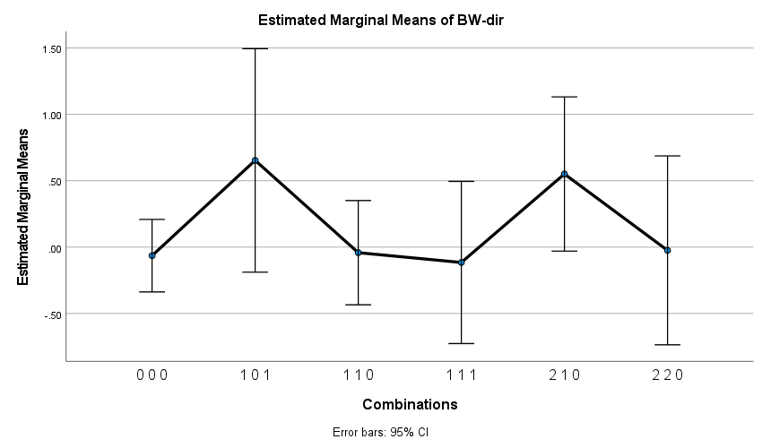

Wean dir

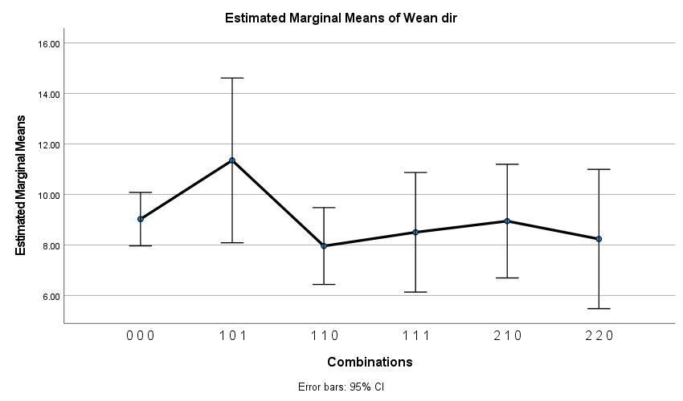

Mature wt

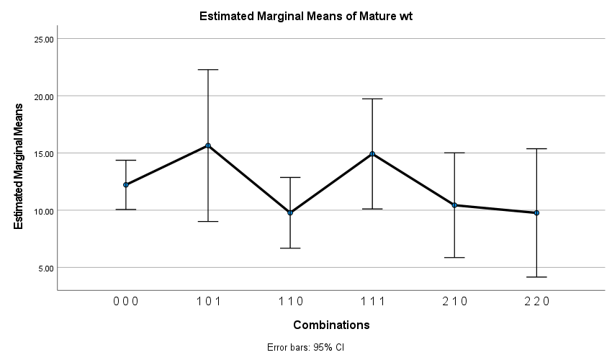

ADG

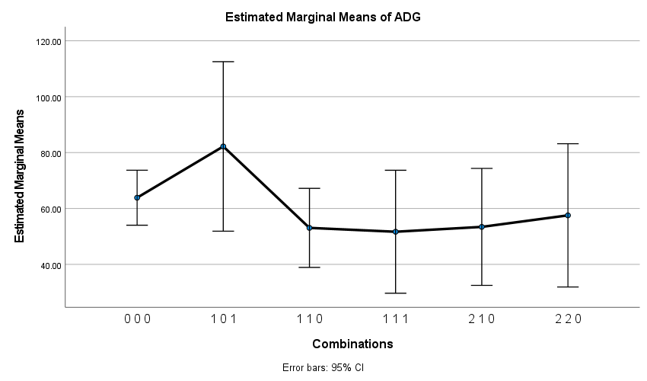

FCR

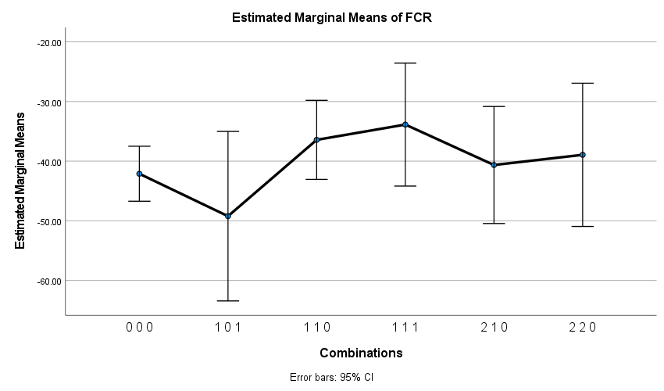

Fat

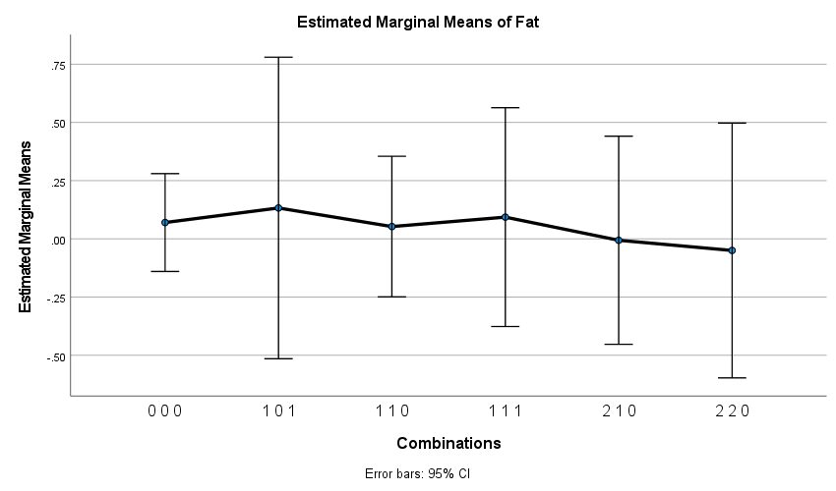

EMA

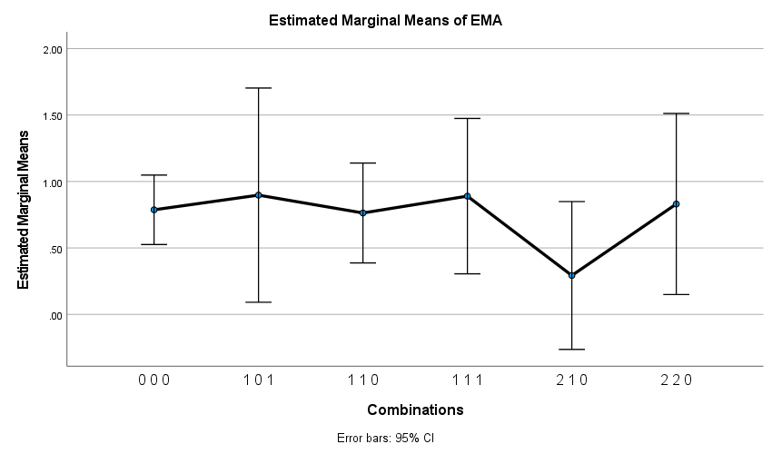

Marb

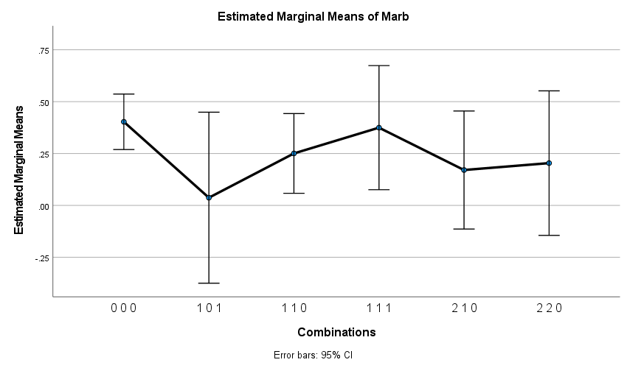

afc_ebv

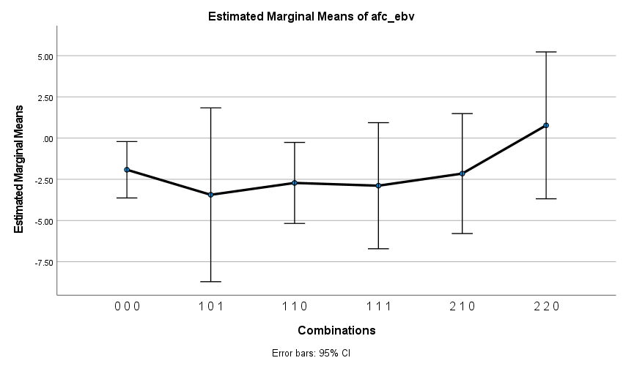

icp_ebv

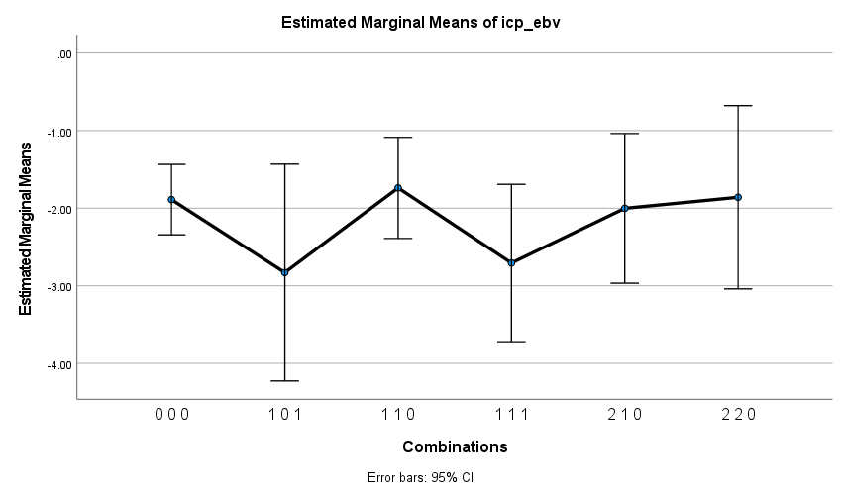

skr_ebv

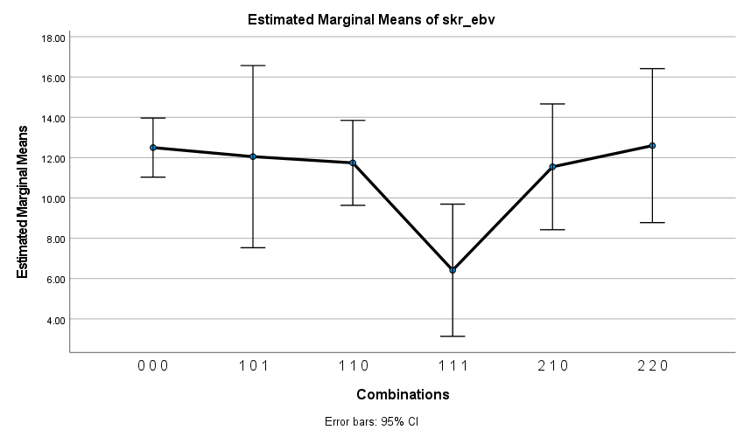

Longevity

