List of Figures
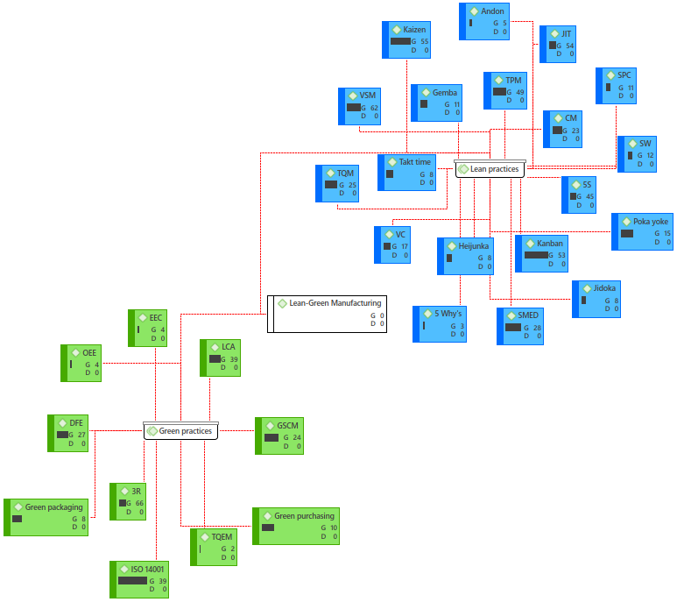
Figure 4.1: Lean and Green practices

Figure 4.2: Number of papers in each country

Figure 4.3: Type of research

Figure 4.4: Size of the industry

Figure 4.5: Number of papers and year of publication
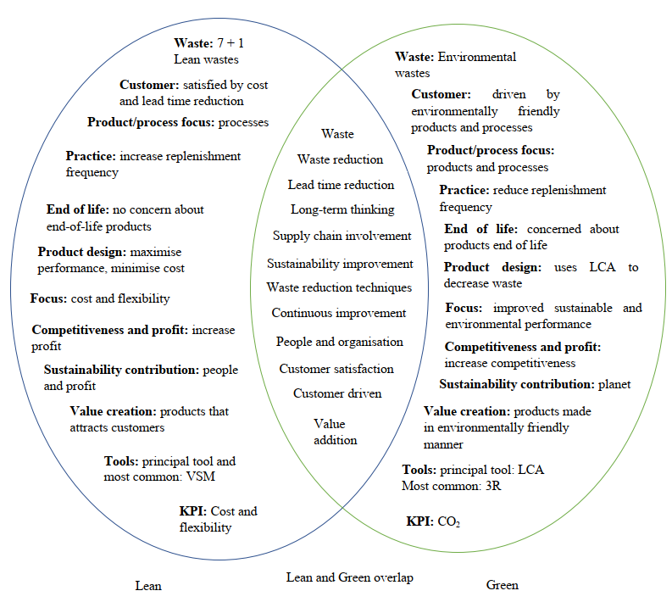
Figure 4.6: General overview showing the complementary and contradicting areas between LM and GM extended post Dües et al. (2013)

Figure 4.7: Relationships between performance criteria and Lean-Green practices.
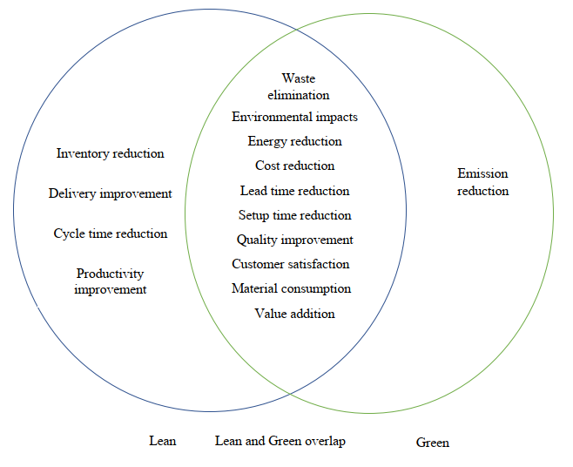
Figure 4.8: Overlap between LM and GM for operational and environmental performance
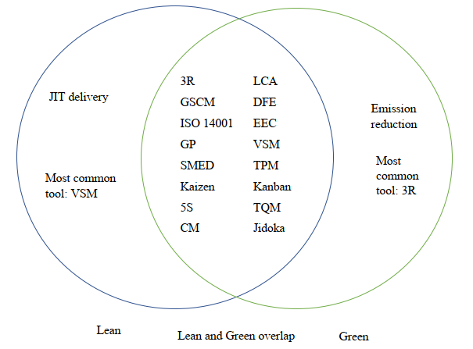
Figure 4.9: Overlap showing the complementary and contradicting techniques between Lean and Green
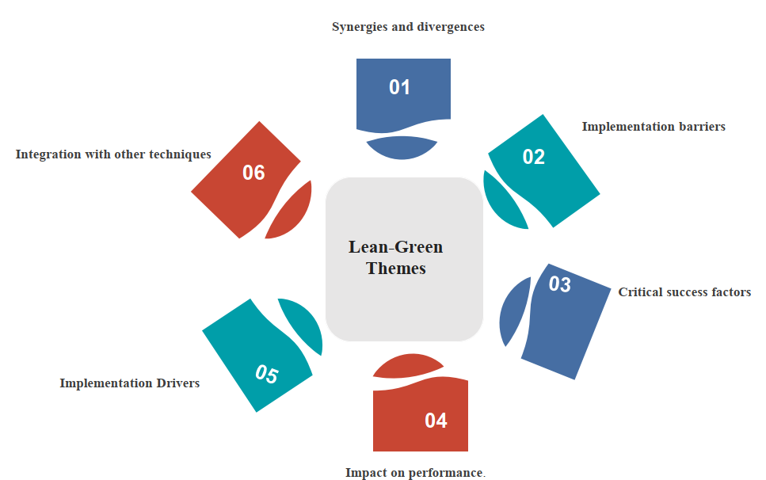
Figure 4.10: Other Lean-Green themes

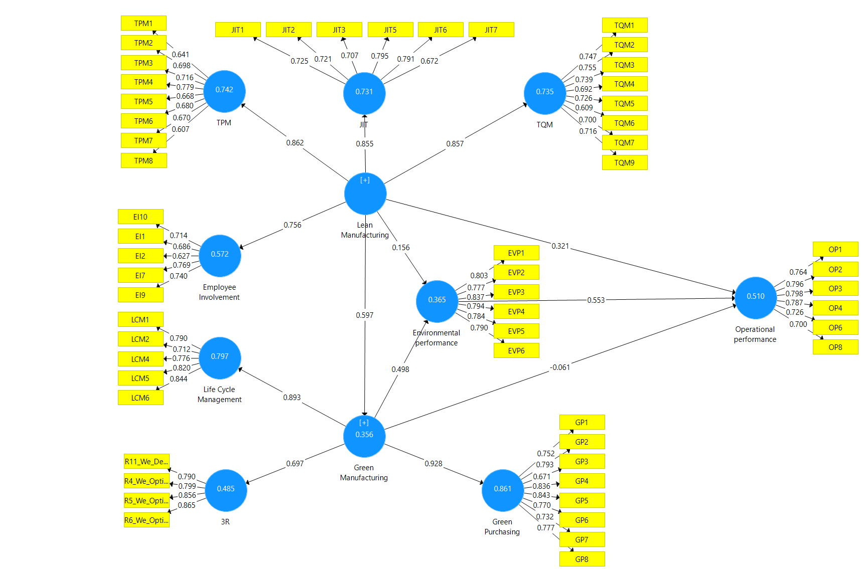
Figure 4.12: Results for the structural model
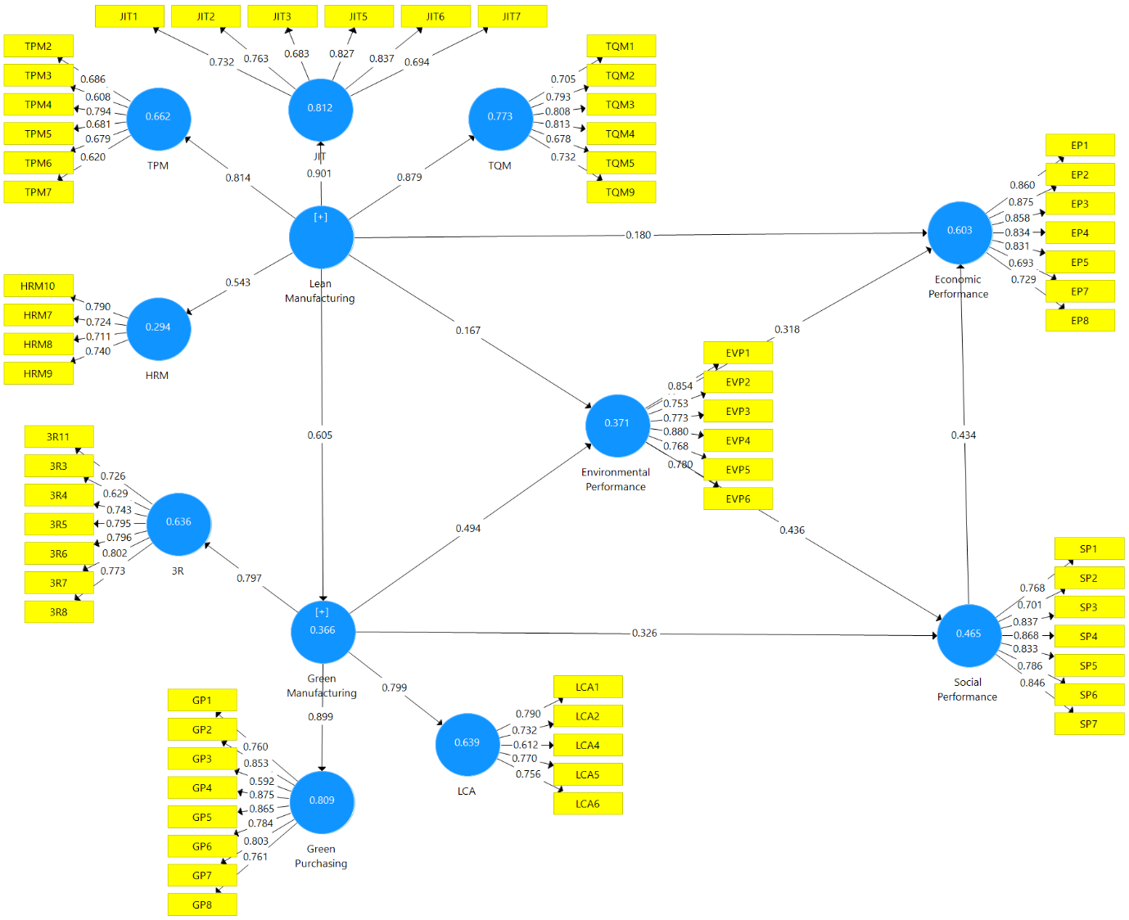
Figure 4.14: Structural model
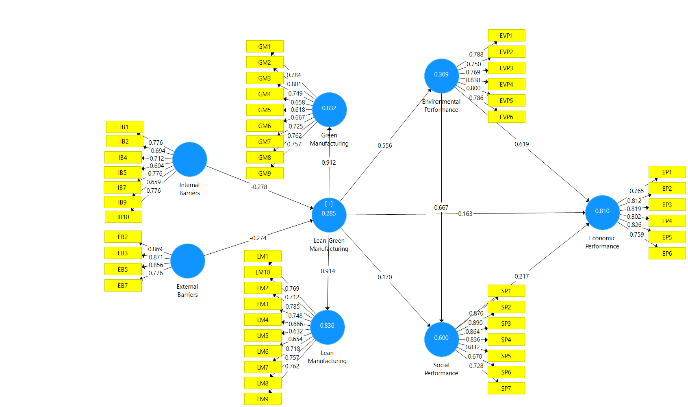
Figure 4.16: SEM structural model

List of Tables

Table 4-7: Measurement reliability and validity
 | Cronbach's Alpha | Composite Reliability | AVE | HTMT values
3R | 0.847 | 0.897 | 0.686 | Does not include 1
Employee Involvement | 0.751 | 0.834 | 0.502 | Does not include 1
Environmental performance | 0.886 | 0.913 | 0.636 | Does not include 1
GM | 0.926 | 0.936 | 0.501 | Does not include 1
Green Purchasing | 0.903 | 0.922 | 0.598 | Does not include 1
JIT | 0.83 | 0.876 | 0.543 | Does not include 1
LM | 0.928 | 0.935 | 0.509 | Does not include 1
LCA | 0.848 | 0.892 | 0.623 | Does not include 1
Operational performance | 0.856 | 0.893 | 0.582 | Does not include 1
TPM | 0.837 | 0.875 | 0.568 | Does not include 1
TQM | 0.86 | 0.891 | 0.507 | Does not include 1

Table 4-8: The f² values
 | 3R | EI | EVP | GM | GP | JIT | LCA | OP | TPM | TQM
EVP |  |  |  |  |  |  |  | 0.396
GM | 0.943 |  | 0.352 |  | 6.207 |  | 3.918 | 0.024
LM |  | 1.336 | 0.152 | 0.553 |  | 2.718 |  | 0.354 | 2.883 | 2.767

Table 4-9: The Stone-Geisser’s Q² values
Endogenous variable | TPM | JIT | TQM | EI | LCA | 3R | GP | GM | EVP | OP
Q² | 0.340 | 0.390 | 0.364 | 0.282 | 0.490 | 0.320 | 0.509 | 0.161 | 0.224 | 0.288

Table 4-10: t statistics and p values and decision on the hypotheses
 | t statistics | p values | Decision
Environmental performance Operational performance | 8.924 | 0.000 | supported
GM Environmental performance | 6.777 | 0.000 | supported
GM Operational performance | 0.973 | 0.331 | Not supported*
LM Environmental performance | 2.042 | 0.042 | supported
LM GM | 11.955 | 0.000 | supported
LM Operational performance | 5.377 | 0.000 | supported

Table 4-11: R², AVE, Cronbach's alpha and composite reliability values
 | Cronbach's Alpha | Composite Reliability | AVE | R²
3R | 0.873 | 0.902 | 0.569 | 0.636
Economic performance | 0.914 | 0.932 | 0.663 | 0.603
HRM | 0.727 | 0.830 | 0.550 | 0.294
Environmental performance | 0.889 | 0.916 | 0.645 | 0.371
Green Manufacturing | 0.925 | 0.934 | 0.508 | 0.366
Green purchasing | 0.912 | 0.930 | 0.626 | 0.809
JIT | 0.851 | 0.890 | 0.575 | 0.812
LCA | 0.786 | 0.853 | 0.540 | 0.639
Lean Manufacturing | 0.912 | 0.924 | 0.518
Social performance | 0.910 | 0.929 | 0.652 | 0.465
TPM | 0.769 | 0.837 | 0.563 | 0.563
TQM | 0.849 | 0.889 | 0.573 | 0.773

Table 4-12: Fornell-Larcker criterion-discriminant validity
 | 3R | EP | EVP | GM | GP | HRM | JIT | LCA | LM | SP | TPM | TQM
3R | 0.754
EP | 0.590 | 0.814
EVP | 0.638 | 0.675 | 0.803 |  |  | 0
GM | 0.708 | 0.486 | 0.595 | 0.713
GP | 0.515 | 0.262 | 0.402 | 0.699 | 0.791
HRM | 0.187 | 0.266 | 0.163 | 0.329 | 0.271 | 0.742
JIT | 0.393 | 0.496 | 0.415 | 0.548 | 0.454 | 0.512 | 0.758
LCA | 0.446 | 0.374 | 0.434 | 0.599 | 0.692 | 0.411 | 0.560 | 0.735
LM | 0.416 | 0.478 | 0.466 | 0.605 | 0.527 | 0.543 | 0.601 | 0.594 | 0.720
SP | 0.625 | 0.697 | 0.630 | 0.585 | 0.429 | 0.120 | 0.328 | 0.425 | 0.346 | 0.807
TPM | 0.299 | 0.217 | 0.329 | 0.462 | 0.438 | 0.538 | 0.64 | 0.401 | 0.641 | 0.197 | 0.750
TQM | 0.364 | 0.447 | 0.435 | 0.560 | 0.502 | 0.382 | 0.55 | 0.560 | 0.679 | 0.340 | 0.598 | 0.757

Table 4-13: Q² and f² values
 | f² |  |  |  | Q²
 | EP | EVP | GM | SP
Social performance | 0.385 |  |  |  | 0.293
Lean Manufacturing | 0.164 | 0.152 | 0.578
Green Manufacturing |  | 0.356 |  | 0.229 | 0.139
Environmental performance | 0.236 |  |  | 0.350 | 0.216

Table 4-14: Hypothesis testing results
 | t-statistic | p-values | Hypothesis | Decision
EVP EP | 3.714 | 0.000 | H6 | Accepted
EVP SP | 4.799 | 0.000 | H7 | Accepted
GM EVP | 4.729 | 0.000 | H4 | Accepted
LM EVP | 1.984 | 0.031 | H2 | Accepted
LM GM | 8.208 | 0.000 | H1 | Accepted
SP EP | 5.942 | 0.000 | H8 | Accepted
LM EP | 2.194 | 0.029 | H3 | Accepted
GM SP | 3.612 | 0.000 | H5 | Accepted

Table 4-15: Indirect impacts results
 | t-statistic | p-Values | Decision
LM EVP EP | 1.967 | 0.04 2 | Significant
LM EVP SP | 1.994 | 0.033 | Significant
GM EVP EP | 2.822 | 0.005 | Significant
GM EVP SP | 2.980 | 0.003 | Significant

Table 4-16: Cronbach's alpha, Composite reliability, AVE and HTMT values
 | Cronbach's alpha  >0.7 | Composite reliability  >0.7 | (AVE)  >0.5 | HTMT
Economic performance | 0.885 | 0.913 | 0.636 | Does not include 1
Environmental performance | 0.88 | 0.908 | 0.623 | Does not include 1
External barriers_ | 0.866 | 0.908 | 0.712 | Does not include 1
Green Manufacturing | 0.888 | 0.909 | 0.529 | Does not include 1
Internal barriers | 0.841 | 0.88 | 0.513 | Does not include 1
Lean Manufacturing | 0.897 | 0.916 | 0.521 | Does not include 1
Lean-Green Manufacturing | 0.725 | 0.82 | 0.536 | Does not include 1
Social performance | 0.915 | 0.933 | 0.667 | Does not include 1

Table 4-17: R² and Q² values
Variables | R² | Q²
Economic Performance | 0.81 | 0.493
Environmental Performance | 0.309 | 0.172
Green Manufacturing | 0.832 | 0.421
Lean Manufacturing | 0.836 | 0.418
Lean-Green Manufacturing | 0.285 | 0.114
Social Performance | 0.6 | 0.372

Table 4-18: f² values
 | Environmental performance | Economic performance | Social performance | Lean-Green Manufacturing
Environmental performance |  | 0.788 | 0.767
Social performance |  | 0.263
Lean-Green Manufacturing | 0.448 | 0.159 | 0.189
External barriers |  |  |  | 0.208
Internal barriers |  |  |  | 0.212

Table 4-19: path coefficient, t-statistics, p-value and decision
Hypotheses | Effect of | On | Path coefficient | t-statistics | p values | Decision
H7 | Environmental performance | Economic performance | 0.619 | 9.883 | 0 | Accepted
H6 | Environmental performance | Social performance | 0.667 | 9.635 | 0 | Accepted
H1 | External barriers | Lean-Green Manufacturing | -0.274 | 2.71 | 0.009 | Accepted
H2 | Internal barriers | Lean-Green Manufacturing | -2.78 | 2.76 | 0.007 | Accepted
H4 | Lean-Green Manufacturing | Economic performance | 0.163 | 2.857 | 0.004 | Accepted
H3 | Lean-Green Manufacturing | Environmental performance | 0.556 | 6.983 | 0 | Accepted
H5 | Lean-Green Manufacturing | Social performance | 0.170 | 2.377 | 0.018 | Accepted
H8 | Social performance | Economic performance | 0.217 | 2.519 | 0.012 | Accepted

